Position: | Electric ,ETO  or ORDINARY SEAMAN | Readiness:
Position: | Electric ,ETO  or ORDINARY SEAMAN | Citizenship: | Azerbaijan
Last name: | Vüsal | Marital status | Single
First name: | Dadaşov | Children:
Middle name: | Tərlan | Nationality: | Azerbaijani
Birth date: | 11.12.1997 | Birth place: | Azerbaijan
Home address: | Baku, Azerbaijan | Phone mobile: | +994707177741
Home address: | Baku, Azerbaijan | Email:
English level: | Average
Russian level: | Average
APPLICATION FORM
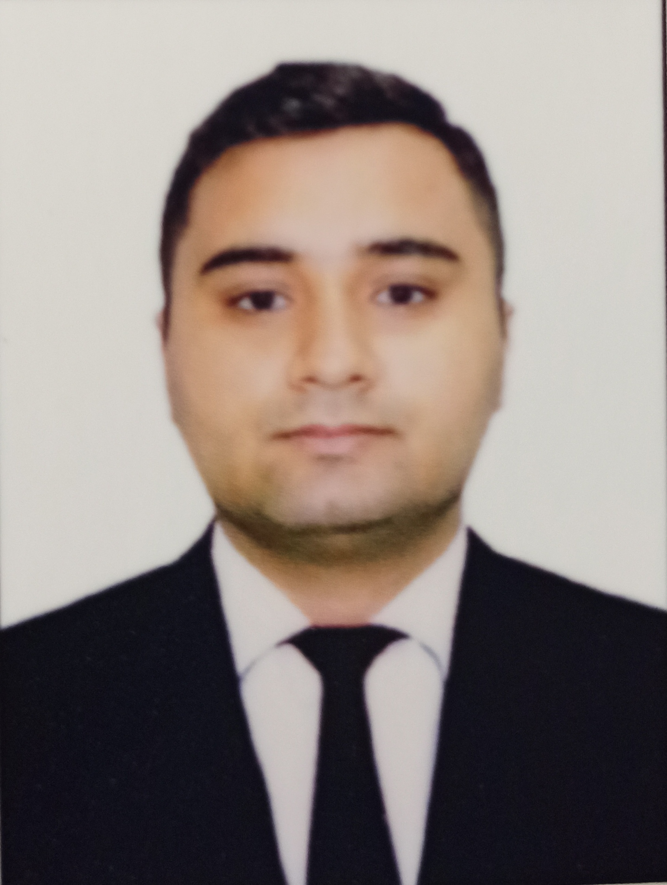

Passports & Certificates
Title | Class | Number |  | Place of issue | Issued | Valid
Passport
Seaman's book |  | DQK 017078 |  | Baku, AZE | 11.02.2021 | 11.02.2026
Seafarers İD document |  | AZE 022004 |  | Baku, AZE | 11.02.2021 | 11.02.2026
Travel passport |  | C03022549 |  | Baku, AZE | 21.08.2020 | 20.08.2030
Certificates
Requirements of regulation Vİ\1 of the international convention STCW-78 , as amended and of the section A-VI\1 of the STCW code and on programme approved by the STATE MARITIME Administration :. -personal survival techniques (STCW -78, A-VI/1-1) -fire prevention and fire fighting (STCW -78, A-VI/1-2) -elementary first aid (STCW -78, A-VI/1-3) -personal safety and social responsibilities (STCW -78, A-VI/1-4) |  |  | SO-0350-21 | Baku, AZE | 03.03.2021 | 03.03.2026
Proficiency in Survival Craft and boats other than fast rescue boats (STCW Code, A-VI/2) |  |  | SL-0180-21 | Baku, AZE | 22.02.2021 | 16.02.2026
Ship security-related familiarization security –awareness training (STCW Code, A –VI/6, Pa.1 to Pa.4.) |  |  | SI-1319-22 | Baku, AZE | 02.06.2022 | 02.06.2027
Training for seafarers with designated security duties (STCW Code, A-Vl/6, Pa.6 to Pa.8.; IMO Mode Course 3.19) |  |  | SH-0497-20 | Baku, AZE | 18.09.2020 | 10.09.2025
Medical certificate |  |  | № | Baku, AZE | 14.06.2022 | 14.06.2024
Rating forming part of an engine-room |  |  | RP09258 |  | 25.10.2018 | 25.10. 2028
İnternational Safety Management Code |  |  | SP-2322-21 | Baku,AZE | 15.12.2021 | 15.12.2026
Basic training and qualifications on oil and chemical tanker cargo operations (STCW Code, A-V/1-1 Pa.1; İMO Model Course 1.01) |  |  | SA-0072-22 | Baku,AZE | 18.02.2022 | 18.02.2027
Training in advanced fire-fighting (STCW Code,. A-Vl/3 Pa.1, Pa.2, Pa.3 and Pa.4; İMO Model Course 1.20) |  |  | SJ-0115-21 | Baku,AZE | 25.02.2021 | 25.02.2026
Medical First Aid (STCW Code, A-Vl/4, Pa. 1, Pa. 2 and Pa. 3; İMO Model Course 1.14) |  |  | SN-0883-21 | Baku,AZE | 13.12.2021 | 13.12.2026
Leadership and Teamwork. (İMO Model Course 1.39) |  |  | DL-0315-22 | Baku, AZE | 22.02.2022 | 09.02.2027
Certificate of Competency Electro-tecnical officer |  |  | Certificate No-000868/22 | Baku,AZE | 08.06.2022 | 08.06.2027

Sea-going Experience (practice)
Vessel’s Name |  | Company | Position | On | Of
SANJAR | SAMAYA CO LTD |  | Electric | 01.02.2021 | 30.06.2021
CLEARWATER | ZEN SHİPPİNG LLC |  | Electric | 01.08.2021 | 01.04.2022
ODESSA 1 | TRİMORYA SHİPPİNG & TRADE CO LTD |  | ETO | 05.01.2023 | 20.07.2023

