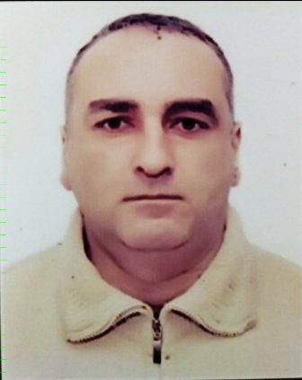
APPLICANT’S PERSONAL DATA

READY TO WORK (DATE): Now POSITION APPLIED FOR: Third mechanic
FIRST / LAST NAME: Sheydeyev Najaf | CITIZENSHIP: AZERBAIJAN
FATHER’S NAME: Tofig | ADDRESS(INCL. POST CODE): AZERBAIJAN REPUBLIC
DATE OF BIRTH: 03.03.1971 | BAKU
PLACE OF BIRTH: AZERBAIJAN | PHONE: +99470 551 71 63  E-MAIL: 71seydayev@gmail.com

MARINE EDUCATION RECEIVED
NAME OF SCHOOL | FROM | TILL | TYPE OF DEGREE RECEIVED
Azerbaijan State Fish Industry Technical College | 2001 | 2005 | mechanic

NATIONAL DOCUMENTS
PASSPORT / SBK |  | NO. | ISSUED | VALID
SEAMAN’S PASSPORT |  | DQK - 016832 | 12.12.2020 | 12.12.2025
TRAVELLING PASSPORT |  | AZE-C03760579 | 02.12.2022 | 01.12.2032
CIVIL PASSORT |  | AA 2774147 | 16.02.2021 | 16.02.2031

CERTIFICATE | STCW CODE | NO | ISSUED | VALID TILL
Medical First Aid | A-VI/4 | SN-1659-22 | 16.12.2022 | 15.12.2027
International Safety Management Code |  | SP-0203-21 | 02.03.2021 | 26.02.2026
Proficiency in survival craft and boats other than fast rescue boats | A-VI/2 | SL-0334-20 | 06.03.2020 | 06.03.2025
Leadership and teamwork | A-III/3 | DL-0437-21 | 19.05.2021 | 19.05.2026
Training for seafarers with designated security duties | A-VI/6 | SH-1142-22 | 23.06.2022 | 22.06.2027
Personal survival techniques  Fire prevention and fire fighting  Elementary first aid  Personal safety and social responsibilities | A-VI/1 | SO-1812-18 | 20.07.2018 | 20.07.2023
Engine resource management | A-III/1 | ER-0303-21 | 12.08.2021 | 12.08.2026
Training in advanced fire-fighting | A-VI-3 | SJ-0012-23 | 10.01.2023 | 10.01.2028

SEA SERVICE LAST 5 YEARS
VESSEL’S NAME | SHIP OWNER | FLAG | VSL’S  TYPE | DTW | RANK | EMPLOY  M/Y | MENT  M/Y
Akstafa | ASCO | Azerbaijan | Dry cargo | 2200 | Third mechanic | 19.09.2009 | 09.10.2010
Saatli | ASCO | Azerbaijan | Dry cargo | 2200 | Third mechanic | 09.10.2010 | 20.12.2010
Akstafa | ASCO | Azerbaijan | Dry cargo | 2200 | Second mechanic | 04.01.2011 | 08.08.2011
Dagistan | ASCO | Azerbaijan | Motor ship | 4350 | Third mechanic | 20.10.2011 | 22.12.2011
Ulduz | ASCO | Azerbaijan | Crane | 750 | Chief mechanic | 25.12.2011 | 05.09.2012
Endeavour | CASPIAN | Azerbaijan | Tug boat | 600 | Third mechanic | 16.09.2012
Castle | CASPIAN | Azerbaijan | Supply ship | 2800 | Third mechanic | 05.09.2013 | 20.12.2013
Server | CASPIAN | Azerbaijan | Supply ship | 3100 | Third mechanic | 09.01.2022 | 25.02.2022

LANGUAGES
LANGUAGE | Reading | Writing | Speaking
English | Good | Good | Good
Russian | Good | Good | Good

