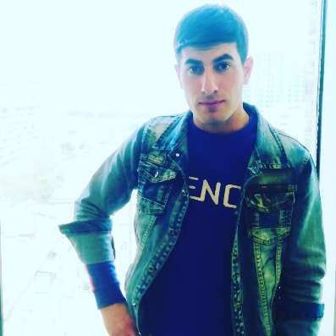

APPLICATION FORM

Position Applied for COOK | Date Available from:

1. Personal Data
Family Name:  HUSEYNOV | First Name :  NIJAT | Middle Name:  GOLISHAD
Date of Birth:  25.03.1998 | Place of Birth :  Yardimli city | Citizenship  AZERBAIJAN
Permanent Address ;  Azerbaijan, Baku city, Ramana, Shusha settlement |  | Phone (Home):  Phone (Business/ Mobile)  +994 50 822 23 29  Email: huseynovnicat1998@gmail.com

2. Maritime Education
Name of school | Town | Country | From | To | Type of degree or diploma

3. Professional Test
Professional Test Date | Name of Test | Score
Professional Interview Date | Result

4. Family Details
Civil Status(Single, Married, Separated, Divorced, Widowed) :
SINGLE
Next of Kin (the first emergency contact) | Relationship
Address of Residence | Phone :

 | Daughter | Son
Family Name
First Name
Date of Birth
City of living
Phone Numbers

5. Identity Documents
Document | Country | Number | Place of Issue | Issue Date | Expiry Date
Seaman's Book | Azerbaijan | 6MHNG4Y | Azerbaijan, Baku | 10.03.2023 | 10.03.2028
Seaarers | Azerbaijan |  | Azerbaijan, Baku

6. Valid Visa
Country or Union | Type | Valid Until

7. Courses Attended and Certificates Obtained
Document | Number | Dates |  | Place
Document | Number | Issue | Expiry | Place

Certificate of Competency | 0634/23 | 01.03.2023 | 01.03.2028 | AZERBAIJAN
KAINAT M ZM | NO.000339 | 26.09.2022 |  | AZERBAIJAN
basic training and qualifications on oil and chemical tanker cargo operation | SA-0964-22 | 13.12.2022 | 08.12.2027 | AZERBAIJAN
-Safety familiarization training  -personal survival techniques  -fire prevention and fire fighting  -elementary first aid  -personal safety and social responsibilities | SO-5858-22 | 15.12.2022 | 15.12.2027 | AZERBAIJAN
-Profeciency in survival craft and boats other than fast rescue boats | SL-4006-22 | 12.12.2022 | 12.12.2027 | AZERBAIJAN
International Safety Management | SP-3646-22 | 13.12.2022 | 13.12.2027 | AZERBAIJAN
Ship Security-related familiarization security-awareness training | SI-3041-22 | 16.12.2022 | 16.12.2027 | AZERBAIJAN

8. Physical Data
Height | 170
Weight | 65
Colour of Hair | BLACK
Colour of Eyes | BROWN
Boilersuit Size | M
Shoes Size | 43

9. Medical History | Yes | No
Have you ever signed off a ship due to medical reasons? |  | +
Did you undergo any medical operation in the past? |  | +
Have you consulted a doctor during the last 12 months for an illness/accident? |  | +
Do you have any health or disability problems now? |  | +

If yes, please give full details:

 | Passed: | Valid till:
International Medical Examination | 06.12.2022 | 06.12.2024
Vaccination Against Yellow Fiver
Vaccination Against Diphtheria

10. References (please give name and address of your current or past employer) | Office remarks

Name of Company
Name of person to contact
Address
Phone

Name of Company
Name of person to contact
Address
Phone

11. Bank address for allotments
Beneficiary
Account No.
Name of Bank
Bank Address

12. Knowledge and experience | Yes | No
OCIMF vetting experience:
ISGOT knowledge:

13. I hereby declare that the above, including Medical History, is true
Place | Date | Signature

14. For Office use only
I know Georgia, Uzbek cuisine.

I know speak Turkish and English

15. Seagoing Experience

Name of vessel | Flag | Vessel’s Type | DWT | Eng Type | HP | Manager or Owner | Rank | From d/m/y | To  d/m/y | Total  m/d
MIRVARI |  | DRY CARGO |  |  |  | Rusalka ship  Management | COOK | 11.06.2022 | 09.11.2022
MIT BEAUTY QUEEN |  | TANKER |  |  |  | Dorian Ship management INC | COOK | 23.04.2023 | 17.08.2023

Total rank sea service: Total type of vessel sea service:
Rank | Years |  | Type of vessel | Years
 |  |  | OIL TANKER
 |  |  | LPG
 |  |  | DRY CARGO
 |  |  | TANKER ICE
 |  |  | OIL /CHEMICAL TANKER
 |  |  | FERRY
Total |  |  | Total:

