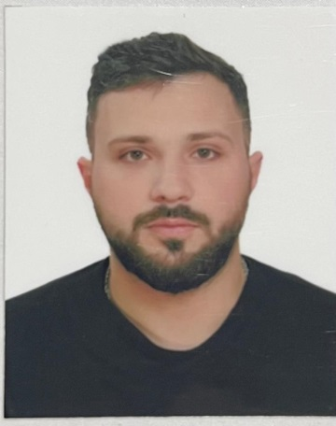

6 | F | P | G | F | D | H
Personal ID Number

Position Applied For: Cook | Date Available from: Any Time

1. Personal Data
Family Name: Qasimov | First Name: Ulvi | Middle Name: Namik
Date of Birth: 15.06.1997 | Place of Birth : Azerbaıjan Baku | Citizenship: Azerbaıjan
Permanent Address: Azerbaıjan , Baku |  | Phone Mobil : Az (+994) 51 984 78 22 WP  E-mail : ulvi7822@gmail.com

2. Maritime Education
Name of school | Town | Country | From | To | Type of degree or diploma
Caspian Marine Education | Baku | Azerbaıjan | 01.03.2022 | 30.09.2020 | Professional

3. Language | Speak | Reading | Write
Azerbaijani | Native | Native | Native
Turkısh | Good | Good | Good
Russian | Native | Native | Native
English | Fair | Fair | Fair

4. Family Details
Civil Status(Single, Married, Separated, Divorced, Widowed) : Single
Next of Kin (the first emergency contact) Qasimov Namik |  |  |  |  |  | Relationship: Father
Address of Residence : Azerbaıjan , Baku |  |  |  |  |  | Phone : (+994) 77 622 71 29
5. Identity Documents

Document | Country | Number |  | Place of Issue |  |  |  | Issue Date |  | Expiry Date
Seaman's Book | Azerbaıjan | DQK 022235 |  | Azerbaijan |  |  |  | 15.12.2022 |  | 15.12.2027
Travel Passport | Azerbaıjan | C01313241 |  | Azerbaijan |  |  |  | 27.08.2017 |  | 26.08.2027
Civil Passport | Azerbaıjan | AA1740756 |  | Azerbaijan |  |  |  | ------------- |  | 03.02.2030
6. I hereby declare that the above, including Medical History, is true
Place: |  |  | Date |  |  | Signature:
7. Courses Attended and Certificates Obtained

Document |  |  | Number |  | Dates |  |  |  | Place
 |  |  |  |  | Issue |  | Expiry
Certificate of Competency |  |  |  |  |  |  |  |  | Azerbaıjan
Training for seafarers with designated security duties |  |  | SH-2275-22 |  | 11.11.2022 |  | 11.11.2027 |  | Azerbaıjan
Proficiency in Survival Craft and Rescue Boats Other Than Fast Rescue Boats |  |  | SL-3649-22 |  | 11.11.2022 |  | 11.11.2027 |  | Azerbaıjan
Ship Security-related familiarization security – awareness |  |  | SI-2811-22 |  | 11.11.2022 |  | 11.11.2027 |  | Azerbaıjan
International Safety Management Code |  |  | SP-3352-22 |  | 11.11.2022 |  | 11.11.2027 |  | Azerbaıjan
-personal survival techniques –fire prevention avdfire fighting –elementary first aid –personal safety and social responsibilities |  |  | SO-5354-22 |  | 11.11.2022 |  | 11.11.2027 |  | Azerbaıjan
Basic training and qualifications on oil and cemical tanker cargo operations (STCW Code A-V/1-1 Pa.1) |  |  |  |  |  |  |  |  | Azerbaıjan

8. Physical Data

Height | 174 sm
Weight | 97 kq
Colour of Hair | Black
Colour of Eyes | Brown
Boilersuit Size | L
Shoes Size | 42

9. References ( please give name and address of your current or past employer )
Name of Company 1
Name of person to contact
Address
Phone
Name of Company 2
Name of person to contact
Address
Phone
10. Bank address for allotments
Beneficiary
Account No.
Name of Bank
Bank Address

11. Seagoing Experience
Name of vessel | Flag | Vessel’s Type | DWT | Manager or Owner | Rank | From d/m/y | To  d/m/y | Total  m/d
Grace | Antigua Barbuda | General Cargo | 8108 | Haifa Shipping | Chief Cook | 11.01.2023 | 17.08.2023

