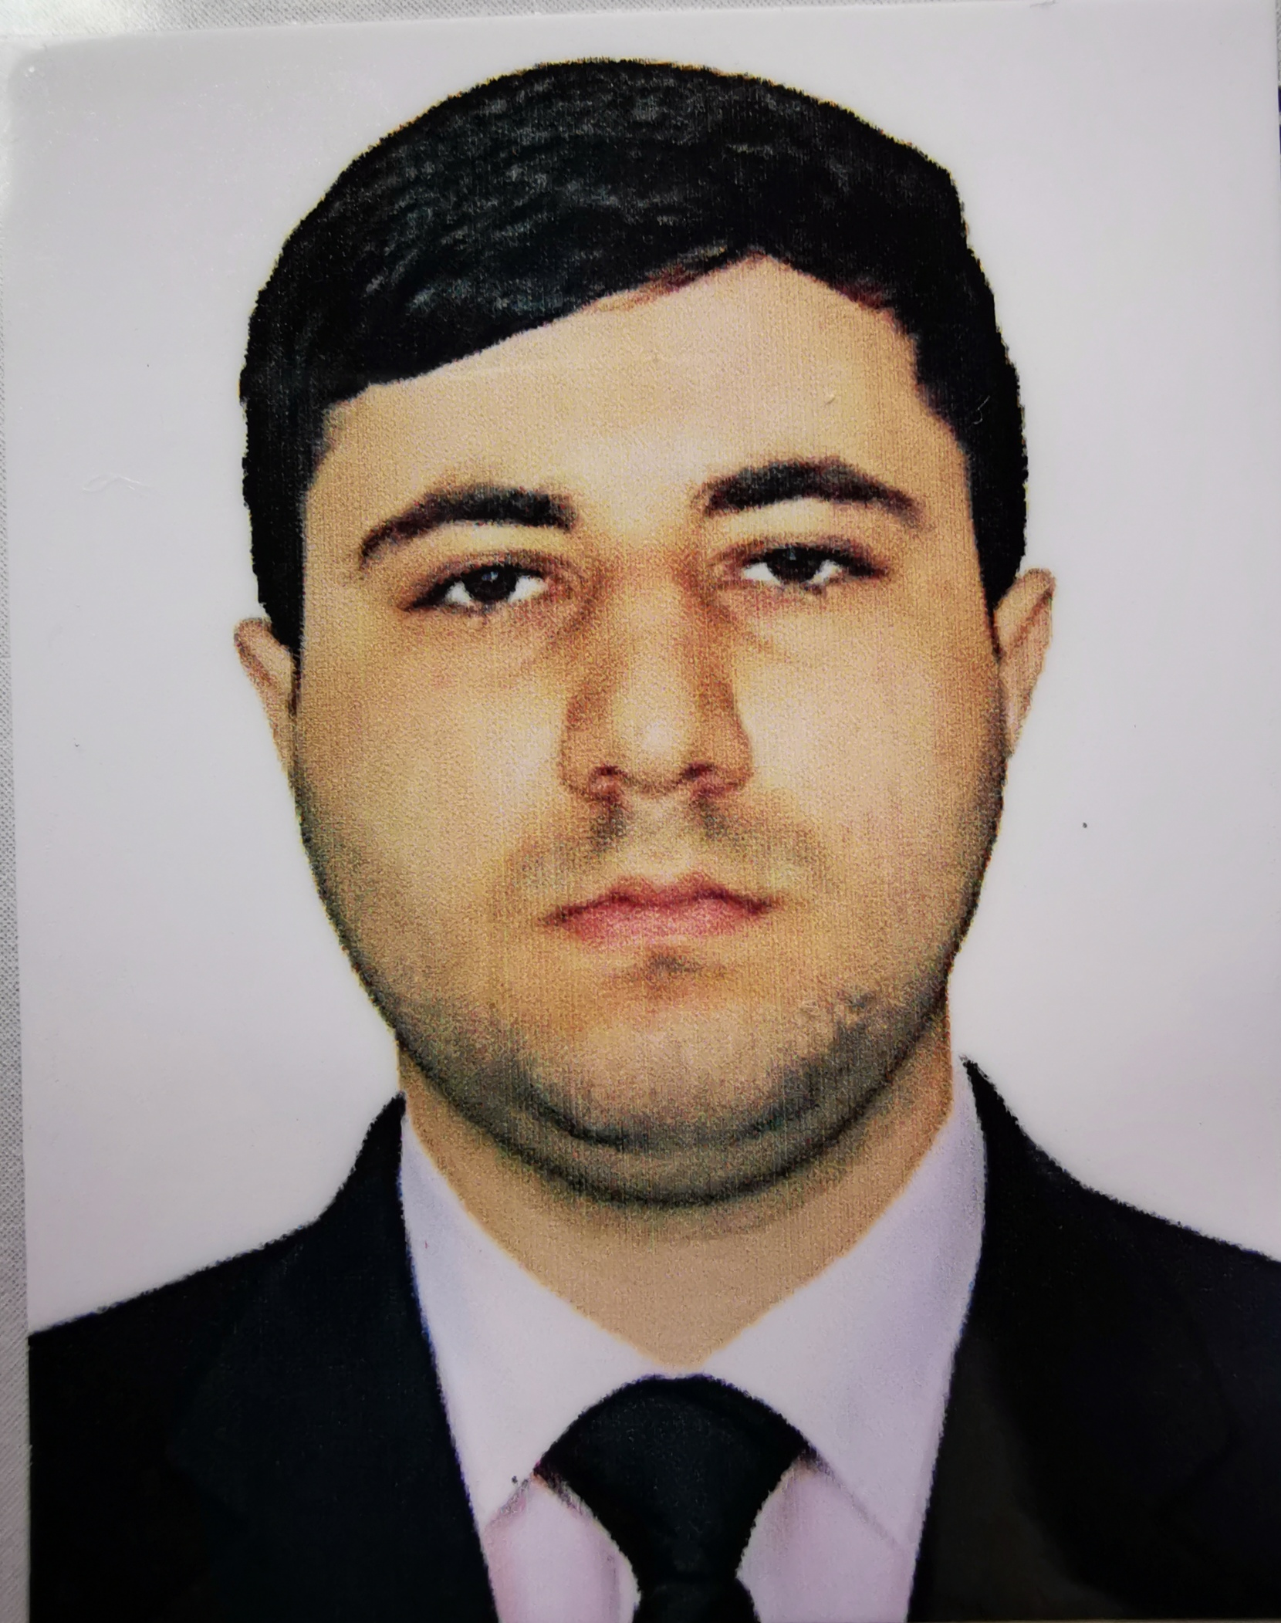

EMPLOYMENT APPLICATION FORM
Rank: 3rd Engineer | Date Available for Joining: ASAP
 | Vessel:

Personal details
Surname: Abasov | First name: Aflatun | Photo:
Date of birth: 24.02.1996 | Place of birth: Azerbaijan, Baku | Nationality: Azerbaijanian
Home address: Azerbaijan, Baku, Yeni surakhani, Kotovski 18/3
Phones: +994517557349

Nearest airport: Heydar Aliyev International airport | Nearest international airport: Heydar Aliyev International airport

Documents

Passport No. | C01967073 | Issued on: | 16.06.2018 | Expiry date: | 15.06.2028
S/book No. | DQK 015954 | Issued on: | 03.03.2020 | Expiry date: | 03.03.2025
US visa C1/D |  | Issued on: |  | Expiry date:

LICENCE PARTICULARS
MOT | Grade | Cert No | Place of Issue | Date of Issue | Expiry date
National License | Officer in Charge of An Engineering Watch | 000867/23 | Azerbaijan, Baku | 16.08.2023 | 16.08.2028
Endorsement | Officer in Charge of An Engineering Watch | 0000867/23 | Azerbaijan, Baku | 16.08.2023 | 16.08.2028
Tanker endorsement | Crude Oil
 | Liquid chemical
 | Liquefied gas
 | Shuttle Tanker Log Book
 | DP Log Book NI
 | DP Log Book hours | 228 days | 516 hours | DP2

CERTIFICATES | Cert No | Date of Issue | Expiry date
International Ship Management code (ISM) | SP-2261-22 | 26.07.2022 | 26.07.2027
G.M.D.S.S. Endorsement
Proficiency In Survival Craft | SL—0247-20 | 23.02.2020 | 23.02.2025
Basic Safety Training | SO-0392-20 | 23.02.2020 | 23.02.2025
Advanced Fire Fighting | SJ-0113-20 | 21.02.2020 | 21.02.2025
Dangerous And Hazardous Substances
Ship Security Officer
Medical First Aid | SN-0081-20 | 04.02.2020 | 04.02.2025
DP Maintenance | DPM038/22 | 22.07.2022 | UNLIMITED
DP Advanced Course
Engine Resourse Management | ER-0058-20 | 04.03.2020 | 04.03.2025
Basic training and qualifications on oil and chemical tanker cargo operation | SA-0081-19 | 01.03.2019 | 01.03.2024
Leadership and Teamwork | DL-0030-20 | 13.02.2020 | 13.02.2025
Security-related training & instruction for all seafarers | SI-0171-21 | 06.04.2021 | 06.04.2026
Designated Security Duties | SH-0042-20 | 23.01.2020 | 23.01.2025
Ship Security Officer
H2S | HS21-038 | 30.05.2021 | 30.05.2024
Yellow fever

Pre-SEA Training / Nautical School / Maritime School | Qualifications | Passed:
Azerbaijan State Marine Academy | Bachelor

SEA SERVICE
Name of Vessel | Year  Built | Flag | Type of Vessel  and Engine (Type) | DWT and KW | Rank | Period of Service |  | Name of Owners
Gyultakin Askerova | 1984 | AZE | Offshore Supply Ship, | 2x2650 KW | Oiler | 10.05.17 | 25.11.17 | Azerbaijan Caspian Shipping company
Astana | 2004 | AZE | Oil and Chemical Tanker | 2300 KW | Oiler | 15.02.19 | 02.07.19 | CMS shipping Co. LTD
Almaty | 2004 | AZE | Oil and Chemical Tanker | 2300 KW | Oiler | 05.08.19 | 27.12.19 | CMS shipping Co. LTD
Caspian Supporter | 2010 | AZE | AHTS DP2 | 2x4500 KW | Oiler | 04.02.20 | 10.07.20 | BUE Caspian LTD
Spear | 2003 | Belize | Oil and Chemical Tanker | 2600 KW | Oiler | 03.09.20 | 16.11.20 | Pegasus Ventures
Caspian Supporter | 2010 | AZE | AHTS DP2 | 2x4500 KW | Oiler | 05.01.21 | 15.04.21 | BUE Caspian LTD
Rawabi 3 | 2012 | Tuvalu | AHTS DP2 CAT 3516C | 2x1920 KW | 3rd Engineer | 25.06.21 | 27.06.22 | Rawabi Valianz Offshore Services
Rawabi 37 | 2012 | Tuvalu | AHTS DP2 YANMAR  8EY26W | 2x2560 KW | 3rd Engineer | 14.10.22 | 31.05.23 | Rawabi Valianz Offshore Services

References |  |  | Exp. with Multinational Crew: | 1 year
Name of company: | Rawabi Vallianz Offshore Services |  | Nationalities: | Indian, Egyptian, Ukrainian, Russian, Arabic, Tanzania, Kenya, Indonesian, Phillipinese, Nigerian, Turkish
No. | +966568176102 (crew cordinator)
Name of company: | Caspian Marine Services ltd |  | Level of English | Advanced
No. | +994502892635 |  | Marlins Test % | 91

Next of kin |  |  | Personal data:
Name/Relationship | Abbasov Briliant/Sister |  | Weight, kg: | 90 | Height, cm: | 174
Home address: | Azerbaijan, Baku, Yeni surakhani, Kotovski 18/3 |  | Eyes: | black | Hair: | Brown
Phones: | +994505158700 |  | Overall size: | 50 (L) | Safety shoes: | 43-44
About you: Highly motivated, well-organized and communicative, with technical mind to solving problems. Experience offshore sector operations and tanker fleet.

