

APPLICATION FORM

 | 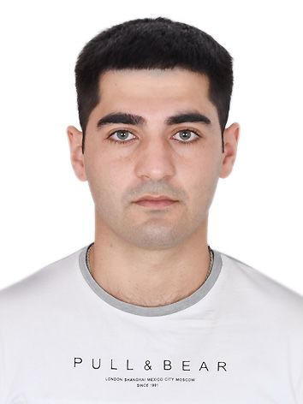
  Position: | OILER | Citizenship: | AZERBAIJAN
  Last name: | SALAMZADE | Marital status | SINGLE
  First name: | OGTAY | Children: | NO HAVE CHILDREN
  Patronymic name: | RASHID | Nationality: | AZERBAIJAN
  Birth date: | 25.10.1996 | Birth place: | AZERBAIJAN, BAKU
  Home address: | AZERBAIJAN,  SUMGAIT | Phone mobile: | (+994)55 488 74 34  What’s App
  Home address: | AZERBAIJAN,  SUMGAIT | E-mail: | salamzadeogtay@ gmail.com

Passports& Seaman’s Book

Title | Number | Place of issue | Issued | Valid
INTERNATIONAL PASSPORT | AZE C02209346 | Azerbaijan, Baku | 03.10.2018 | 02.10.2028
SEAMAN’S BOOK | DQK 022756 | Azerbaijan, Baku | 18.02.2023 | 18.02.2028
SEAFARERS ID DOCUMENT | AZE 027624 | Azerbaijan, Baku | 18.02.2023 | 18.02.2028

Diplom &Certificates

Title |  |  |  | Number | Place of issue | Issued | Valid
CERTIFICATE OF COMPETENCY  RATING FORMING FORMING PART OF AN  ENGINE-ROOM WATCH A-III/4 |  |  |  | № RP12430  0416/23 | Azerbaijan, Baku | 10.02.2023 | PERMANENT
Has successfully completed following safety familiarization basic training and instruction for all seafarers courses which has been developed in accordance with the mandatory minimum requirements of Regulation VI/I of the international Convention STCW- 78. As amended and of the Section A-VI/I 0f STCW Code and on programmer approved by the State Maritime Administration:  -safety familiarization training  (STCW-78, A-VI/I pa.1)  -personal survival techniques  (STCW-78, A-VI/1 pa.2.1.1)  -fire prevention and fire fighting  (STCW-78, A-VI/1 pa.2.1.2)  -elementary first aid  (STCW-78, A-VI/1 pa.2.1.3)  -personal safety and social responsibilities  (STCW-78,A-VI/I pa.2.1.4) |  |  |  | № SO-4529-22 | Azerbaijan, Baku | 07.10.2022 | 07.10.2027
- Ship security –related familiarization securityawareness training.  (STCW Code, A-VI/6,Pa.1 to Pa.4) |  |  |  | № SI-2269-22 | Azerbaijan, Baku | 22.09.2022 | 16.09.2027
Has successfully completed “INTERNATOINAL |  |  |  | № SP-2915-22 | Azerbaijan, Baku | 30.09.2022 | 30.09.2027
 |  | SAFETY MANAGEMENT CODE” course whitch has | f
 |  | been developed in accordance with the requirements o
Chapter IX of the International Convention SOLAS-74
,as amended and International Safety Management
Code and on programmer approved by the State Maritime Agency
 | -Proficiency in survival craft and boats other than fast rescue boats  (STCW Code, A-VI-2, Pa.1, Pa.2, Pa.3 and Pa.4 ) |  |  | № SL-2925-22 | Azerbaijan, Baku | 21.09.2022 | 21.09.2027
 | --Training for seafarers with designated security duties  (STCW Code , A-VI/6, Pa.6 to Pa.8 ) |  |  | № SH-1929-22 | Azerbaijan, Baku | 29.09.2022 | 29.09.2027
 | -Basic training and qualifications onoil and chemical tanker cargo operations  (STCW Code, A-V/1-1 Pa.1; IMO Model Course 1.01) |  |  | № SA-0730-22 | Azerbaijan,  Baku | 26.09.2022 | 26.09.2027

Medical Information
Tide | Number | Place of issue | Issued | Valid
-Extraction From Seafarers Medical Certificate | ----------------- | Azerbaijan, Baku | 17.08.2022 | 07.08.2024
-COVID -19 Coromo vac Vaccination  3rd-Dose (booster) | B30600065A | Azerbaijan, Baku | 13.01.2022

Knowledge of other Languages
1.Russian | 2.Turkish | 3.Azerbaijan | 4. English
Good | Fluent | Fluent | Beginner

Biometrics
SEX : MALE | HEIGHT : 170 sm | OVERALL SIZE : M
EYES COLOR : MIXED | WEIGHT : 77 kg | SHOE SIZE : 43 sm

Next of Kin
NEXT OF KİN : | FATHER | KİN PHONE : | (+994)70 788 87 00 What’s App
KİN NAME, SURNAME : | SALAMOV RASHID | KİN ADDRESS : | AZERBAIJAN, BAKU

