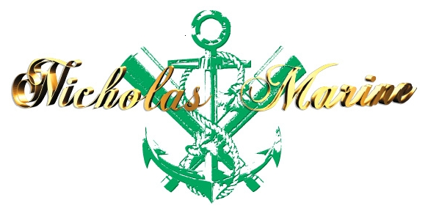 | AZERBAIJAN  Tel: +994555068288  E-mail:
  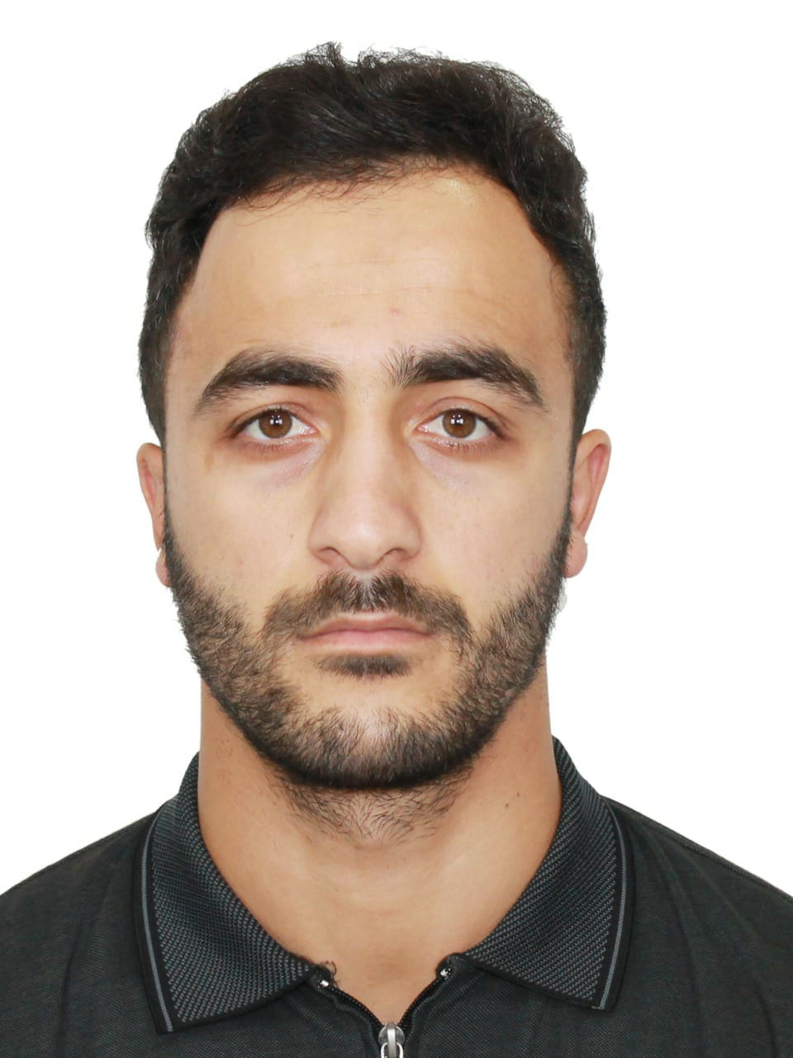
APPLICATION FORM
A. SEAMANS PERSONAL DETAILS
POSITION TO APPLY FOR |  |  |  |  |  |  |  |  |  |  |  |  |  | CERTIFIED FOR
NAME / SURNAME |  |  |  |  | ABDULLA GADASHOV
FATHER'S NAME |  |  |  |  | VALIHAT |  |  |  |  |  |  | MOTHER'S NAME
D.O.B./P.O.B. |  |  |  |  | 07.10.1992 |  |  |  |  |  |  | NATIONALITY |  |  |  |  |  |  |  | AZERBAIJAN
ADDRESS |  |  |  |  | AZERBAIJAN. BAKU..,KHAZAR ray..,SAGAN QES.,M.HUSEYINZADE KUC.,ev.19
 | +994555068288 |  |  |  |  |  | PHONE NO.: |  |  |  | +944 |  |  |  |  |  |  | E-mail |  |  |  | abdulla.qedew@gmail.com
MARITAL STATUS |  |  |  |  | Married |  |  |  |  |  | CHILDREN UNDER 18 YEARS
NEXT OF KIN |  |  |  |  |  |  |  |  |  |  | RELATION
NEXT OF KIN ADDRESS AND PHONE |  |  |  |  |  |  |  | +944509803644
GRADUATED FROM |  |  |  |  | BISTP-EDUCATION CENTER. |  |  |  |  |  |  |  |  |  |  |  |  |  |  |  |  | USA VISA: NO
DEGREE OF DIPLOMA ISSUED |  |  |  |  |  | RATING FORMING PART OF AN ENGINE-ROOM WATCH
WEIGHT |  | 82 |  | HEIGHT |  |  |  |  | 163 |  |  |  | EYES COLOR |  |  | brown |  |  |  |  | HAIR COLOR |  |  |  |  | BLACK
B. DOCUMENTATION
CERTIFICATES |  |  |  |  |  |  |  |  |  |  | NUMBER |  |  |  | 1SSUING DATE |  |  |  | VAL1DATION DATE |  |  |  |  |  | ISSUING PLACE
CERTIFICATE OF COMPETENCY. |  |  |  |  |  |  |  |  |  |  | ID. RP10599 |  |  |  | 04.10.2021 |  |  |  |  |  |  |  |  |  | AZERBAIJAN
SEAMANS BOOK. |  |  |  |  |  |  |  |  |  |  | DQK№017990 |  |  |  | 14.07.2021 |  |  |  | 14.07.2026 |  |  |  |  |  | AZERBAIJAN
INTERNATIONAL PASSPORT. |  |  |  |  |  |  |  |  |  |  | C01700467 |  |  |  | 23.03.2017 |  |  |  | 22.03.2027 |  |  |  |  |  | AZERBAIJAN
INTERNATIONAL SAFETY MANAGEMENT. |  |  |  |  |  |  |  |  |  |  | SP- 1533-21 |  |  |  | 30.08.2021 |  |  |  | 30.08.2026 |  |  |  |  |  | AZERBAIJAN
PRAOFICENEY IN SURVIVAL CARFT. |  |  |  |  |  |  |  |  |  |  | SL-1344-21 |  |  |  | 26.08.2021 |  |  |  | 26.08.2026 |  |  |  |  |  | AZERBAIJAN
(STCW-78,A-VI/1-1/1-2/1-3/1-4.) |  |  |  |  |  |  |  |  |  |  | SO-2208-21 |  |  |  | 27.08.2021 |  |  |  | 19.08.2026 |  |  |  |  |  | AZERBAIJAN
TRAINING FOR SEAFARERS WITH DESIGNATED SECURİTY DUTIES. |  |  |  |  |  |  |  |  |  |  | SH-0724-21 |  |  |  | 24.08.2021 |  |  |  | 23.08.2026 |  |  |  |  |  | AZERBAIJAN
SHIP SECURİTY-REALATED FAMİLİARİZATİON SECURİTY-AWARENESS TRAİNİNG.. |  |  |  |  |  |  |  |  |  |  | SI-1031-21 |  |  |  | 26.08.2021 |  |  |  | 20.08.2026 |  |  |  |  |  | AZERBAIJAN
EXTRACT FORM SEAFARERS MEDICAL CERTİFİCATE |  |  |  |  |  |  |  |  |  |  |  |  |  |  | 28.04.2021 |  |  |  | 28.04.2023 |  |  |  |  |  | AZERBAIJAN
Another States  Seaman's books |  |  | Rank |  |  |  |  |  |  | Document No |  |  |  |  |  |  | Issued |  |  |  |  |  |  | Valid
NO |  |  | NO |  |  |  |  |  |  | NO |  |  |  |  |  |  | NO |  |  |  |  |  |  | NO
Another States Certificates of competency |  |  | Rank |  |  |  |  |  |  | Document No |  |  |  |  |  |  | Issued |  |  |  |  |  |  | Valid
NO |  |  | NO |  |  |  |  |  |  | NO |  |  |  |  |  |  | NO |  |  |  |  |  |  | NO

 | C. PREVIOUS SEA SERVICE
VESSEL |  | FLAG | TYPE / DWT | ENG / HP | RANK | S/ON | S/OFF | OWNERS
TEYMUR EHMEDOV |  | AZERBAIJAN | GENRAL CARGO | 2x2550 Kw | OILER-FITER | 12.04.2018 | 18.10.2018 | CASPIAN shipping
GEZENFER MUSABEYOV |  | AZERBAIJAN | GENRAL CARGO | 2x2550 Kw | OILER-FITER | 04.01.2019 | 10.06.2019 | CASPIAN shipping
TEYMUR EHMEDOV |  | AZERBAIJAN | GENRAL CARGO | 2x2550 Kw | OILER-FITER | 09.09.2019 | 02.04.2020 | CASPIAN shipping
MV CASPIAN RELIANCE |  | AZERBAIJAN | TUG VESEL | 2x2864 KW | OILER-FITER | 01.08.2021 | 25.02.2022 | BUE CASPIAN LIMTED
SVİTOCH |  | Marine wt ltd | General cargo |  |  | 28.02.22 | 10.04.22 | LLC MAKO Marine of
Gerda S |  | Turkiye | GENRAL CARGO | 2x876 | OILER FITER | 15.05.2022 | 20.11.2020 | GERDA S Shipping

PLEASE COMPLETE CONTACT DETAILS OF YOUR PREVIOUS EMPLOYERS FOR REFERENCES

COMPANY | ADDRESS | TEL NUMBERS
BUE CASPIAN LIMTED | AZERBAIJAN BAKU ISR PLAZA | (+994 12) 4972581  (+994 12) 4972582  baku.reception@topaz-marine.com  (+994 12) 4972596
CASPIAN SHIPPING COMPANIY | Republic of Azerbaijan, Baku city, Neftchilar ave.,2 | (012) 404-39-00contact@asco.az

English abilities: Good: ⁯ Average: YES Poor: ⁯

ACCEPTABLE SALARY:

SIGNATURE: DATE:

