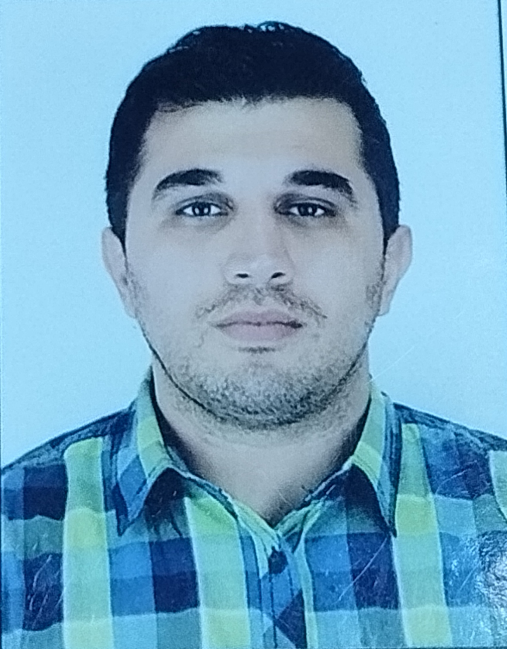

APPLICATION FORM

Position Applied for Engineering-İD0005840 | Date Available from:ASAP

1. Personal Data
Family Name: Abbasov | First Name:Rufat | Middle Name:Alasgar
Date of Birth 03.08.1989 | Place of Birth Azerbaijan | Citizenship :Azerbaijan
Permanent Address Azerbaijan ,Sumgait |  | Phone Mobil:Az(+994)55 430 0185  E-mail:rufat-abbasov89@mail.ru

2. Maritime Education
Name of school | Town | Country | From | To | Type of degree or diploma
AZERBAIJAN STATE MARINE Fishing İndustry School | Baku | Azerbaijan | 01.09.2005 | 15.01.2009 | Ship Second Engineer (3000kw or more)

3. Language | Speak |  | Reading |  | Write
English |  | Poor |  | Poor | Poor
Russian |  | Satisfactory |  | Satisfactory | Poor
Turkish |  | Good |  | Good | Good

4. Identity Documents
Document | Country | Number | Place of Issue | Issue Date | Expiry Date
Seaman's Book | Azerbaijan | DQK 024667 | State of maritime administration | 12.08.2023 | 12.08.2028
Travel Passport | Azerbaijan | C00001441 | Ministry of internal affairs | 23.02.2023 | 22.02.2033
Civil Passport | Azerbaijan | AZE14938300 | Sumgait | 13.08.2014 | 03.08.2024

5. Courses Attended and Certificates Obtained
Document | Number | Dates |  | Place
Document | Number | Issue | Expiry | Place

Second Engineer (3000 propulsion power or more) | 0005840 | 07.06.2019 | 07.06.2024 | Azerbaijan
Endorsement of Certificate | 000416/19 | 07.06.2019 | 07.06.2024 | Azerbaijan
Engine resource management | ER-0076-20 | 12.03.2020 | 12.03.2025 | Azerbaijan
Basic Trainings | SO-0151-21 | 08.02.2021 | 04.02.2026 | Azerbaijan
Dangerous, hazardous and harmful cargoes | SK-0194-20 | 25.06.2020 | 10.06.2025 | Azerbaijan
Medical first aid | SN-1250-23 | 17.08.2023 | 17.08.2028 | Azerbaijan
Training in advanced fire-fighting | SJ-0154-19 | 14.02.2019 | 14.02.2024 | Azerbaijan
Proficiency in Survival Craft and Rescue Boats | SL-0760-22 | 13.04.2022 | 07.04.2027 | Azerbaijan
Leadership and teamwork | DL-1574-22 | 10.10.2022 | 06.10.2027 | Azerbaijan
Proficiency in fast rescue boats | SU-0269-23 | 11.08.2023 | 11.08.2028 | Azerbaijan
ISM Code | SP-0135-21 | 10.02.2021 | 10.02.2026 | Azerbaijan
Training of seafarers with designated security duties in compliance with ISPS Code | SH-0505-19 | 19.03.2019 | 19.03.2024 | Azerbaijan

6. Physical Data
Height | 181 sm
Weight | 86 kq
Colour of Hair | Black
Colour of Eyes | Brown
Boilersuit Size | 50
Shoes Size | 43

7. Medical History | Yes | No
Have you ever signed off a ship due to medical reasons? |  | +
Did you undergo any medical operation in the past? |  | +
Have you consulted a doctor during the last 12 months for an illness/accident? |  | +
Do you have any health or disability problems now? |  | +

If yes, please give full details:

 | Passed: | Valid till:
International Medical Examination | - | -
Vaccination Against Yellow Fiver
Vaccination Against Diphtheria

8. References (please give name and address of your current or past employer) | Office remarks

Name of Company | ASCO
Name of person to contact | Hr
Address | Azərbaijan Baku Mikayil Huseynov 2
Phone | +99412 404 3700

Name of Company
Name of person to contact
Address
Phone

9. Bank address for allotments
Beneficiary
Account No.
Name of Bank
Bank Address

10. Seagoing Experience

Name of vessel | Flag | Vessel’s Type | DWT | Eng Type | HP | Manager or Owner | Rank | From d/m/y | To  d/m/y | Total  m/d
AHTS Andoqa | Azerbaijan | AHTS | 1178 | Wartsila | 3915 | Azerbaijan | 3rd Engineer | 01.03.2010 | 01.08.2012 | 1y 4m 0d
Ali Mustafayev | Azerbaijan | Tanker | 4055 | Volgograd Q74 | 1498 | Azerbaijan | 3rd Engineer | 01.09.2012 | 01.10.2014 | 1y
Adalyat Gyulmamnadov | Azerbaijan | AHTS | 377 | Zulser | 2500 | Azerbaijan | 2nd Engineer | 01.11.2014 | 01.10.2015 | 6m
Nakhchivan | Azerbaijan | Ferry | 5991 | Man | 2720 | Azerbaijan | 2nd Engineer | 01.12.2015 | 01.05.2017 | 8m
Akademik Hesen Aliyev | Azerbaijan | Ferry | 5991 | Man | 2720 | Azerbaijan | 2nd Engineer | 01.07.2017 | 01.06.2018 | 5m
Zira | Azerbaijan | AHTS | 1484 | Nilgata | 3000 | Azerbaijan | 2nd Engineer | 01.07.2018 | 01.03.2019 | 4m
Shirvan | Azerbaijan | Crain | 1346 | Zulser | 2160 | Azerbaijan | 2nd Engineer | 01.05.2019 | 01.07.2021 | 13m
Zulfi Hajiyev | Azerbaijan | Crain | 1346 | Zulser | 2160 | Azerbaijan | 2nd Engineer | 01.08.2021 | 01.02.2023 | 9m
Atamoglan Karimov | Azerbaijan | Crain | 456 | Zulser | 760 | Azerbaijan | 2nd Engineer | 01.03.2023 | Present day | 3m

Total rank sea service: Total type of vessel sea service:
Rank | Years |  | Type of vessel | Years
3rd Engineer | 2y 4m |  | AHTS | 2y 2m
2nd Engineer | 4y |  | Tanker | 1y
 |  |  | Ferry | 1y1m
 |  |  | Crain | 2y1m
Total | 6y 4m |  | Total: | 6y 4m

