Cv Form
PERSONAL DETAILS
Family name |  | ABISHZADE |  |  | 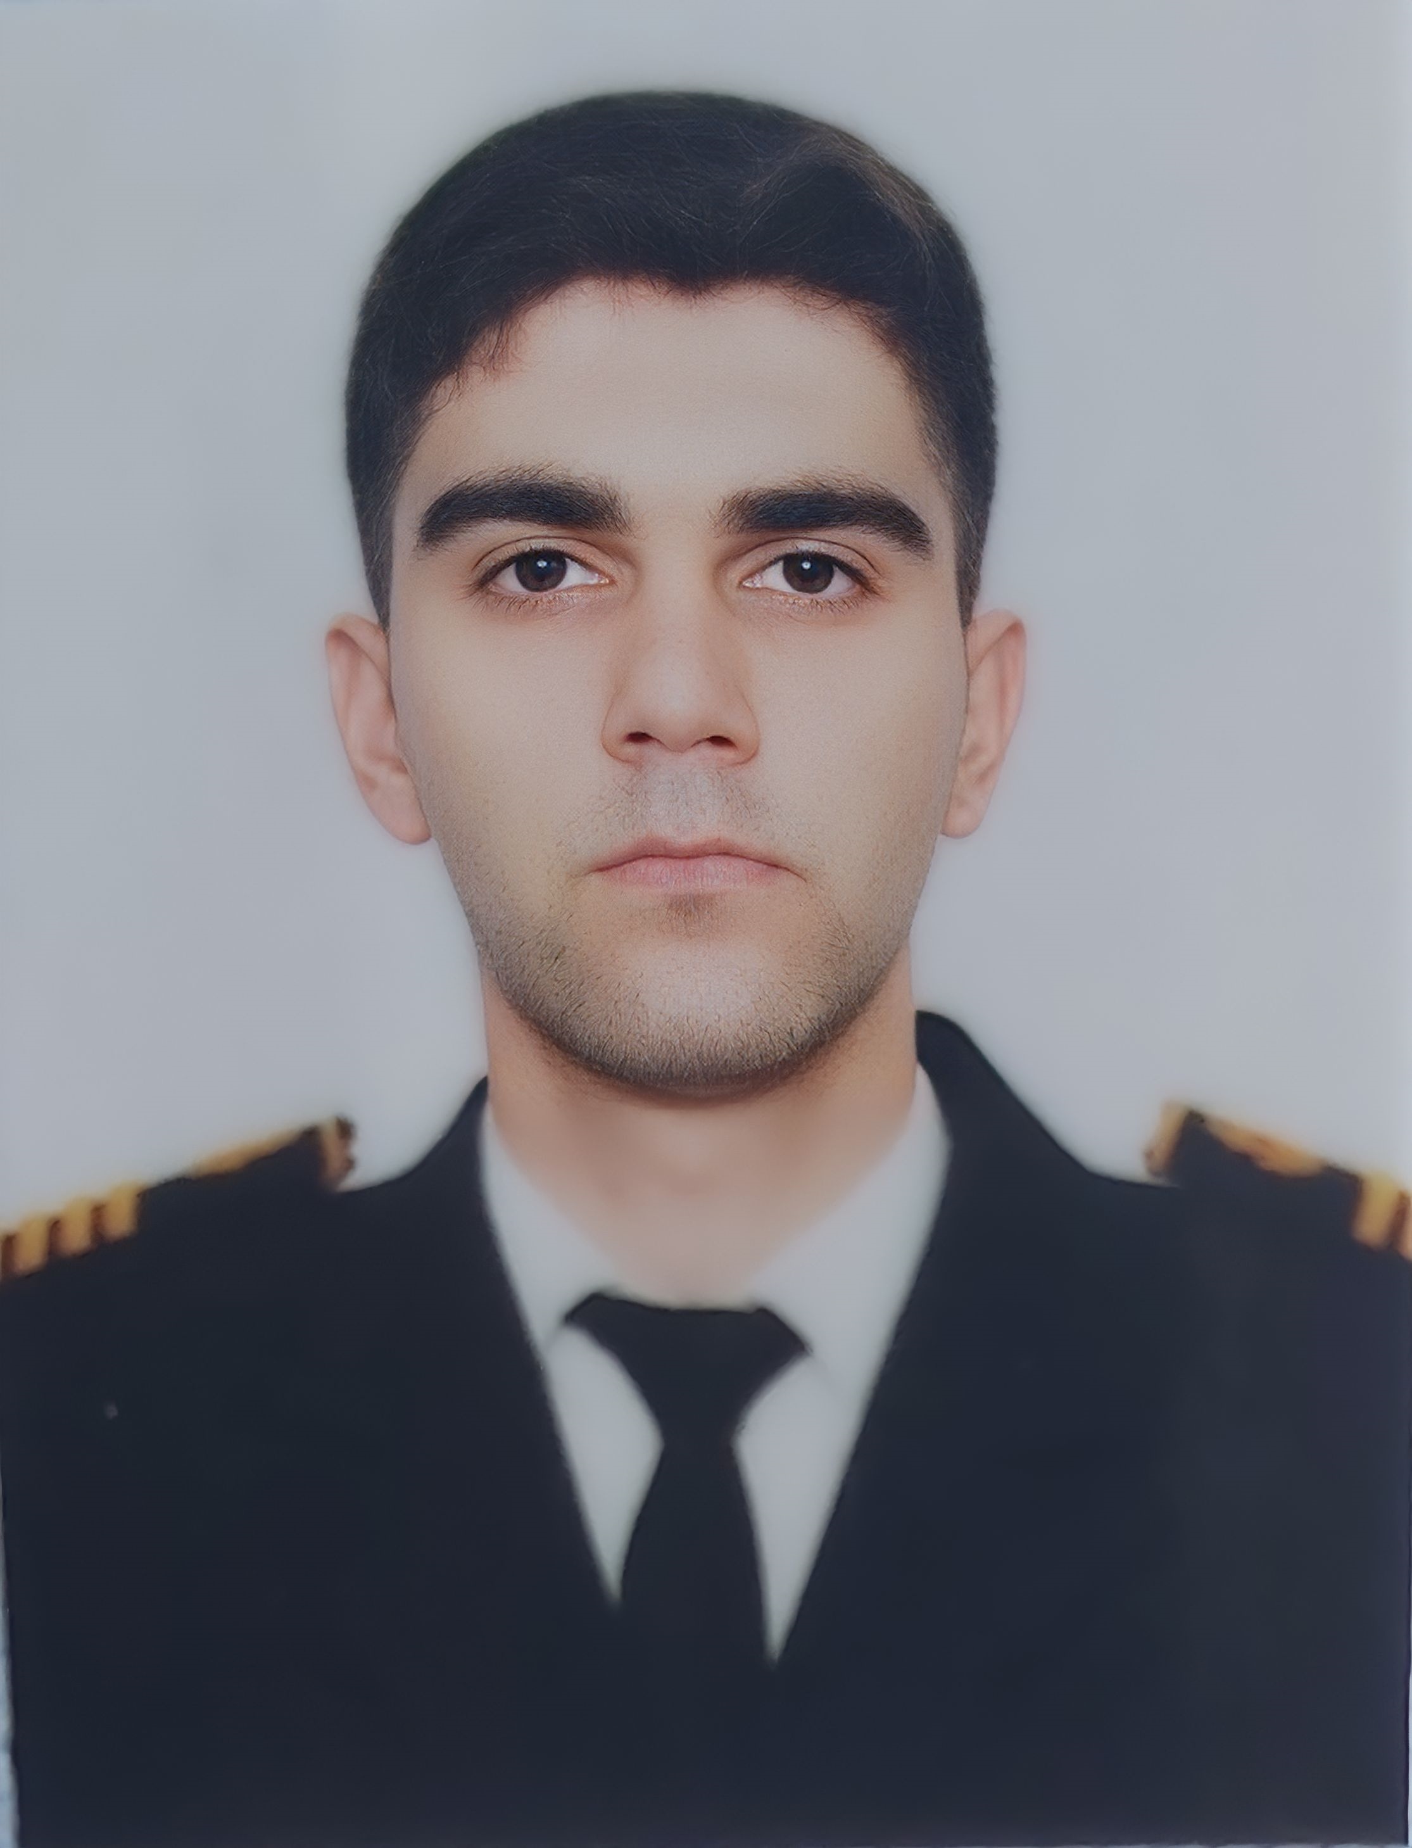
First name |  | MURSAL
Father’s name |  | ROVSHAN
Date and place of birth |  | 11.02.2002
Marital status |  | UNMARRIED
Permanent address |  | AZERBAIJAN, SALYAN
Nearest airport |  | Heydar Aliyev International Airport Baku, Azerbaijan
Height (cm) | Weight (kg) | Eyes color | Hair color | Size of safety shoes | Size of coveralls
181cm | 67kg | BROWN | BLACK | 42 | M
CONTACT DETAILS
Mobile | E-mail address
+994 55 999 76 36  Whatsapp | abiszadm@gmail.com
NEXT OF KIN (FOR EMERGENCY)
Next of kin | ABISHOV ROVSHAN | Relationship | FATHER
Phone | +994 55 999 76 56 | Address | Azerbaijan, Salyan
TRAVEL PASSPORT DETAILS
Document | Number | Place of Issue | Issued | Valid
PASSPORT | C03690386 | Azerbaijan | 29.09.2022 | 28.09.2032
SEAMAN’S BOOK DETAILS
Document | Number | Place of Issue | Issued | Valid
Seaman book | DQK016025 | Azerbaijan ,Baku | 29.02.2020 | 28.02.2025
SEAARERS IDENTITY | AZE020909 | Azerbaijan ,Baku | 29.02.2020 | 28.02.2025
EDUCATION
Full name of School | Place of Issue | Grade/Class | From | To
AZERBAIJAN STATE MARINE ACADEMY | Azerbaijan, Baku | Marine Navigation Engineering | 15.09.2019 | 14.06.2023
KNOWLEDGE OF LANGUAGE
Languages | Speaking | Reading | Writing
Azerbaijan | Excellent | Excellent | Excellent
Turkish | Excellent | Excellent | Excellent
English | Intermediate | Intermadiate | Intermadiate
COMPUTER SKILLS
Windows | Microsoft Office | Internet
Excellent | Excellent | Excellent
MEDICAL INFORMATION
Document | Grade | Place of issue | Date of issue | Date of expiry
Med.Sertificate | Able seafarer deck | Azerbaijan Baku | 28.07.2023 | 28.07.2024
CERTIFICATE OF COMPETENCY
Class/Grade | Issuing country | Certificate | Date issued | Expires | Details of Limitations
Able seafarer deck | Azerbaijan Marine Administration | No: 2175/23  ID  No:RP12345 | 29.09.2023 | Unlimited | A-II/5
GMDSS General operator's certificate | Azerbaijan Marine Administration | No:  DQ-0192-23 | 24.02.2023 | 14.06.2027 | -
STCW AND OTHER CERTIFICATES
Name of course/Certificate | Institute | Place | Date of issue | RANK | Date of expiry | Cert.No
International Safety Management | Azerbaijan Marine Administration | Azerbaijan Baku | 25.06.2021 | Seaman | 15.04.2026 | SP-0891-21
Basic safety training | Azerbaijan Marine Administration | Azerbaijan Baku | 17.06.2021 | Seaman | 31.05.2026 | SO-1222-21
Ship Security-related familiarization security-awareness | Azerbaijan Marine Administration | Azerbaijan Baku | 18.06.2021 | Seaman | 04.06.2026 | SI-0514-21
Training for seafarers with designated security duties | Azerbaijan Marine Administration | Azerbaijan Baku | 02.08.2023 | Seaman | 02.08.2028 | SH-2084-23
Proficiency in survival craft and boats other than fast rescue boats | Azerbaijan Marine Administration | Azerbaijan Baku | 09.08.2023 | Seaman | 09.08.2028 | SL-2927-23
Radar navigation, radar plotting and use of ARPA | Azerbaijan Marine Administration | Azerbaijan Baku | 17.02.2023 | Seaman | 12.01.2028 | SR-0082-23
Operational Use of Electronic Chart Display and Information Systems (ECDIS) | Azerbaijan Marine Administration | Azerbaijan Baku | 01.03.2023 | Seaman | 16.01.2028 | SZ-0165-23

SEA EXPERIENCE (LAST 5 YEARS – MOST RECENT EXPERIENCE ON TP LINE)
Vessel | Company | Type of vessel | Flag | DWT | GRT | Rank | Sign on | Sign off
Gyultakin Askerova | ASCO | Offshore Tug/Supply | Azerbaijan | 1348 | 2737 | Seaman | 29.06.2021 | 14.09.2021
Neftegaz-62 | ASCO | Offshore Tug/Supply | Azerbaijan | 1393 | 2723 | Seaman | 16.06.2022 | 07.09.2022
Sabit Orujov | ASCO | Passenger | Azerbaijan | 549 | 2621 | Seaman | 02.02.2023 | 28.02.2023
General Asadov | ASCO | Passenger | Azerbaijan | 549 | 2621 | Seaman | 01.03.2023 | 24.05.2023

