

APPLICANT’S PERSONAL DATA  READY TO WORK (DATE): Now POSITION APPLIED FOR: СH. OFFICER |  | 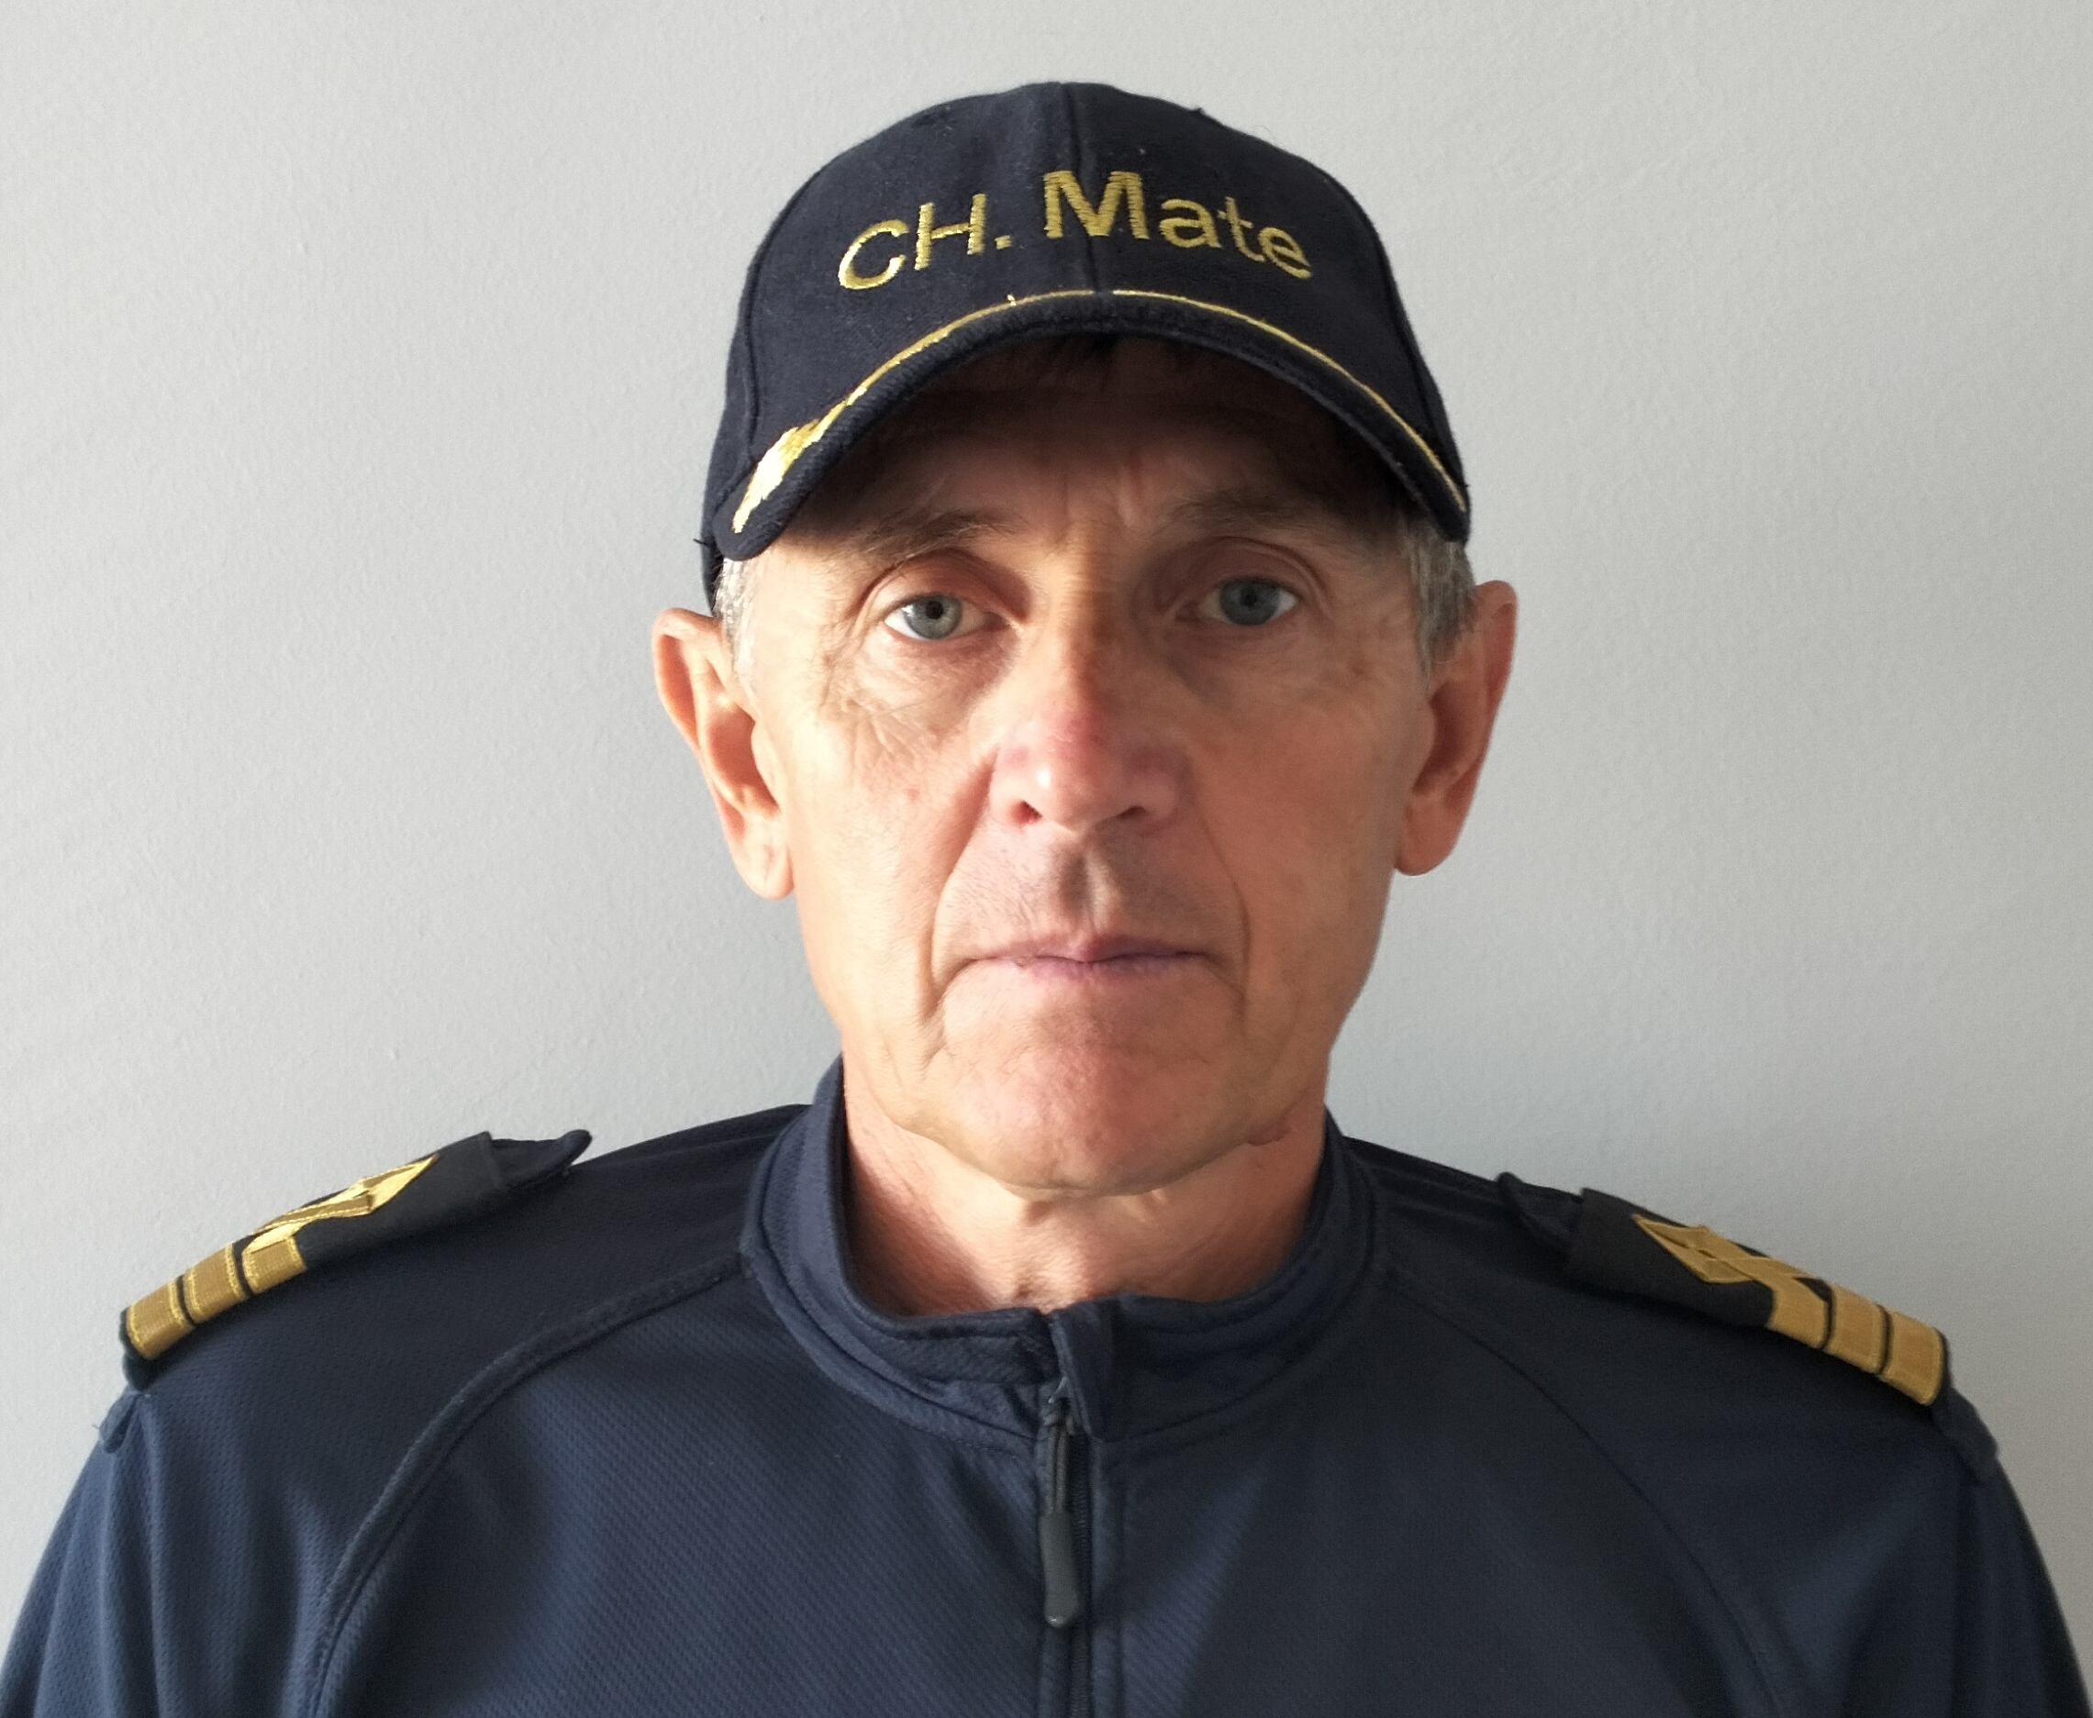
FIRST / LAST NAME: IGOR TOMCHUK | CITIZENSHIP: RUSSIA
FATHER’S NAME: ANATOLIY | ADDRESS(INCL. POST CODE): BAKU TEMPORARY
DATE OF BIRTH: 12.06.1965
PLACE OF BIRTH: USSR | PHONE: +380636837959  E-MAIL: itom6512@gmail.com

CLOTHES | SIZES:
OVERALL | XL
SAFETY SHOES | 44

ADD INFORMATION
HEIGHT | 183
WEIGHT | 78

NAME OF SCHOOL | FROM | TILL | TYPE OF DEGREE RECEIVED
TALLINN MARINE SCHOOL | 1983 | 1986 | NAVIGATOR

PERSONAL PROFILE

I’m Open & Communicative, Flexible, Diligent and Responsible. I’m able to work independent or as a part of team. Big experience working on dry cargo ships, ship cranes, bulkheads, Mac Gregor type of hatch cover. Long time working with international crew.

SUMMARY OF SKILLS
LANGUAGES: Russian (Native), English (Average)
COMPUTER SKILLS: Windows (XP), Microsoft Office Package (MS Word & Excel).

NATIONAL DOCUMENTS
PASSPORT / SBK | NO. | ISSUED | VALID
SEAMAN’S PASSPORT | RUS - 0466314 | 28.05.2019 | 27.05.2024
TRAVELLING PASSPORT | 53 0723520 | 17.09.2014 | 17.09.2024

CERTIFICATE | STCW CODE | NO | ISSUED | VAILD TILL
BASIC SAFETY TRAINING AND INSTRUCTION | A-VI/1 | 620-161/19-18C | 11.06.2019 | 11.06.2024
ADVANCED FIRE FIGHTING | A-VI/3 | 625-165/19-22C | 14.06.2019 | 14.06.2024
LEADERSHIP AND TEAMWORK | A-II/1, A-II/2,  A-III/1,A-III/2, A-III/3, A-III/6 | 3109 | 01.06.2022 | 01.06.2027
OPERATION USE OF ELECTRONIC CHART DISPLAY AND NFORMAT ON SYSTEMS | A-I/12 | 0990772 | 22.05.2019 | 22.05.2024
GMDSS GENERAL OPERATOR | A-IV/2 | LED203553805 | 20.06.2019 | 29.05.2024
MEDICAL CARE ON BOARD SHIP | A-VI/4 | 8 | 17.11.2020 | 17.11.2025
RADAR OBSERVATION AND  PLOTTING | A-I/12 | 0989949 | 24.05.2019 | 24.05.2024
OPERATIONAL USE OF AUTOMATIC  RADAR PLOTTING AIDS | A-I/12 | 0990355 | 31.05.2019 | 31.05.2024

MEDICAL FIRST AID | A-VI/4 | 628-154/19-15C | 05.06.2019 | 05.06.2024
PROFICIENCY IN SURV IVAL CRAFT AND BOATS OTHER THAN FAST | A-VI/2 | 622-164/19-14C | 13.06.2019 | 13.06.2024
TRAINING OF SHIP SECURITY  OFFICER | A-VI/5 | 0911098 | 07.06.2019 | 07.06.2024

SEA SERVICE LAST 5
VESSEL’S NAME | SHIP OWNER | FLAG | VSL’S TYPE | DTW | RANK | EMPLOY  M/Y | MENT  M/Y
BREMER ANNA | RORD BRAREN | GIBRALTAR | DRY CARGO | 4350 | CH. OFF | 09.11.2014 | 15.02.2015
BREMER ANNA | RORD BRAREN | GERMANY | DRY CARGO | 4350 | CH. OFF | 22.06.2015 | 07.10.2015
BREMER ANNA | RORD BRAREN | GERMANY | DRY CARGO | 4350 | CH. OFF | 13.01.2016 | 18.05.2016
BREMER ANNA | RORD BRAREN | GERMANY | DRY CARGO | 4350 | CH. OFF | 06.09.2016 | 02.01.2017
MEIKE B | SKOTRA LTD | ANTIGUA &  BARBUDA | DRY CARGO | 4140 | CH. OFF | 12.03.2020 | 12.09.2020
RIGHT STEP | SKOTRA LTD | ANTIGUA &  BARBUDA | DRY CARGO | 5535 | CH. OFF | 21.11.2020 | 27.04.2021
RIGHT STEP | SKOTRA LTD | ANTIGUA &  BARBUDA | DRY CARGO | 5535 | CH. OFF | 23.10.2021 | 15.05.2022
RIMONA | PLATIN SHIPPING AND MARINE TRADINDG | MALTA | BULK CARRIER | 8160 | CH. OFF | 26.07.2022 | 26.07.2023

