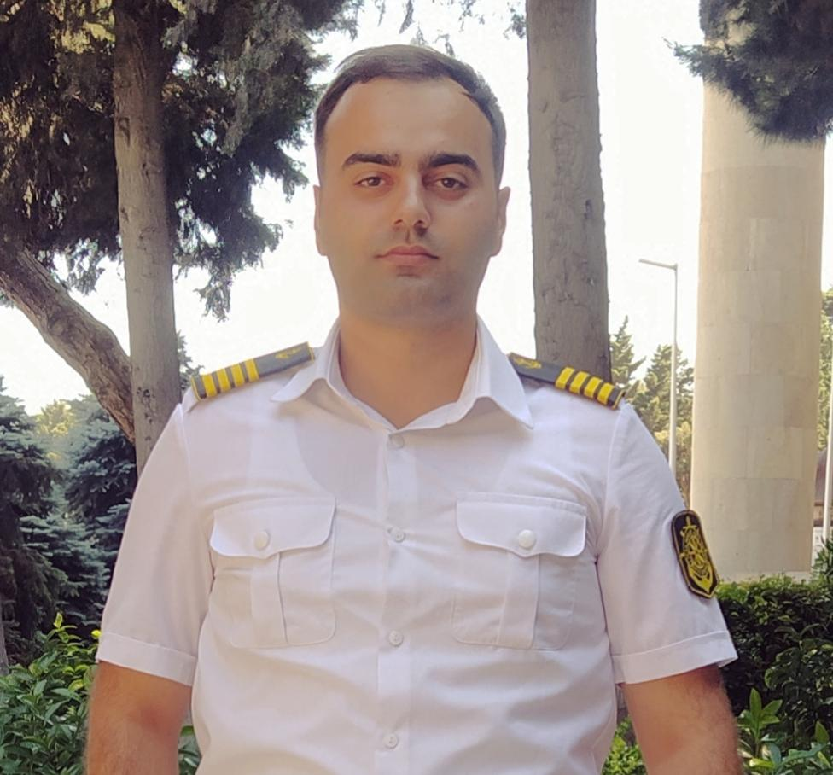  About me  I was born on 20.01. 2002. I started secondary school in 2008 and graduated from that school in 2019 with high results. In the same year, I was admitted to the Marine Navigation Engineering major of the Azerbaijan State Maritime Academy. I graduated from the academy in 2023. During my studies at the academy, I had experience on three ships. I have been selected from others by my perceptiveness and diligence as long as I have been in practice. Ability to cope with assigned tasks. I always finish what I start, I never leave it unfinished. I easily communicate with people, I can quickly adapt to the ship and the crew. I can work without supervision and effectively.  contact details  Telephone and Whatsapp  +994 50 772 12 74  Emergency telephone  +994 77 565 27 35  E-Mail:  Qeferliii.23@gmail.com  main language  Azerbaijani  foreign language  English – A2  Turkish – B2 |  | GAfarli jalal  education  Full secondary school named after A.Efendi  15.09.2008 — 14.06.2019  Azerbaijan State Marine Academy  15.09.2019 — 25.06.2023  overall average score - 87/100  graduation exam point – 71/100  experience  Azerbaijan Caspian Shipping CJSC Cadet  29.06.2021 — 15.09.2021  I have been on the ship General Aliaga Shiklinski ship, a Crane vessel of the offshore support fleet.  Azerbaijan Caspian Shipping CJSC Cadet  16.06.2022 — 07.09.2022  I have been on the Karabakh ferry of the merchant fleet.  Azerbaijan Caspian Shipping CJSC Cadet  02.02.2023 — 25.05.2023  I have also been the Azerbaijan Ro-Pax ship of merchant fleet. At the end of the experience I received a letter of commendation from the captain for my exceptional services.  certificate and documents
  Name of certificate | İssued on | Valid until
  Seamen`s record book | 13.05.2020 | 13.05.2025
  Able seaman 2.5 | 10.10.2023
  Seafarer`s medical certificate | 12.10.2022 | 12.10.2024
  Ship Security- related familiarization security awareness training | 18.06.2021 | 04.06.2026
  Familiarization basic training and instruction for all seafarers | 17.06.2021 | 31.05.2026
  International Safety Management Code | 25.06.2021 | 02.06.2026
  Proficiency in survival craft and boats ötür than fast rescue boats | 31.07.2023 | 31.07.2028
  Training for seafarers with designated security duties | 27.07.2023 | 27.07.2028
  Basic training and qualifications on oil and chemical tanker cargo operations | 25.07.2023 | 25.07.2028

