APPLICATION FORM

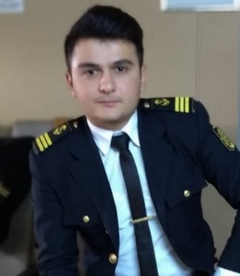
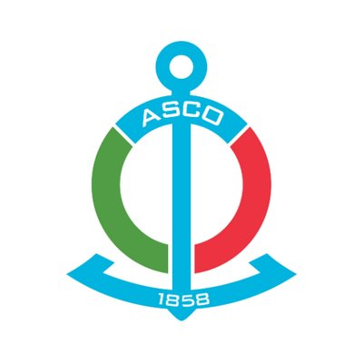

 |  |  |  |  | 6 | E | M | B | X | W | K
Personal ID Number

Position Applied for: OCEANGOING SECOND ENGİNEER | Date Available from:ANY TIME

1. PersonalData
FamilyName:  MİRMAMMADOV | FirstName:  MURAD | MiddleName:  MURAD
DateofBirth: 24.02.1998 | Place of Birth: SALYAN,  AZERBAIJAN | Citizenship: AZERBAIJANI
Permanent Address: ARBATAN village.,  SALYAN,AZERBAIJAN |  |  | Phone (Home): +994556030100  Phone (Business/ Mobile  E-mail: muradmirmemmedov1@gmail.com

2. MaritimeEducation
Name of hıgh school | Town | Country | From | To | Type of degree or diploma
AZERBAIJAN STATE MARINE ACADEMY | BAKU | AZERBAIJAN | 2016 | 2020 | Bachelors

3. Language skills | spoken | written
English | fluent | fluent
Turkısh | fluent | fluent
Russian | fluent | fluent

4. FamilyDetails
Civil Status(Single, Married, Separated, Divorced, Widowed) : SINGLE
Next of Kin (the first emergency contact) MirmammadovZaur | Relationship /Uncle
Address of Residence: ARBATAN village., SALYAN, AZERBAIJAN | Phone +994557241617

5. IdentityDocuments
Document | Country | Number | PlaceofIssue | IssueDate | ExpiryDate
Seaman's  Book | AZERBAIJAN | AZE024915 | State Maritime  Administration | 29.04.22 | 29.04.27
Travel  Passport | AZERBAIJAN | C03027063 | AZERBAIJAN BAKU | 05.06.2020 | 04.06.2030

7. Courses Attended and Certificates Obtained

Document | Number | Dates |  | Place
Document | Number | Issue | Expiry | Place
CertificateofCompetency | 0007428 | 24.08.2023 | 24.08.2028 | State Maritime  Adminstration
Basic training for oil and chemical tanker cargo operatıon | 0020 | 03.11.2022 | 03.11.2027 | Ukraıne,  Odessa
Advanced training for chemical tanker cargo operations | 0005 | 22.02.2023 | 22.02.2028 | Ukraıne,  Odessa
Advanced training for oıl tanker cargo  operations | 0008 | 04.11.2022 | 04.11.2027 | Ukraıne,  Odessa
Safety familiarisation-Personal survival techniques- fire prevention and fire fighting  elementary first aid- personal safety and  social responsibilities | SO-1395-22 | 07.04.2022 | 07.04.2027 | State Maritime  Adminstration
Proficiency in Survival Craft and Rescue Boats Other than fast | SL-0683-22 | 04.04.2022 | 04.04.2027 | State Maritime  Adminstration
Training in Advance Fire-fighting | SJ-0392-22 | 06.10.2022 | 06.10.2027 | State Maritime  Adminstration
Medical First Aid Training | SN-0298-22 | 19.11.2022 | 19.11.2027 | State Maritime  Adminstration
International Safety Management Code | SP-0803-22 | 30.03.2022 | 28.03.2027 | State Maritime  Adminstration
Leadership and Teamwork | DL-0521-22 | 17.11.2022 | 12.11.2027 | State Maritime  Adminstration
Engine Resource Management | ER-0235-22 | 13.10.2022 | 13.10.2027 | State Maritime  Adminstration
Ship Security-related familiarization security-awareness training | SI-0628-22 | 05.08.2022 | 27.07.2027 | State Maritime  Adminstration
Training of seafarers with designated  security duties | SH-0667-21 | 28.08.2021 | 28.08.2026 | State Maritime  Adminstration

8. PhysicalData
Height | 174
Weight | 75
ColourofHair | Black
ColourofEyes | brown
BoilersuitSize | XL
ShoesSize | 42

9. MedicalHistory | Yes | No
Have you ever signed off a ship due to medical reasons? |  | +
Did you undergo any medical operation in the past? |  | +
Have you consulted a doctor during the last 12 months for an illness/accident? |  | +
Do you have any health or disability problems now? |  | +

 | Passed: | Validtill:
International Medical Examination | 08.08.2023 | 08.08.2025
Vaccination Against Yellow Fiver
Vaccination Against Diphtheria

10. SeagoingExperience

Nameofvessel | Vessel’s  Type | DWT | EngType | BHP | Manageror  Owner | Rank | From  d/m/y | To  d/m/y
GARADAGH | Dry cargo | 3390 | SKL | 1280 kW | ASCO | oıler | 23.06.2017 | 30.10.2017
BALAKEN | Ro-Ro,  Cargo | 5398 | MAN B&W | 4000 kW | ASCO | oıler | 12.01.2018 | 15.04.2018
Shah Ismayıl Khataı | Oıl Tanker | 13442 | MAN B&W | 2x 1620 kw | ASCO | oıler | 13.06.2019 | 31.08.2019
M/V Khosrov Bey | Bulk Carrıer | 7855 | Yanmar | 2750 kw | Aykop Shipping | 3-rd engineer | 15.09.2021 | 22.04.2022
M/V Aleksandr  Antonov | Bulk Carrier | 5322 | Dizel Q7 | 1980 kw | Spring Marine | 3-rd engineer | 17.06.2022 | 25.10.2022
M/T Orıs Helga | Chemıcal Tanker | 7890 | MAK M25 | 2970 kw | Sealife Shipping | 3-rd engıneer | 03.12.2022 | 30.07.2023

