CURRICULUM VITAE
PERSONAL DETAILS
Family name |  | HESENZADE |  |  | 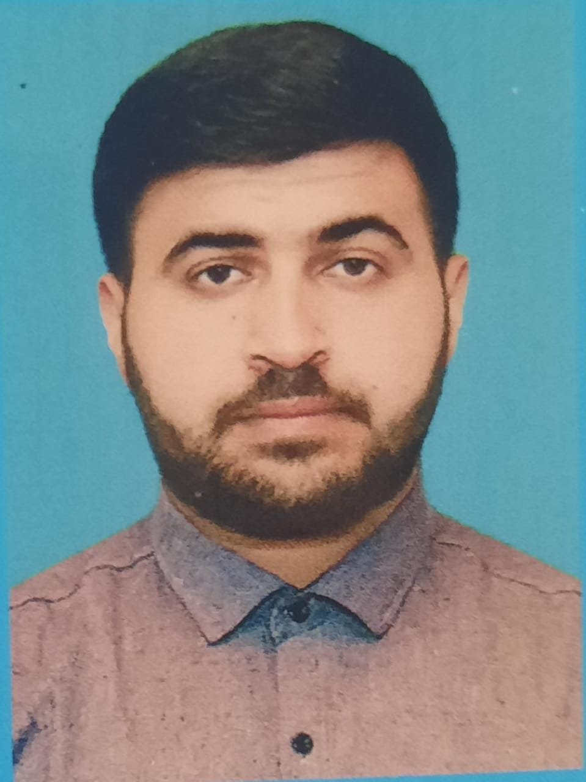
First name |  | AYDIN
Father’s name |  | ALIZAMAN
Date and place of birth |  | 25.10.1993
Nationality |  | Azerbaijan
IMarital status |  | MARRIED
Permanent address |  | Azerbaijan, Masalli Qizilagac
Nearest airport |  | Heydar Aliyev International Airport Baku, Azerbaijan
Height (cm) | Weight (kg) | Eyes color | Hair color | Size of safety shoes | Size of coveralls
1.65 CM | 85 kg | BROWN | BLACK | 41 | XL

Mobile | E-mail address
+994503885586  Whatsapp | Aydinhesenzade773@gmail.com

Next of kin | Hesenov Elizaman | Relationship | father
Phone | +994504261585 | Address | Azerbaijan Masalli Qizilagac

Document | Number | Place of Issue | Issued | Valid
PASSPORT | C03758804 | Azerbaijan | 30.01.2023 | 30.01.2033
SEAMAN’S BOOK DETAILS
Document | Number | Place of Issue | Issued | Valid
Seaman book | DGK022513 | Azerbaijan ,Baku | 20.01.2023 | 20.01.2028
SEAARERS IDENTITY | AZE027384 | Azerbaijan ,Baku | 20.012023 | 20.01.2028
EDUCATION
Full name of School | Place of Issue | Grade/Class | From | To
A.D.D.K | Azerbaijan | Electrician engineer | 2011 | 2017
KNOWLEDGE OF LANGUAGE
Languages | Speaking | Reading | Writing
Azerbaijan | Excellent | excellent | Excellent
Russian | Normal | normal | normal
Turkish | Excellent | excellent | Excellent
COMPUTER SKILLS
Windows | Microsoft Office | Internet
Excellent | Excellent | Excellent
MEDICAL INFORMATION
Document | Grade | Place of issue | Date of issue | Date of expiry
Med.Sertificate | Engine-room watch | Azerbaijan | 01.07.2022 | 01.07.2024
CERTIFICATE OF COMPETENCY
Class/Grade | Issuing country | Certificate  No.000983/23 | Date issued | Expires | Details of Limitations
ELECTRON RNGINEER OFFICIER | Azerbaijan Marine Administration | RP-0007954 | 19.09.2023 | 19.09.2028 | A-3/6

STCW AND OTHER CERTIFICATES
Name of course/Certificate | Institute | Place | Date of issue |  | Cert.No | Date of expiry
International Safety Managemen | Azerbaijan Marine Adminstration | Azerbaijan Baku | 04.07.2023 |  | SP-2058-23 | 04.07.2028
Proficiency in survival craft and boats other than fast rescue boats | Azerbaijan Marine Adminstration | Azerbaijan Baku | 01.11.2018 |  | SL-2716-18 | 01.11.2023
Medical First Aid | Azerbaijan Marine Adminstration | Azerbaijan Baku | 28.07.2023 |  | SN-1168-23 | 28.07.2028
Training for seafarers with designated security duties | Azerbaijan Marine Adminstration | Azerbaijan Baku | 30.04.2018 |  | SH-0510-18 | 27.04.2023
Basic safety trainig | Azerbaijan Marine Adminstration | Azerbaijan Baku | 25.10.2018 |  | S0-2673-18 | 23.10.2023
Basic training and qualifications on oil and chemical tanker cargo operations | Azerbaijan Marine Adminstration | Azerbaijan Baku
Ship Security-related familization security-awareness | Azerbaijan Marine Adminstration | Azerbaijan Baku | 10.01.2023 |  | SI-0041-23 | 10.01.2028

Vessel | Company | Type of vessel | Flag | DWT | GRT | BHP | Rank | Sign on | Sign off
MV RIVER RAIN | CUNDA SHIPPING | General cargo | Panama | 3977T | 2963 | 2160 BHP | Electrician engineer | 04.06.2015 | 02.02.2016
MT SPEAR | Pegasus Ventuves | Tanker Vessel | Belize City | 5249T | 4182 | 2300  BHP | El. engineer | 25 12.2016 | 10.05.2017
MAHMUD REHIMOV | ASCO | General cargo | Azerbaijan | 4485T | 4110 | 2x1320  BHP | El. engineer | 12.11.2017 | 25.07.2018
MAESTRO NIYAZI | ASCO | General cargo | Azerbaijan | 5885T | 4953 | 2x1496  BHP | El. engineer | 22.10.2018 | 15.06.2020
SHAIR SABIR | ASCO | General cargo | Azerbaijan | 5491T | 4182 | 2x1428  BHP | El.engineer | 25.08.2021 | 27.05.2022
GENERAL ASLANOV | ASCO | General cargo | Azerbaijan | 5491T | 4182 | 2x1387  BHP | El.engineer | 16.08.2022 | 14.01.2023
M/V LIDER PERIHAN | LIDER SHIPPING | Cargo, Container | PANAMA | 10634 | 7306 | 3600 BHP | El. engineer | 04.1.2023 | 17.05.2023
M/T GANJA | ASCO | TANKER | Azerbaijan | 7500 | 5075 | 2026 | El.engineer | 05.08.2023 | 04.19.2023

