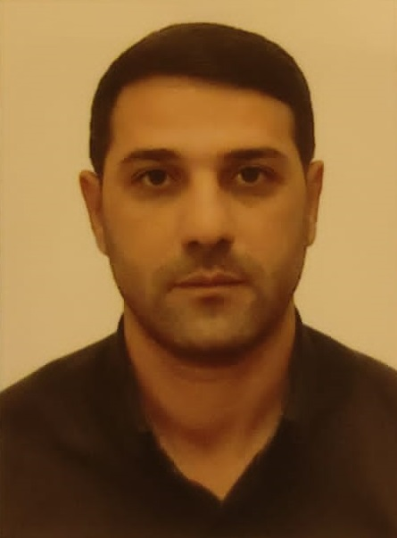
APPLICATION FORM

Personal ID Number

Position Applied for: ELECTRO ENGINEER | Date Available from: ANY TIME

1. PersonalData
Family Name: Valıyev | First Name: Allahverdı | Middle Name: Sarıbala
Date of Birth: 28.10.1988 | Place of Birth: Azerbaijan, Jalilabad | Citizenship: Azerbaijan
Permanent Address: Azerbaijan, Jalilabad |  | Mobile: +994557494921/+994515818311  E-mail: valiyevallahverdi2@gmail.com

2. MaritimeEducation
Nameofschool | Town | Country | From | To | Type of degree or diploma
Azerbaija State Marine Academy | Baku | Azerbaijan | 2006 | 2010 | Bachelors

3. ProfessionalTest
EnglishTestDate | NameofTest | Score
ProfessionalTestDate | NameofTest | Score
ProfessionalInterviewDate | Result

4. FamilyDetails
Civil Status(Single, Married, Separated, Divorced, Widowed) : Marrıed

Next of Kin (the first emergency contact) : Sahıb Baghırlı | Relationship: Cousın
Address of Residence: KHIRDALAN, AZERBAIJAN | Phone :+994504642895

 | Doughter | Son
FamilyName | Valizade | Valızade
FirstName | Nilay | Raul
DateofBirth | 09.01.2020 | 02.05.2017
Cityofliving
PhoneNumbers

5. IdentityDocuments
Document | Country | Number | Place of Issue | IssueDate |  | ExpiryDate
Seaman's Book | AZERBAIJAN | DQK 022401 | Azerbaijan State Maritime  and Port Agency |  | 10.01.2023 | 10.01.2028
Travel Passport | AZERBAIJAN | C01122257 | Azerbaijan, Jalilabad |  | 27.09.2015 | 26.09.2025

6. ValidVisa
CountryorUnion | Type | ValidUntil

7. Courses Attended and Certificates Obtained
Document | Number | Dates |  | Place
Document | Number | Issue | Expiry | Place

Certificate of Competency | 002018/22 | 28.12.2022 | 09.12.2027 | Azerbaijan State Maritime  and Port Agency
Advenced Training for Oil Tanker Cargo Operations | SB-0002-23 | 10.01.2023 | 10.01.2028 | Azerbaijan State Maritime  and Port Agency
Advenced Training for Chemical Tanker Cargo Operations | AS-0002-23 | 12.01.2023 | 12.01.2028 | Azerbaijan State Maritime  and Port Agency
Basic Traning and qualifications on oil and Chemical tanker cargo operations | SA-1021-22 | 27.12.2022 | 27.12.2027 | Azerbaijan State Maritime  and Port Agency
Proficiency in Survival Craft and Rescue Boats | SL-3888-22 | 28.11.2022 | 28.11.2027 | Azerbaijan State Maritime  and Port Agency
Advanced Fire Fighting | SJ-1707-22 | 05.12.2022 | 05.12.2027 | Azerbaijan State Maritime  and Port Agency
Medical First Aid Training | SN-1639-22 | 08.12.2022 | 08.12.2027 | Azerbaijan State Maritime  and Port Agency
Leadership and Teamwork | DL-1782-22 | 07.12.2022 | 07.12.2027 | Azerbaijan State Maritime  and Port Agency
Updating | XS-1397-22 | 09.12.2022 | 09.12.2027 | Azerbaijan State Maritime  and Port Agency
Safe operation and maintenance of high voltage systems 1000 volts or more | DM-0327-22 | 09.12.2022 | 09.12.2027 | Azerbaijan State Maritime  and Port Agency
Training for seafarers with designated security duties | SH-2365-22 | 02.12.2022 | 02.12.2027 | Azerbaijan State Maritime  and Port Agency
Ship Security-related familirization security-awareness training | SI-2920-22 | 25.11.2022 | 25.11.2027 | Azerbaijan State Maritime  and Port Agency
Personal survival techniques, fire prevention and fire-fighting, elementary first aid, personal safety and social responsibilities | SO-5659-22 | 29.11.2022 | 29.11.2027 | Azerbaijan State Maritime  and Port Agency
ISM Code | SP-3534-22 | 30.11.2022 | 30.11.2027 | Azerbaijan State Maritime  and Port Agency
Dangerous, hazardous and harmfull cargoes | SK-0003-23 | 09.01.2023 | 09.01.2028 | Azerbaijan State Maritime  and Port Agency
Seaferers Medical Certificate |  | 24.11.2022 | 24.11.2024 | Azerbaijan State Maritime  and Port Agency

8. PhysicalData
Height | 174 sm
Weight | 80 kg
Colour of Hair | Black
Colour of Eyes | Brown
Boiler suit Size | 52
ShoesSize | 42

9. MedicalHistoryo | Yes | No
Have you ever signed off a ship due to medical reasons? |  | NO
Did you undergo any medical operation in the past? |  | NO
Have you consulted a doctor during the last 12 months for an illness/accident? |  | NO
Do you have any health or disability problems now? |  | NO

If yes, please give full details:

 | Passed: | Validtill:
InternationalMedicalExamination
VaccinationAgainstYellowFiver
VaccinationAgainstDiphtheria

10. References (please give name and address of your current or past employer) | Officeremarks

Name of Company | Azerbaijan Caspian Shipping Company
Name of person to contact
Address | Azerbaijan, Baku, M.Rasulzade 13
Phone

NameofCompany | Baku Shipyard LLC
Name of person to contact
Address | Azerbaijan, Baku, Salyan street 85
Phone

11. Bank address for all otments
Beneficiary
AccountNo.
NameofBank | Azerbaijan International Bank
BankAddress

12. Knowledgeandexperience | Yes | No
OCIMF vettingexperience:
ISGOT knowledge:

13. I hereby declare that the above, including Medical History, is true
Place

14. ForOfficeuseonly

15. Seagoing Experience
Z
Nameofvessel | Flag | Vessel’s Type | DWT | EngType | HP | ManagerorOwner | Rank | From d/m/y | To d/m/y | Total  m/d
SHAMKHOR | Azerbaijan | Oil Tanker | 12334 |  |  | Azerbaijan Caspian Shipping Company | Electrician | 20.09.2011 | 21.12.2011 | 3/01
DAGHESTAN | Azerbaijan | Ferry | 3950 | 6K45GFCA | 2x4350 | Azerbaijan Caspian Shipping Company | Electrician | 20.01.2012 | 25.04.2012 | 3/04
NAKHCHEVAN | Azerbaijan | Ferry | 3950 | 6K45GFCA | 2x4350 | Azerbaijan Caspian Shipping Company | Electro  Engineer | 27.05.2012 | 25.09.2012 | 3/00
ACADEMIC TOPCHUBASHOV | Azerbaijan | Ferry | 3950 | 6K45GFCA | 2x4350 | Azerbaijan Caspian Shipping Company | Electro  Engineer | 15.11.2012 | 10.07.2013 | 7/28
MERCURI-1 | Azerbaijan | Ferry | 3950 | 6K45GFCA | 2x4350 | Azerbaijan Caspian Shipping Company | Electro  Engineer | 20.09.2013 | 18.11.2013 | 2/00
GEHREMAN HESENOV | Azerbaijan | Oil Tanker | 4987 | 6ЦН36/45 | 2x 1150 | Azerbaijan Caspian Shipping Company | Electro  Engineer | 15.01.2014 | 21.04.2014 | 3/06

Total rank sea service: Total type of vessel sea service:
Rank | Years |  | Typeofvessel | Years
 |  |  | OIL TANKER
 |  |  | LPG
 |  |  | DRY CARGO
 |  |  | TANKER ICE
 |  |  | OIL /CHEMICAL TANKER
 |  |  | FERRY
Total |  |  | Total:

