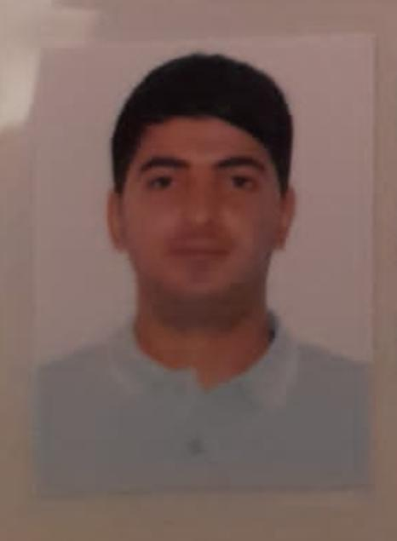

APPLICATION FORM

Position Applied for SEAMAN | Date Available from:

1. Personal Data
Family Name:Samadov | First Name: Niyazi | Middle Name:
Date of Birth: 10.11.1997 | Place of Birth (City and Country):  Azerbaijan, Ujar | Citizenship: Azerbaijan
Permanent Address  Azerbaijan, Ujar |  | Phone (Home):  Phone (Business/ Mobile) +99450 777 58 04 Watcaap

2. Maritime Education
Name of school | Town | Country | From | To | Type of degree or diploma

3. Professional Test
English Test Date | Name of Test | Score
Professional Test Date | Name of Test | Score
Professional Interview Date | Result

 | Son
Family Name | SAMADOV
First Name | INTIGAM
Relations | FATHER
City of living | AZERBAIJAN UJAR
Phone Numbers | 050 634 93 20

5. Identity Documents
Document | Country | Number | Place of Issue | Issue Date | Expiry Date
Seaman's Book | Azerbaijan | DQK 012730 | Azerbaijan | 11.09.2018 | 11.09.2023
Travel Passport | Azerbaijan | C02204824 | Azerbaijan | 08.11.2018 | 07.11.2028
Identity document | Azerbaijan | AZE 017430 | Azerbaijan | 11.09.2018 | 11.09.2023

6. Valid Visa
Country or Union | Type | Valid Until

7. Courses Attended and Certificates Obtained
Document | Number | Dates |  | Place
Document | Number | Issue | Expiry | Place

Certificate of competency. (SEAMAN) | 1283-18 | 11.09.2018 | 11.09.2023 | State Maritime Agency
Ship security-related familiarizatin security awareness training | SI-1309-23 | 15.05.2023 | 08.05.2028 | State Maritime Agency
Traininf for seafers with designated security duties | SH-1072-23 | 04.05.2023 | 04.05.2028 | State Maritime Agency
Proficiency in survival carft and boats other than fast rescue boats | SL-1550-23 | 11.05.2023 | 10 05.2028 | State Maritime Agency
International Safety Management | SP-1395-23 | 03.05.2023 | 03.05.2028 | State Maritime Agency
Safety familiarization training  Personel survival techniques  Fire prevention and fire fighting  Elementary first aid  Personel safety and social responsibilities | SO-2116-23 | 12.05.2023 | 08.05.2028 | State Maritime Agency
Basic training and quaifications on oil and chemical tanker cargo operations | SA-0371-23 | 11.05.2023 | 11.05.2028 | State Maritime Agency

8. Physical Data
Height | 173 cm
Weight | 80 kg
Colour of Hair | Black
Colour of Eyes | CHESTNUT
Boilersuit Size | 52
Shoes Size | 42

9. Medical History | Yes | No
Have you ever signed off a ship due to medical reasons? |  | X
Did you undergo any medical operation in the past? |  | X
Have you consulted a doctor during the last 12 months for an illness/accident? |  | X
Do you have any health or disability problems now? |  | X

If yes, please give full details:

 | Passed:2022 | Valid till:2024
International Medical Examination
Vaccination Against Yellow Fiver
Vaccination Against Diphtheria

10. References (please give name and address of your current or past employer) | Office remarks

Name of Company | STATU SHIPPING | Good
Name of person to contact | HAKAN ARSLAN
Address | ISTANBUL
Phone | +90533 580 17 87

Name of Company
Name of person to contact |  | Good
Address
Phone

11. Bank address for allotments
Beneficiary
Account No.
Name of Bank
Bank Address

12. Knowledge and experience | Yes | No
OCIMF vetting experience:
ISGOT knowledge:

13. I hereby declare that the above, including Medical History, is true
Place Baku | Date 09.07.2021  09.07.2023 | Signature Aliyev A

14. For Office use only

15. Seagoing Experience

Name of vessel | Flag | Vessel’s Type | DWT | Manager or Owner | Rank | From d/m/y | To  d/m/y
TOPAZ ARROW | Azerbaijan | AHTS | 1252 | Topaz Marine | Steward | 20.04.2019 | 10.10.2019
TOPAZ ARROW | Azerbaijan | AHTS | 1050 | Topaz Marine | Able seaman | 01.07.2020 | 12.01.2021
ANGORA -3 | LIBERIA | General cargo | 7000 | STATU SHIPPING | Able seamam | 16.07.2021 | 11.05.2022
MYSEA | LIBERIA | General cargo | 7000 | PALMALI SHIPPING | Able seaman | 08.08.2022 | 08.04.2023
Alcore Star | Qazakhstan | Oil product tanker | 13002 | Arrow Star Shipping | Able seaman | 15.07.2023 | 12.09.2023

