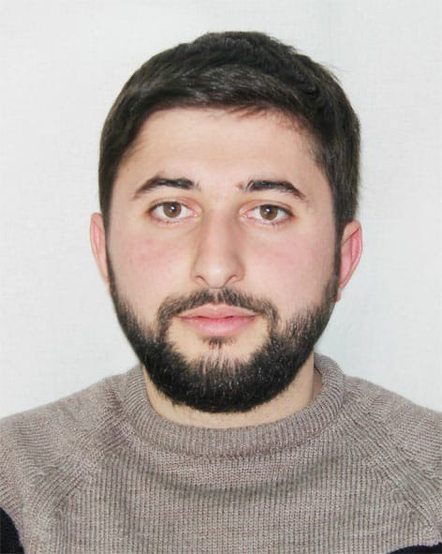
APPLICATION FOR SHIPBOARD EMPLOMENT
ELVAR SALAYEV
PERSONAL INFORMATION
POSITION: SAILOR (RATİNG FORMİNG PART OF AN ENGİNE-ROOM WATCH)
First name: ELVAR
Last name: SALAYEV
Middle name: ATAF
Date of Birth: 25.02.1994
Height: 171 cm
Weight: 70 kg
Blood Type: A (2) RH+
CONTACT DETALIS
Tel# +994993130515
Mobile# +905364969488
Email Address: salayev2010@gmail.com

TRAVEL DOCUMENTS
 | Number | Date of issue | Expiry date | Place of issue
Passport | C02314666 | 12.11.2018 | 11.11.2028 | Azerbaijan
Seaman’s Book | DQK 018297 | 01.09.2021 | 01.09.2026 | Azerbaijan

EDUCATIONAL ATTAINMENT
School/University | Number | Degree | Year Graduated | Place of issue
“KAINAT-M TM” LLC | MT №000759 | 09.04 2021 | 28.10. 2021 | Azerbaijan

LICENSES
 | Number | Date issued | Expiry date | Place of issue
COC | 0133/22 | 28.01.2022 | No limit | Azerbaijan

TRAINING CERTIFICATES (STCW)
Name of Certificate | Number | Date issued | Expiry Date | Place of issued
Training for seafarers with designated security duties | SH-1019-21 | 11.11.2021 | 11.11.2026 | Azerbaijan
International Safety Management Code | SP-2049-21 | 24.11.2021 | 24.11.2026 | Azerbaijan
Ship Security-related familiarization security-awareness training | S1-1370-21 | 22.11.2021 | 22.11.2026 | Azerbaijan
Safety training, initial training and guidance for all seafarers | SO-3045-21 | 19.11.2021 | 19.11.2026 | Azerbaijan
Proficiency in survival craft and boats other than fast rescue boats | SL-1987-21 | 29.11.2021 | 29.11.2026 | Azerbaijan

Places where he works
Company | Country | Ship | Duration
MARCAP LLC | UAE, Abu Dhabi | NBHH 1 | 01.05.2022  01.07.2022
Cunda Shipping | TURKEY | Evgenia Z | 30.01.2023  30.08.2023
Cunda Shipping | TURKEY | Svetoslava | 05.09.2023

Seafarer*s medical certificate

