CURRICULUM VITAE
PERSONAL DETAILS
Family name |  | GULIYEV |  |  |  | 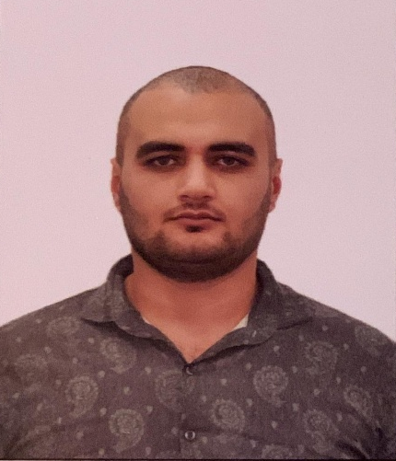
First name |  | AGIL
Father’s name |  | BALOGHANOV
Date and place of birth |  | 26.04.1998 Azerbaijan
Nationality |  | Azerbaijani
Marital status |  | Single
Permanent address |  | Azerbaijan, BAKU
Nearest airport |  | Heydar Aliyev International Airport Baku, Azerbaijan
Height (cm) | Weight (kg) |  | Eyes color | Hair color | Size of safety shoes | Size of coveralls
1.78 cm | 84 kg |  | BROWN | BLACK | 42 | 54
CONTACT DETAILS
Mobile | E-mail address
+7 978 170 66 09
NEXT OF KIN (FOR EMERGENCY)
Next of kin |  | Relationship | Brother
Date of birth |  | Address | Baku,Azerbaijan
Phone |  | Mobile phone
TRAVEL PASSPORT DETAILS
Document | Number | Place of Issue | Issued | Valid
PASSPORT | C01474282 | Azerbaijan | 04.11.2017 | 03.11.2027
SEAMAN’S BOOK DETAILS
Document | Number | Place of Issue | Issued | Valid
Seaman book | DQK022547 | Azerbaijan ,Baku | 24.01.2023 | 24.01.2028
SEAARERS IDENTITY | AZE027418 | Azerbaijan ,Baku | 24.01.2023 | 24.01.2028
EDUCATION
Full name of School | Place of Issue | Grade/Class | From | To
Kaspian Education Center | Azerbaijan , Baku | 0133/23 | 06.01.2023 | 13.01.2033
KNOWLEDGE OF LANGUAGES
Languages | Speaking | Reading | Writing
Azerbaijan | Excellent | Excellent | Excellent
Russian | Excellent | Excellent | Excellent
Turkish | Excellent | Excellent | Excellent

MEDICAL INFORMATION
Document | Grade | Place of issue | Date of issue | Date of expiry
Med.Sertificate | COOK | Azerbaijan | 29.09.2022 | 29.09.2024
CERTIFICATE OF COMPETENCY
Class/Grade | Issuing country | Certificate No. | Date issued | Expires | Details of Limitations
COOK | Azerbaijan Marine Administration | 0133/23 | 13.01.2023 |  | COOK
STCW AND OTHER CERTIFICATES
Name of course/Certificate | Institute | Place | Date of issue | Cert.No | Date of expiry
International Safety Management | Azerbaijan Marine Adminstration | Azerbaijan Baku | 11.11.2022 | SP-0038-23 | 11.11.2027
Proficiency in survival craft and boats other than fast rescue boats | Azerbaijan Marine Adminstration | Azerbaijan Baku | 11.11.2022 | SL-0125-23 | 11.11.2027
Training for seafarers with designated security duties | Azerbaijan Marine Adminstration | Azerbaijan Baku | 11.11.2022 | SH-0050-23 | 11.11.2027
Basic safety trainig | Azerbaijan Marine Adminstration | Azerbaijan Baku | 11.11.2022 | S0-0066-23 | 11.11.2027
Ship Security-related familization security-awareness | Azerbaijan Marine Adminstration | Azerbaijan Baku | 11.11.2022 | SI-0004-23 | 11.11.2027
SEA EXPERIENCE (LAST 5 YEARS – MOST RECENT EXPERIENCE ON TOP LINE)
Vessel | Company | Type of vessel | Flag | GRT | BHP | Rank | Sign on | Sign off
GAS SHADOW | ARKSTONG LTD | GAS CARRIER 2G LPG | GUINEA-BISSAU | 4054 | 97 x 12 | COOK | 16.02.2023 | 15.08.2023

