APPLICATION FORM
O/S
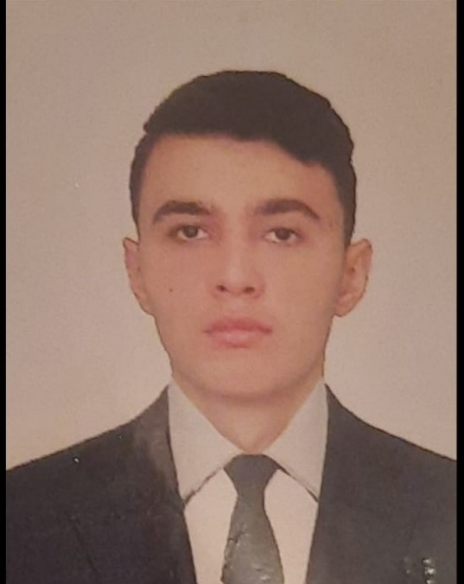

Personal Data:
First name: Shoyub
Second name: Madatov
Date of birth: 28.04.2004
Place of birth: Astara/Azerbaijan
Nationality: Azerbaijani
Marital status: Single
Permanent address: Azerbaıjan Republıc Reg Astara Vil Shahagac
E-mail address : soyub.madatov@mail.ru

Tel : +994 70 866 60 58
Whatsapp : +994 70 866 60 58

Certificate | Number | Issued | Valid | Place of Issue
Certificate of Competency | 2316/22 | 24.10.2022 |  | Azerbaijan State Maritime Administration
International Safety Management Code | SP-1982-22 | 30.06.2022 | 30.06.2027 | Azerbaijan State Maritime Administration
Ship Security-related familiarization security-awareness training | SI-1530-22 | 23.06.2022 | 23.06.2027 | Azerbaijan State Maritime Administration
Proficiency in survival craft and boats other than fast rescue boats | SL-1807-22 | 28.06.2022 | 28.06.2027 | Azerbaijan State Maritime Administration
( IMO Model Courses 1.13,1.19,1.20,1.21) | SO-2877-22 | 24.06.2022 | 22.06.2027 | Azerbaijan State Maritime Administration
Training for seafarers with designated security duties | SH-1246-22 | 05.07.2022 | 05.07.2027 | Azerbaijan State Maritime Administration
Seaman record book | DQK 021013 | 13.08.2022 | 13.08.2027 | Azerbaijan State Maritime Administration
Seafars Identity Document | AZE025877 | 13.08.2022 | 13.08.2027 | Azerbaijan State Maritime Administration
Passport | C03007292 | 12.03.2021 | 12.03.2026 | Azerbaijan Ministry Of Internal Affairs.
Certificate of medical |  | 14.05.2022 | 14.05.2024 | Azerbaijan republic ministry of health

Job Experience

Company & Owner | Vessel | Type of  Vessel | Flag | DWT | GRT | BHP | Rank | Area of Operation | Type of ops | From | To
Hanem denizcilik ve yapi ticaret A.Ş | M/V Gahura | General Cargo | Panama | 5566 | 3564 | 3603 | O/S | A1, A2, A3 | DRY CARGO | 10.01.2023 | 09.08.2023
Nationalities sailed with:

Languages: Fluent Moderate Basic

Azeri
English
Russian
Turkish
Computer Skills
Advanced:

Date available: 18.08.2023 O/S MADATOV SHOYUB ARİF

