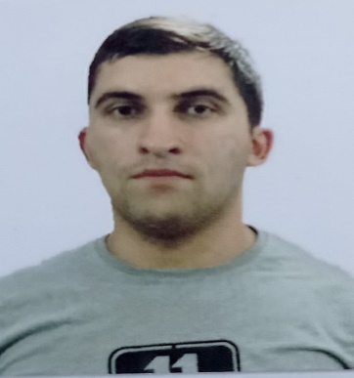

APPLICATION FORM

Personal ID Number

Position Applied for: ORDINARY SEAMAN | Date Available from:18.10.2023

1. Personal Data
Family Name:NAHMATOV | First Name: SAMIL | Middle Name: NIZAMI
Date of Birth: 04.02.1998 | Place of Birth (City and Country):  AZERBAIJAN, ASTARA | Citizenship: AZERBAIJAN
Permanent Address: BAKU AZERBAIJAN |  | Phone (Home): +9947036360121  Phone (Business/ Mobile):+994703630121  E-mail:nehmetov.1997@mail.ru

2. Maritime Education
Name of school | Town | Country | From | To | Type of degree or diploma
Kainat-M TM MMC | BAKU | AZERBAİJAN | 2019 | 2019 | ORDINARY SEAMAN

4. Identity Documents
Document | Country | Number | Place of Issue | Issue Date | Expiry Date
Passport | Azerbaijan | C03019121 | MINISTRY OF INTERNAL AFFAIRS | 11.02.2022 | 10.02.2030
Seaman’s Record Book | Azerbaijan | DQK 014799 | Azerbaijan State Maritime Administration | 25.07.2019 | 25.07.2024
Certificate of Competency | Azerbaijan | 0035/20 | Azerbaijan State Maritime Administration | 15.01.2020 | 15.01.2025

6. Courses Attended and Certificates Obtained
Document | Number | Dates |  | Place
Document | Number | Issue | Expiry | Place

Proficiency in survival craft and boats other than fast rescue boats | SL-1605-19 | 20.12.2019 | 19.12.2024 | Azerbaijan State Maritime Administration
Training for seafarers with designated security duties | SH-1552-19 | 16.12.2019 | 13.12.2024 | Azerbaijan State Maritime Administration
Ship Security-related familiarization security-awareness training | SI-2568-19 | 11.12.2019 | 11.12.2024 | Azerbaijan State Maritime Administration
International Safety Management Code | SP-1841-19 | 19.12.2019 | 15.12.2024 | Azerbaijan State Maritime Administration
Safety familiarization traning, Personal survival techniques,fire prevention and fire fighting,elementary first aid,personel safety and social responsibilities | SO-3146-19 | 17.12.2019 | 17.12.2024 | Azerbaijan State Maritime Administration
Seafarer’s Medical Certificate |  | 02.12.2022 | 02.12.2024 | Azerbaijan republic ministry of health

7. Physical Data
Height | 1.69
Weight | 76
Colour of Hair | Black
Colour of Eyes | Brown
Boilersuit Size | L
Shoes Size | 43
8. References (please give name and address of your current or past employer) | Office remarks
Name of Company | ISKELE SHIPPING
Name of person to contact | SEMIH SENCER
Address | Istanbul, Esentepe Milangaz caddesi
Phone | +905308856634

10. Seagoing Experience

Name of vessel | Flag | Vessel’s Type | DWT | GRT | BHP | Rank | From d/m/y | To  d/m/y | Total  m/d
Muammer Bey | Vanuatu | General cargo | 4196T | 2497 | 2X1690 | ORDINARY  SEAMAN | 08.12.2022 | 19.05.2023 | 5 MONTH 11 DAYS
KLC COMMANDER | Vanuatu | General Cargo | 5788T | 2992 | 1X3500 | ORDINARY SEAMAN | 07.11,2021 | 01.04.2022 | 5 MONTH
BAKI-357 | Azerbaijan | Tanker | 3280T | 2615 | 3X180 | ORDINARY SEAMAN | 23.06.2021 | 25.10.2021 | 4 MONTH
MY EFEKAN 2 | Vanuatu | General Cargo | 2620T | 1220 | 2X600 | ORDINARY SEAMAN | 16.07.2020 | 04.01.2021 | 6 MONTH

Total rank sea service: Total type of vessel sea service:

