CURRICULUM VITAE
PERSONAL DETAILS
Family name |  | SALIMOV |  |  | 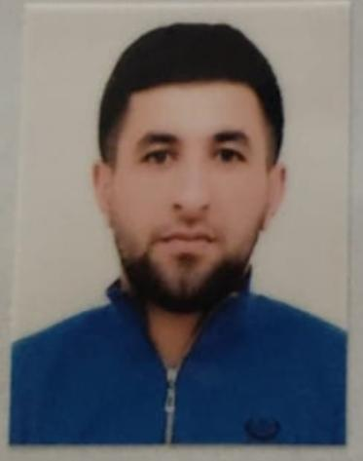
First name |  | EYVAZ
Father’s name |  | BAHRUZ
Date and place of birth |  | 10.04.1994
Nationality |  | Azerbaijani
Marital status |  | Married
Permanent address |  | Azerbaijan, Guba
Nearest airport |  | Heydar AliyevInternational Airport Baku, Azerbaijan
Height (cm) | Weight (kg) | Eyes color | Hair color | Size of safety shoes | Size of coveralls
1.78 cm | 83 kg | BROWN | BLACK | 42 | XL
CONTACT DETAILS
Mobile | E-mail address
+99451 631 33 71  Watcaap | Eyvazselimov7@gmail.com
NEXT OF KIN (FOR EMERGENCY)
Next of kin | Selimov Ceyhun | Relationship | Brother
Mobil phone | +99451 301 64 83 | Address | Azerbaijan Guba r Rustov q
TRAVEL PASSPORT DETAILS
Document | Number | Place of Issue | Issued | Valid
PASSPORT | C03438080 | Azerbaijan | 11.06.2022 | 10.06.2032
SEAMAN’S BOOK DETAILS
Document | Number | Place of Issue | Issued | Valid
Seaman book | DGK019701 | Azerbaijan ,Baku | 08.04.2022 | 08.04.2027
SEAARERS IDENTITY | AZE024617 | Azerbaijan ,Baku | 08.04.2022 | 08.04.2027
EDUCATION
Full name of School | Place of Issue | Grade/Class | From | To
KAINAT MTM MMC | Azerbaijan , Baku | A/B MZ-000045 | 18 10.2021 | 11.05.2022
KNOWLEDGE OF LANGUAGES
Languages | Speaking | Reading | Writing
Azerbaijan | Excellent | excellent | Excellent
English | Excellent | excellent | Excellemt
Turkish | Excellent | excellent | Excellent
Russia | Excellent | Excellent | Excellent
COMPUTER SKILLS
Windows | Microsoft Office | Internet
Excellent | Excellent | Excellent
MEDICAL INFORMATION
Document | Grade | Place of issue | Date of issue | Date of expiry
Med.Sertificate | SEAMAN | Azerbaijan Baku | 24.12.2021 | 24.12.2023
CERTIFICATE OF COMPETENCY
Class/Grade | Issuing country | Certificate  N-0330/23 | Date issued | Expires | Details of Limitations
Rating forming part of a navigational watch | Azerbaijan Marine Administration | RP 12370 | 02.02.2023 | No limit | A-2/4
STCW AND OTHER CERTIFICATES
Name of course/Certificate | Institute | Place | Date of issue | Cert.No | Date of expiry
International Safety Management | Azerbaijan Marine Adminstration | Azerbaijan Baku | 13.01.2023 | SP-0061/23 | 23.12.2027
Training for seafarers with designated security duites | Azerbaijan Marine Adminstration | Azerbaijan  Baku | 13.01.2023 | SH-0063/23 | 27.12.2027
Proficiency in survival craft and boats other than fast rescue boats | Azerbaijan Marine Adminstration | Azerbaijan Baku | 09.01.2023 | SL-0043/23 | 22.12.2027
Basic safetytrainig | Azerbaijan Marine Adminstration | Azerbaijan Baku | 13.01 2023 | SO-0094/23 | 16.12.2027
Ship Security-related familization security-awareness | Azerbaijan Marine Adminstration | Azerbaijan Baku | 10.01.2023 | SI-0056/23 | 26.12.2027
SEA EXPERIENCE (LAST 5 YEARS – MOST RECENT EXPERIENCE ON TOP LINE)
Vessel | Company | Type of vessel | Flag | DWT | GRT | Rank | Sign on | Sign off
M/T BABADAG | ASCO | BUNKERING TANKER | AZERBAIJAN | 1131 | 1073 | Seaman | 10.01.2022 | 01.05.2022

