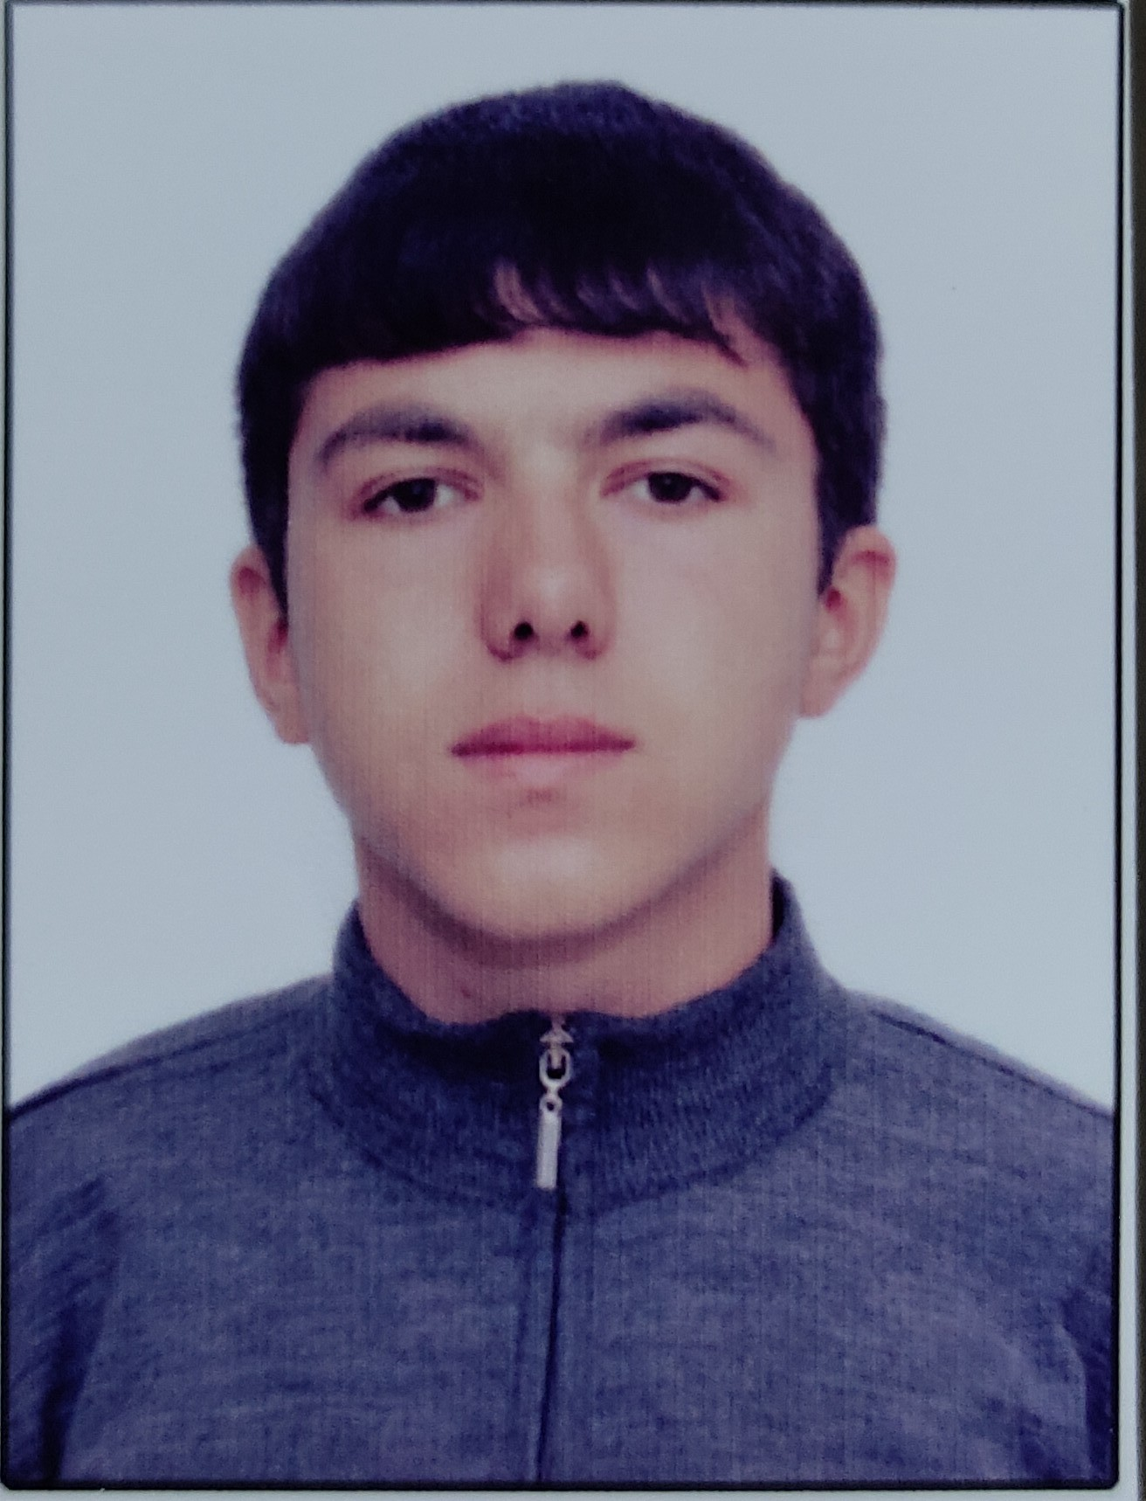

APPLICATION FORM

R | P | 1 | 0 | 8 | 2 | 0
Personal ID Number

Position Applied for: Oiler | Date Available from: Any time

1. Personal Data
Family Name:  IDRISOV | First Name:  ULVI | Middle Name:  MUBARIZ
Date of Birth: 18.01.2002 | Place of Birth (City and Country):  AZERBAIJAN/XACMAZ | Citizenship: AZERBAIJAN
Permanent Address: AZERBAIJAN.XACMAZ |  | Phone Mobile/WP +994775758804  MOBİLE. +994 556104860

2. Maritime Education
Name of school | Town | Country | From | To | Type of degree or diploma
” KAİNAT-M TM” LLC | BAKU | AZERBAIJAN | 09.04.21 | 28.10.21

3. Professional Test
English Test Date | Name of Test | Score
Professional Test Date | Name of Test | Score
Professional Interview Date | Result

4. Family Details
Civil Status(Single, Married, Separated, Divorced, Widowed) : SİNGLE

Next of Kin (the first emergency contact) IDRISOV MUBARIZ | Relationship: FATHER
Address of Residence  AZERBAYCAN XACMAZ | Phone : +994553847222

 | Daughter | Son
Family Name
First Name
Date of Birth
City of living
Phone Numbers

5. Identity Documents
Document | Country | Number | Place of Issue | Issue Date | Expiry Date
Seaman's Book | AZERBAIJAN | DQK 018483 | AZERBAIJAN, BAKU | 23.09.21 | 23.09.26
Travel Passport | AZERBAIJAN | C02197733 | AZERBAİJAN, BAKU | 19.12.21 | 18.12.31

6. Valid Visa
Country or Union | Type | Valid Until
N/A | N/A | N/A
N/A | N/A | N/A

7. Courses Attended and Certificates Obtained
Document | Number | Dates |  | Place
Document | Number | Issue | Expiry | Place

Certificate of Competency | ID№RP10820 | 14.01.2022 |  | AZERBAIJAN
TRAINING FOR SEAFARERS WITH DESIGNATED SECURITY DUTIES | SH-1246-21 | 13.12.2021 | 13.12.2026 | AZERBAIJAN
Proficiency in Survival Craft and Rescue Boats | SL-2317-21 | 21.12.2021 | 21.12.2026 | AZERBAIJAN
Basic Trainings | SO-3342-21 | 08.12.2021 | 08.12.2026 | AZERBAIJAN
SHIP SECURITY – RELATED TRAINING AND INSTRUCTION | SI-1560-21 | 10.12.2021 | 10.12.2026 | AZERBAIJAN
ISM Code | SP-2258-21 | 09.12.2021 | 09.12.2026 | AZERBAIJAN

8. Physical Data
Height | 170sm
Weight | 64 kq
Colour of Hair | Black
Colour of Eyes | Brown
Boilersuit Size | M
Shoes Size | 42

9. Medical History | Yes | No
Have you ever signed off a ship due to medical reasons? |  | No
Did you undergo any medical operation in the past? |  | No
Have you consulted a doctor during the last 12 months for an illness/accident? |  | No
Do you have any health or disability problems now? |  | No

If yes, please give full details:

 | Passed: | Valid till:
International Medical Examination | 12.04.2023 | 12.04.2025
Vaccination Against Yellow Fiver | N/A | N/A
Vaccination Against Diphtheria | N/A | N/A

10. References (please give name and address of your current or past employer) | Office remarks

Name of Company | VIYA SHIP MANAGEMENT
Name of person to contact | SAMİ
Address
Phone | +90 544 599 86 40

11. Bank address for allotments
Beneficiary
Account No.
Name of Bank
Bank Address

12. Knowledge and experience | Yes | No
OCIMF vetting experience:
ISGOT knowledge:

13. I hereby declare that the above, including Medical History, is true
Place: Baku | Date 25.01.2022 | Signature:

14. For Office use only

15. Seagoing Experience

Name of vessel | Flag | Vessel’s Type | DWT | Eng Type | HP | Manager or Owner | Rank | From d/m/y | To  d/m/y | Total  m/d
FISH FRY 9 | CAMEROON | LIVE SEAFOOD CARRIER | 784 | 735kw |  | SEZER IŞIN | OILER | 30/03/2022 | 03/03/2023 | 11/3
RANIS | PANAMA | DRY CARGO | 1559 | 1020kw |  |  | OILER | 07/06/2023 | 23/09/2023 | 3/16

Total rank sea service: Total type of vessel sea service:

