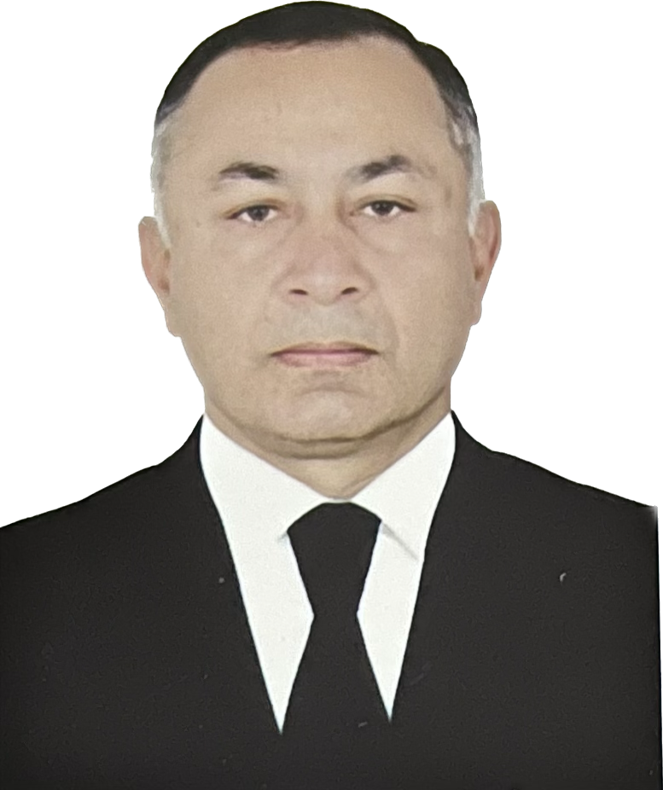

APPLICATION FORM

Position Applied for :Shef Of | Date Available from:10.11.2023

1. Personal Data
Family Name: | First Name :Shohrat | Middle Name:Aghayev
Date of Birth: 22.01.1972 | Place of Birth :Azerbaijan | Citizenship  AZERBAIJAN
Permanent Address ;SURAKHANI HOVSAN |  | Phone (Home):  Phone (Business/ Mobile)+994707175372  Email:agayevshohrat0@gmail.com

2. Maritime Education
Name of school | Town | Country | From | To | Type of degree or diploma
ADDA | BAKİ | AZERBAİJAN | 1999 | 2003 | Navigator

3. Languages
English | Bad
Russia | Native
Turkish | Native
Azerbaıjan | Native

4. Family Details
Civil Status(Single, Married, Separated, Divorced, Widowed) :
Married
Next of Kin (the first emergency contact) | Relationship
Address of Residence | Phone :

5. Identity Documents
Document | Country | Number | Place of Issue | Issue Date | Expiry Date
Seaman's Book | Azerbaijan | DQK015579 | State of maritime administration | 17.12.2019 | 17.12.2024
Travel Passport | Azerbaijan | C03127571 | Ministry of internal affairs | 13.04.2021 | 12.04.2031
Civil Passport | Azerbaijan |  | ASAN

6. Valid Visa
Country or Union | Type | Valid Until

7. Courses Attended and Certificates Obtained
Document | Number | Dates |  | Place
Document | Number | Issue | Expiry | Place

Certificate of Competency
Basic Trainings
Proficiency in Survival Craft and Rescue Boats | Sl391722 | 02.12.2022 | 02.12.2027
Advanced Fire Fighting | SJ052623 | 18.04.2023 | 13.04.2028
Medical First Aid Training | SN144323 | 22.09.2023 | 22.09.2029
Medical First Aid Training and Medical Care
GMDSS & Endorsement | Dq051521 | 21.12.2021 | 18.11.2026
Radar Observation & Plotting
Automatic Radar Plotting Aids Simulator (ARPA) | Sq010119 | 26.04.2019 | 26.04.2024
Bridge Team Management | Sw004321 | 12.02.2021 | 12.02.2026
Shiphandling & Maneuvering | Sv002021 | 03.02.2021 | 03.02.2026
Ship Security-related familiarization security awareness training
ISM Code | Sp133419 | 11.09.2019 | 11.09.2024
Safety Officer | SG038222 | 25.11.2022 | 25.11.2027
ECDISTraining Course | Sz003022 | 04.02.2021 | 04.02.2026
Risk Assessment Course
C.O.W./ I.G.S
Fire Practice on Tankers
Hazardous Materials | Sk-020423 | 10.04.2023 | 07.04.2028
Training of seafarers with designated security duties in compliance with ISPS Code

8. Physical Data
Height
Weight | 80
Colour of Hair | Black
Colour of Eyes | Brown
Boilersuit Size | 52
Shoes Size | 40-41

9. Seagoing Experience

Name of vessel | Flag | Vessel’s Type | DWT | Eng Type | HP | Manager or Owner | Rank | From d/m/y | To  d/m/y
AGDAM | AZERİBAİJAN | RO-Ro | 11950 | Burmester | 2000 | ASCO | MASTER | 2017 | 2023
VOLGADON 207 | Panama | Dry cargo | 4500 | Rd | 800 | SALYUTA SHİPPİNG | SHEF OF | 03.05.2022 | 14.10.2022
Garabakh | Azerbaijan | Ro-ro | 11950 | Burmester | 2000 | ASCO | MASTER | 2014 | 2017

