APPLICATION FORM

Position Applied for |  |  |  |  |  |  |  |  | Date Available from:
1. Personal Data
Surname: Sadixov |  |  | Name: Rasim |  |  |  |  |  | Position applied for: Officer in charge of an engineering watch
Date of Birth: 03.05.2000 |  |  | Place of Birth (City and Country):  Azerbaijan , Baku |  |  |  |  |  | 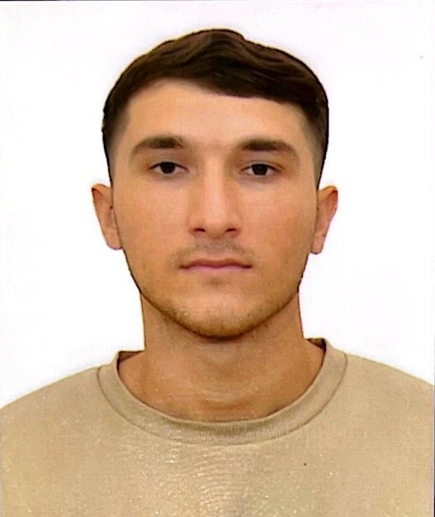
Permanent Address
Baku city, Pirallahi settlement, street 29 , house 10, flat 17
Tel. (Home): +994124571081
Tel. (Mobile) +994554938565
+994517777411
E-mail:rasim550@mail.ru
Citizenship: Azerbaijan
2. Maritime Education
Name of school |  | Country |  |  |  | Town | From |  |  | To |  | Type of degree or diploma
Azerbaijan State Marine Academy |  | Azerbaijan |  |  |  | Baku | 2017 |  |  | 2021
3. Professional Test
English Test Date |  |  |  | Name of Test |  |  |  |  |  |  | Score
Professional Test Date |  |  |  | Name of Test |  |  |  |  |  |  | Score
Professional Interview Date. NO |  |  |  | Result.
4. Family Details
Civil Status(Single, Married, Separated, Divorced, Widowed) : Single
Next of Kin (the first emergency contact) NO |  |  |  |  |  |  |  |  |  |  | Relationship NO
Address of Residence |  |  |  |  |  |  |  |  |  |  | Phone :
 | Daughter |  |  |  | Son |  |  |  |  |  | Daughter |  | Son
Family Name
First Name
Date of Birth
City of living
Phone Numbers

Page 1 of 3

5. Identity Documents
Document | Country | Number |  | Place of Issue |  |  |  | Issue Date |  | Expiry Date
Seaman's Book | Azerbaijan | DQK№023032 |  | Republic of Azerbaijan State Maritime and Port Agency |  |  |  | 16.03.2023 |  | 16.03.2028
Travel Passport | Azerbaijan | C04071604 |  | Ministry Of Internal Affairs |  |  |  | 19.02.2022 |  | 18.02.2032
Civil Passport | Azerbaijan | AZE16204844 |  |  |  |  |  | 06.06.2016  .2012 |  | 03.05.2025
6. Valid Visa NO
Country or Union |  |  | Type |  |  | Valid Until
7. Courses Attended and Certificates Obtained
Document |  |  |  | Number | Dates |  |  |  | Place
 |  |  |  | Number | Issue |  | Expiry
Certificate Of Competency |  |  |  | 001093/23 | 17.10.2023 |  | 17.10.2028 |  | Azerbaijan
Endorsement Of Certificate |  |  |  | 001093/23 | 17.10.2023 |  | 17.10.2028 |  | Azerbaijan
Engine Resource Management |  |  |  | ER-0207-23 | 11.07.2023 |  | 11.07.2028 |  | Azerbaijan
Medical First Aid |  |  |  | SN-1302-23 | 25.08.2023 |  | 24.08.2028 |  | Azerbaijan
Ship Security-related familiarization security-awareness  training |  |  |  | SI-0636-23 | 28.02.2023 |  | 27.02.2028 |  | Azerbaijan
Training For Seafarers With Designated Security Duties |  |  |  | SH-0531-21 | 30.07.2021 |  | 19.07.2026 |  | Azerbaijan
Proficiency In Survival Craft |  |  |  | SL-1085-21 | 23.07.2021 |  | 23.07.2026 |  | Azerbaijan
Training In Advanced Fire-Fighting |  |  |  | SJ-1108-23 | 30.08.2023 |  | 30.08.2028 |  | Azerbaijan
International Safety Management Code |  |  |  | SP-0770-23 | 03.03.2023 |  | 03.03.2028 |  | Azerbaijan
Leadership And Teamwork |  |  |  | DL-0751-23 | 06.09.2023 |  | 06.09.2028 |  | Azerbaijan
Basic training and instruction for all seafarers |  |  |  | SO-1286-23 | 27.03.2023 |  | 17.03.2028 |  | Azerbaijan
Dangerous, hazardous and harmfull cargoes |  |  |  | SK-0494-23 | 15.08.2023 |  | 15.08.2028 |  | Azerbaijan
Seafarers Medical Certificate |  |  |  |  | 11.08.2023 |  | 11.08.2024 |  | Azerbaijan

Page 2 of 3
8. Seagoing Experience

C. PREVIOUS SEA SERVICE
VESSEL | FLAG | TYPE / DWT | ENG / kW | RANK | S/ON | S/OFF | OWNERS
Akademik Hesen Aliev | Azerbaijan | Passenger/Ro-Ro Cargo | MAN B&W 6K45GFCA 2x4350 | Motorman | 22.04.2022 | 01.07.2022 | Caspian Shipping Company
Teymur Ehmedov | Azerbaijan | General Cargo | SKL 6NVDS-48A-2U 2x640 | Motorman | 09.09.2022 | 16.12.2022 | Caspian Shipping Company
Agdam | Azerbaijan | Ro-Ro Cargo | MAN B&W 5S26MC 2x2000 | Motorman | 29.04.2023 | 24.06.2023 | Caspian Shipping Company

Page 3 of 3

