CURRICULUM VITAE
(Application for Electro-Technical)

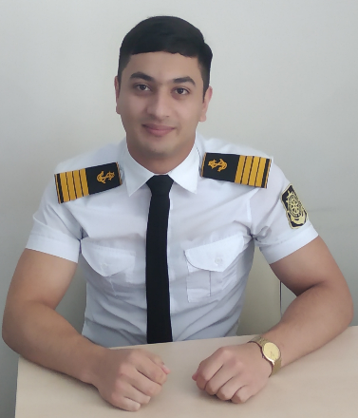

Personal Date
Name : Adnayev Elgun Alikhan
Place Date of Birth : Azerbaijan, Barda
Date of Birth : 05 December 1998
Nationality : Azerbaijan
Citizenship : Azerbaijan
Sex : M
Blood Group : A(II) RH+
Height : 172cm
Colour of eyes : Brown
Marrial Status : Single

Address : Barda,Katalparaq
Mobile Phone : +99450 417 16 65
E-mail : elgunadnayev@gmail.co

Documents

No | Kind | Number | Date of Issued | Expired Date
1 | Passport | RP09972 | 25.12.2019 | 25.12.2029
2 | Seaman Book | DQK010983 | 24.08.2023 | 24.08.2028
3 | Seafarers' Identity Document | AZE015176 | 24.08.2023 | 24.08.2028
4 | ID Card | AA2223106 | 13.07.2021 | 13.07.2031

Education

No | Name of University | Type of degree | Date of Issued | Expired Date
1 | Azerbaijan State Marine Academy | Bachelor | 15 September 2016 | July 2020
2 | Azerbaijan State Marine Academy | Master | 15 September 2020 | July 2022

Certificates

No | Certificate | Number of Certificate | Date of Issued on/valid until
1 | Electro-technical Rating | 1356/19 | 25.12.2019-25.12.2029
2 | Safety familiarization, basic training and instruction for all seafarers | SO-3762-23 | 27.07.2023-24.07.2028
3 | Proficiency in survival craft and boats other than fast rescue boats (STCW Code, A-VI/2 Pa.1,Pa.2,Pa.3 and Pa.4) | SL-2897-23 | 08.08.2023-08.08.2028
4 | International Safety Management Code | SP-2448-23 | 26.07.2023-26.07.2028
5 | Ship Security-related familirization security -awareness training  (STCW Code,A-VI/6,Pa.1 to Pa.4,) | SI-2284-23 | 18.07.2023-18.07.2028
6 | Training for seafarers with designated security duties (STCW Code, A-VI/6,Pa.6 to Pa.8;  IMO Model Course 3.19) | SH-0584-21 | 05.08.2021-05.08.2026

Sea Experience

No | Name Of Company | Rank | Name of Vessel | Flag | Type of Vessel | GRT | Periode of  Service |  | TTL MM
 |  |  |  |  |  |  | From | To | TTL MM
1 | ASCO | Probationer | M/V Nakchivan | Azerbaijan | Passenger/Ro-Ro Cargo Ship | 11450 | 22.06.2017 | 26.10.2017 | 4 m 7 d
2 | ASCO | Probationer | M/V Geophyzik-1 | Azerbaijan | Research Vessel | 952 | 03.08.2018 | 26.10.2018 | 2 m 25d
3 | "Topaz Marine and Energy" "BUE Caspian LTD" | Electric | M/V Caspian Provider | Azerbaijan | Offshore/  Cargo | 2471 | 30.07.2019 | 30.08.2019 | 1 m 18 d
4 | ASCO | Electric | M/V Akademik Hesen Aliyev | Azerbaijan | Passenger/Ro-Ro Cargo Ship | 11450 | 19.01.2020 | 31.05.2020 | 4 m 9 d

Electrical experience

Name of Company | Rank | Name of Factory | from | to | TTL  MM
General Board System | Electric montager | Baku Goknur Cabel Factory | 15.10.2020 | 16.03.2021 | 5 month

