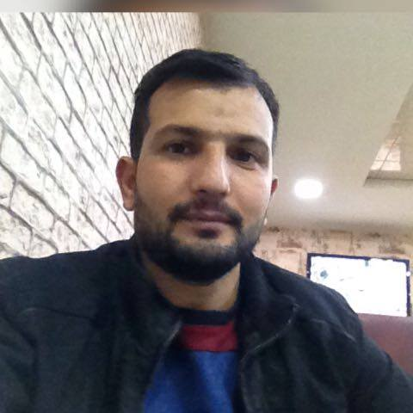
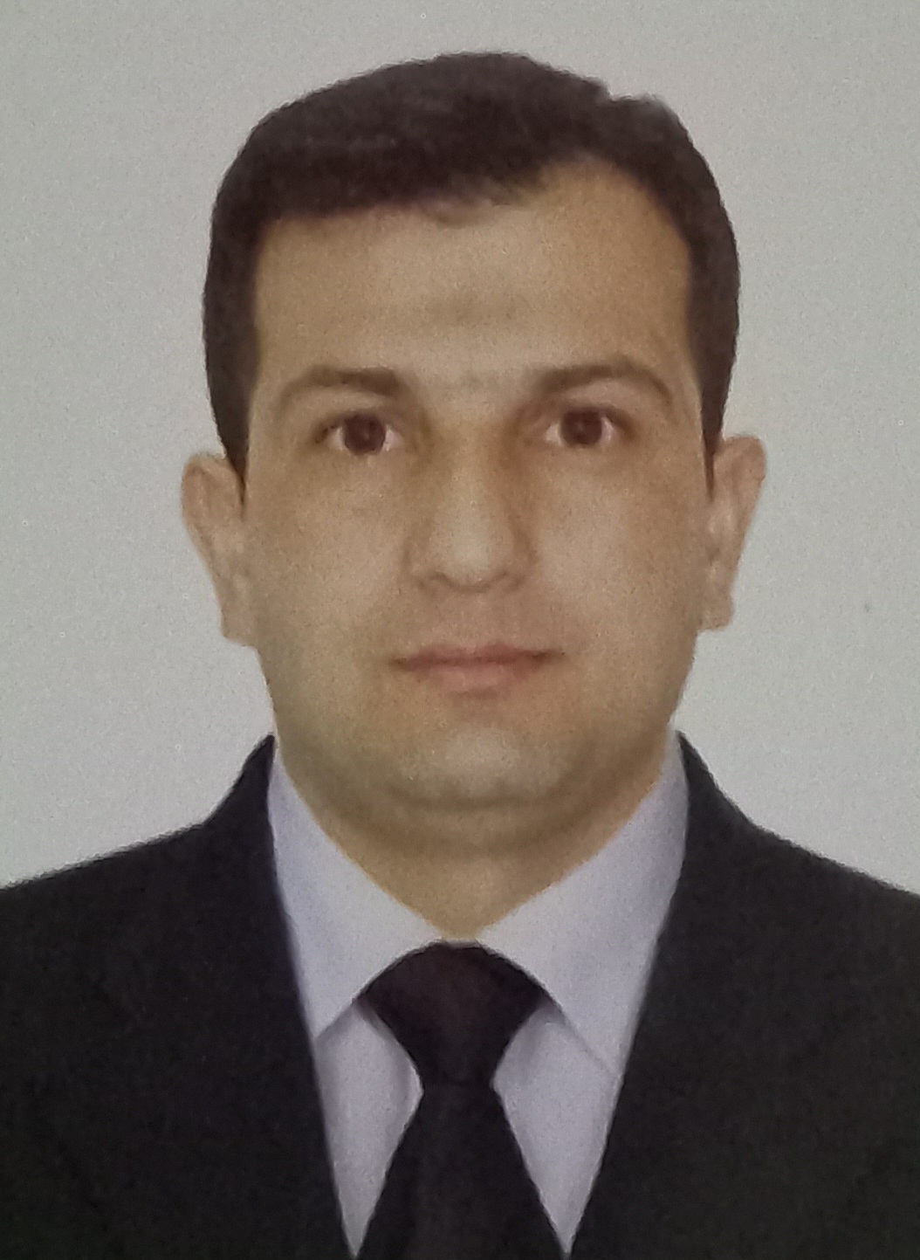

APPLICATION FORM

 |  |  |  |  | 4 | 0 | Z | 8 | G | G | 5

Position Applied for: | Date Available from: ANY TIME

1. Personal Data
Family Name: Suleymanov | First Name: Yusif | Middle Name: Ahliman
Date of Birth: 03.06.1987 | Place of Birth (City and Country): AZERBAIJAN.Salyan | Citizenship: AZERBAIJANIAN
Permanent Address: Salyan Kurqaraqasli |  | Phone Mobile:+994503553597  E-mail: yusif.suleymanov.@mail.ru

2. Maritime Education
Name of school | Town | Country | From | To | Type of degree or diploma
KAINAT TADRIS MAKAZI

3. Professional Test
English Test Date | Name of Test | Score
Professional Test Date | Name of Test | Score
Professional Interview Date | Result

4. Family Details
Civil Status(Single, Married, Separated, Divorced, Widowed) : Married

Next of Kin (the first emergency contact) Suleymanov Asif | Relationship: Brother
Address of Residence Salyan Kurqaraqasli | Phone :+994507548289

 | Daughter | Son
Family Name |  | Suleymanli
First Name |  | Saleh
Date of Birth |  | 09.04.2015
City of living |  | Salyan Kurqaraqasli
Phone Numbers

5. Identity Documents
Document | Country | Number |  | Place of Issue |  | Issue Date | Expiry Date
Seaman's Book | AZERBAIJAN | DQK022416 |  | State MaritimeAdmistration |  | 12.01.2023 | 12.01.2028
Travel Passport | AZERBAIJAN | C03111648 |  | AZERBAIJAN. SALYAN |  | 08.01.2023 | 07.01.2033
Civil Passport | AZERBAIJAN | AZE027287 |  | AZERBAIJAN.SALYAN |  | 12.01.2023 | 12.01.2028
6. Valid Visa
Country or Union |  |  | Type |  | Valid Until
N/A |  |  | N/A |  | N/A
N/A |  |  | N/A |  | N/A
 |  |  |  |  | X

7. Courses Attended and Certificates Obtained
Document | Number | Dates |  | Place
Document | Number | Issue | Expiry | Place

Certificate of Competency | RP09007 | 08.01.2019 | 08.01.2029 | State Maritime Admistration
Updating
Safe operation and maintenance of high voltage systems 1000 volts or more
Training for seafarers with designated security duties | SH-0789-18 | 10.07.2018 | 10.07.2023 | State Maritime Admistration
Ship Security-related training and instruction
Engine resource management
Passenger safety,cargo safety and hull integrity training
Dangerous hazardous and harmfull cargoes
Inert Gas system
Advanced training for oil tanker cargo operations | SA-0274-18 | 01.08.2018 | 26.07.2023 | State Maritime Admistration
Gas Analysers and Their Operation
Proficiency in Survival Craft and Rescue Boats | SL-4318-22 | 27.12.2022 | 16.12.2027 | State Maritime Admistration
Advanced Fire Fighting
Medical First Aid Training
Medical First Aid Training and Medical Care
Leadership and Teamwork
GMDSS General Operator
GMDSS Endorsement
Radar Observation & Plotting
Automatic Radar Plotting Aids Simulator (ARPA)
Bridge Team Management
Shiphandling& Maneuvering
Ship Security-related Training and instruction | SI-3229-22 | 30.12.2022 | 19.12.2027 | State Maritime Administation
Operational Use of Electronik Chart Display and information Systems
Crowd management training
Crisis management and human behaviour training
Training and qualification for ro-ro passenger ship
International Safety Management Code | SP-3873-22 | 29.12.2022 | 20.12.2027 | State Martime Administration
Shıp Security Officer
Training for seafarers with designated security duties
-personal survival techniques –fire prevention avdfire fighting –elementary first aid –personal safety and social responsibilities | SO-6174-22 | 30.12.2022 | 09.12.2027 | State Maritime Administration

8. Physical Data
Height | 160
Weight | 63
Colour of Hair | BLACK
Colour of Eyes | BROWN
Boilersuit Size | SMALL
Shoes Size | 40

9. Medical History | Yes | No
Have you ever signed off a ship due to medical reasons? |  | No
Did you undergo any medical operation in the past? |  | No
Have you consulted a doctor during the last 12 months for an illness/accident? |  | No
Do you have any health or disability problems now? |  | No

If yes, please give full details:

 | Passed: | Valid till:
International Medical Examination | 26.01.2023 | 26.01.2025
Vaccination Against Yellow Fiver | N/A | N/A
Vaccination Against Diphtheria | N/A | N/A

10. References (please give name and address of your current or past employer) | Office remarks

Name of Company
Name of person to contact
Address
Phone

Name of Company
Name of person to contact
Address
Phone

11. Bank address for allotments
Beneficiary
Account No.
Name of Bank
Bank Address

12. Knowledge and experience | Yes | No
OCIMF vetting experience:
ISGOT knowledge:

13. I hereby declare that the above, including Medical History, is true
Place: | Date | Signature:

14. For Office use only

15. Seagoing Experience

Name of vessel | Flag | Vessel’s Type | DWT | Eng Type | HP | Manager or Owner | Rank | From d/m/y | To  d/m/y | Total  m/d
SILVER STAR | AZERBIJAN | Dry cargo | 3000 |  |  | Caspian Shipping Company | Able Seaman | 06.06.2018 | 08.12.2019 | 6 months
PALMALI CONFIDECE | Malta | Dry cargo | 6000 | VART SILA |  | Palmali Shipping Company | Able Seaman | 05.10.2019 | 07.10.2020 | 1year
M/V SARA | PALAU | Dry cargo | 8000 |  |  | SIO Shipping | Able Seaman | 15.08.2021 | 09.02.2022 | 6 months
AGNES | TANZANIA | Dry cargo | 3500 |  |  | ADLER | Able Seaman | 24.04.2022 | 26.10.2022 | 6  months
M/V LINA | PANAMA | Dry cargo | 38000 |  |  | GAMMA Shipping | Able Seaman | 02.02.2023 | 06.09.2023 | 6 months

Total rank sea service: Total type of vessel sea service:
 |  |  | Type of vessel
 |  |  | OIL TANKER
 |  |  | LPG
ABLE SEAMAN | 5 |  | DRY CARGO | 5
 |  |  | TANKER ICE
 |  |  | OIL /CHEMICAL TANKER
 |  |  | FERRY
Total | 5 |  | Total: | 5

