VOLKAN ÖZDEMİR

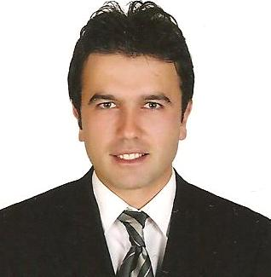
BİRTH DAY 19/11/1976
BIRTH PLACE ISTANBUL/TURKEY
MILITARY SITUATION YES
GSM +90 545 931 47 22 – 546 852 64 61-
ID TR 52822105500
E-MAİL wezierr@gmail.com
ADRESS BEYKOZ – YALIKOY ISTANBUL
DRİVER'S LİCENSE CLASS B (1998)

EXPERİENCE

ARMADOR SHIPPING M\V KAPTAN ERDOGAN 2.ENG 2021\2022 6MONTH
POLAR SHIPPING M\V OZGUN 2.ENG 2017-2018 9 MONTH
TRANSPASIFIK SHIPPING M\T HACI TELLİ 2. ENG 2016-2017 5 MONTH
KURUOĞLU SHIPPING M\V KURUOĞLU 3 2. ENG 2015-1016 6MONTH
ELIT SHIPPING M\V ATLAS SEMA 2. ENG 2014-2015 6 MONTH
LIDER SHIPPING M\V LDR ILYAS 2. ENG 2013-2014 6 MONTH
DENIZ LINE SHIPPING M\F SAMSUN 4. ENG 2012-2013 10 MONTH
MARTI SHIPPING M\V MARTI PRINCES 4. ENG 2011-2012 4 MONTH
YILMAR SHIPPING M\V JASPER 2. ENG 2009-2011 6 MONTH

SEAMANS BOOK NUMBER : S00392659 22/10/2024
3000 KW ALL WATERS ENGİNEER OFFICER
3500 KW MEDITERNAN BLACK SEA POWER SECOND ENGINEER
1100 KW MEDITERNAN BLACK SEA CHEEF ENGINEER

I HAVE KNOWLEDGE GOOD AUTOMATION

PASSPORT NUMBER : U25019285 / 21 SEP 2031

MEDICAL EXAMINITION EXPARE 30\10\2025

EDUCATION

SCHOOL İSTANBUL MARİNE TECHNİCAL SCHOOL 1990 / 1993
SECTİON SHİP MACHİNERY
COMPUTER HARDWARE, SOFTWARE,WİNDOWS, WİNDOWS 11 NT , NETWORK, OFFİCE ETC.
ENGLİSH İNTERMEDİATE LEVEL 4
INTERESTS

READ THE BOOK , TRAVEL , TECHNOLOGİCAL DEVELOPMENTS EXAMİNATİON, HAVE A WALK , THERE ARE SOCİAL AND CULTURAL ACTİVİTİES.

PERSONAL İNFORMATİON
HONESTLY HAVE A PERSONALİTY , GİVİNG ATTENTİON TO DETAİL, CAN TAKE RESPONSİBİLİTY, DİCTİON PROPERLY PRESENTABLE.

