APPLICATION FORM

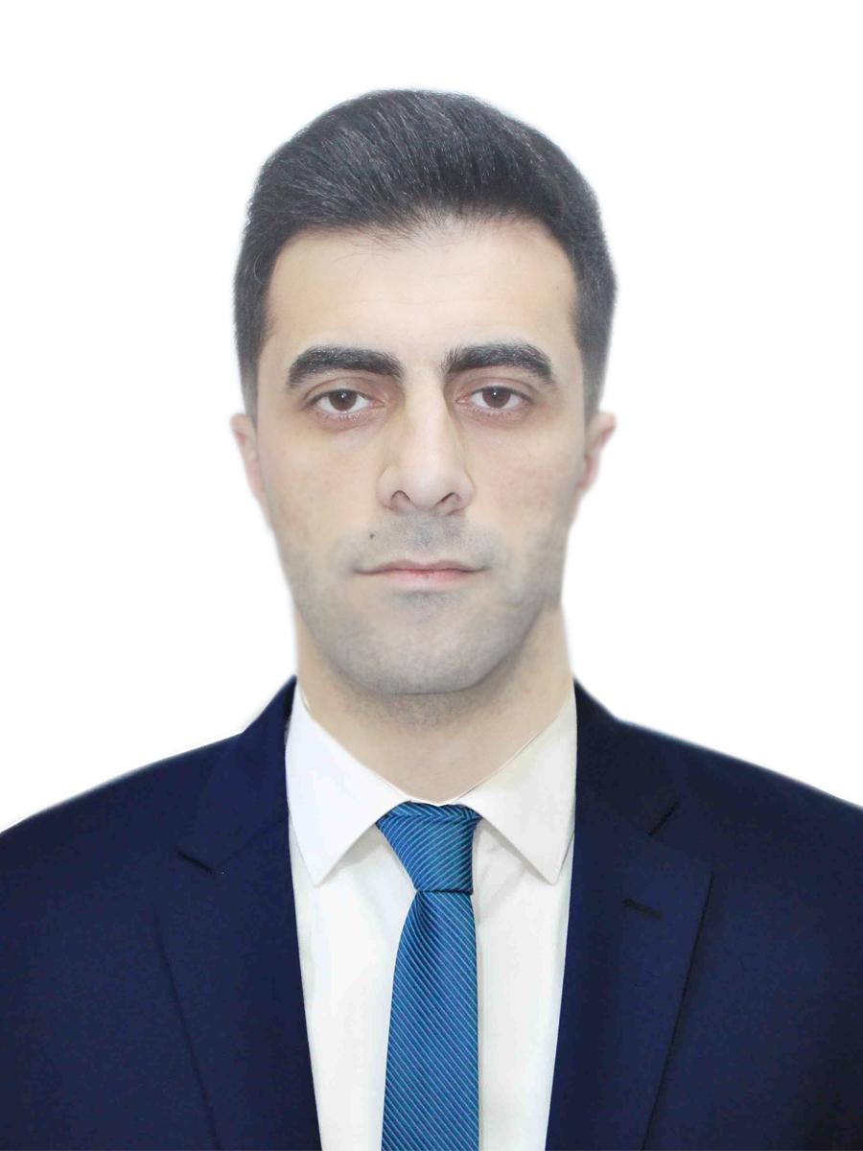

5 | Y | 1 | N | T | E | 3
Personal ID Number

Position Applied for: Electro-Technical Officer | Date Available from: ANY TIME

1. Personal Data
Family Name: Agharzayev | First Name: Rizvan | Middle Name: Ruslan
Date of Birth: 10.04.1995 | Place of Birth (City and Country): Gusar, Azerbaijan | Citizenship: AZERBAIJANIAN
Permanent Address: Gusar, Azerbaijan |  | Phone Mobile / whatsapp: +994516141390  E-mail: agarzayev_rizvan@mail.ru  Gmail: rizvan.agarzayev1@gmail.com
Nearest Airport (and Distance) : GYD

2. Maritime Education
Name of school | Town | Country | From | To | Type of degree or diploma
Azerbaijan State Marine Academy | Baku | Azerbaijan | 2012 | 2016 | Bachelor

3. Professional Test
English Test Date | Name of Test  Marlins test | Test result - 80%
Professional Test Date | Name of Test
Professional Interview Date | Result

4. Family Details
Civil Status(Single, Married, Separated, Divorced, Widowed) : single

Next of Kin (the first emergency contact) +99450863320] |  |  |  |  |  |  |  |  | Relationship: brother
Address of Residence Azerbaijan, Gusar , Giloba village |  |  |  |  |  |  |  |  | Mobile Phone / Whatsapp : +994508633200
 | Daughter |  |  | Son
Family Name
First Name
Date of Birth
City of living
Phone Numbers
 |  | 5. Identity Documents
Document |  |  | Country |  | Number |  | Place of Issue |  |  |  | Issue Date |  |  |  |  | Expiry Date
Seaman's Book |  |  | AZERBAIJAN |  | DQK022530 |  | AZERBAIJAN |  |  |  | 20.01.2023 |  |  |  |  | 20.01.2028
Travel Passport |  |  | AZERBAIJAN |  | C01439276 |  | AZERBAIJAN |  |  |  | 29.08.2017 |  |  |  |  | 28.08.2027
Civil Passport |  |  | AZERBAIJAN |  | AA2163069 |  | AZERBAIJAN |  |  |  |  |  |  |  |  | 02.09.2030
 |  | 6. Valid Visa
Country or Union |  |  |  |  |  | Type |  |  |  |  |  | Valid Until
N/A |  |  |  |  |  | N/A |  |  |  |  |  | N/A
N/A |  |  |  |  |  | N/A |  |  |  |  |  | N/A
7. Courses Attended and Certificates Obtained
Document |  |  |  |  |  | Number |  | Dates |  |  |  |  |  |  | Place
 |  |  |  |  |  |  |  | Issue |  | Expiry
Certificate of Competency |  |  |  |  |  | 000030/23 |  | 12.01.2023 |  | 21.11.2027 |  |  |  |  | AZERBAIJAN
Training for seafarers with designated security duties |  |  |  |  |  | SH-0051-23 |  | 12.01.2023 |  | 10.01.2028 |  |  |  |  | AZERBAIJAN
Ship Security-related familiarization security-awareness training |  |  |  |  |  | SI-0096-22 |  | 25.01.2022 |  | 25.01.2027 |  |  |  |  | AZERBAIJAN
Dangerous hazardous and harmfull cargoes |  |  |  |  |  | SK-0055-21 |  | 19.02.2021 |  | 19.02.2026 |  |  |  |  | AZERBAIJAN
Advanced training for oil tanker cargo operations |  |  |  |  |  | SB-0340-22 |  | 23.12.2022 |  | 23.12.2027 |  |  |  |  | AZERBAIJAN
Proficiency in Survival Craft and boats other than fast rescue boats |  |  |  |  |  | SL-0067-21 |  | 01.02.2021 |  | 01.02.2026 |  |  |  |  | AZERBAIJAN
Updating |  |  |  |  |  | XS-1385-22 |  | 22.11.2022 |  | 22.11.2027 |  |  |  |  | AZERBAIJAN
Training in Advanced Fire Fighting |  |  |  |  |  | SJ-0036-21 |  | 02.02.2021 |  | 02.02.2026 |  |  |  |  | AZERBAIJAN
Medical First Aid Training |  |  |  |  |  | SN-0060-23 |  | 13.01.2023 |  | 13.01.2028 |  |  |  |  | AZERBAIJAN
Leadership and Teamwork |  |  |  |  |  | DL-1819-22 |  | 15.12.2022 |  | 15.12.2027 |  |  |  |  | AZERBAIJAN
Safe operation and maintenance of high voltage systems 1000 volts or more |  |  |  |  |  | DM-0117-18 |  | 11.05.2018 |  | 11.05.2023 |  |  |  |  | AZERBAIJAN
Crowd management training |  |  |  |  |  | SC-0010-22 |  | 11.01.2022 |  | 11.01.2027 |  |  |  |  | AZERBAIJAN
Crisis management and human behavior training |  |  |  |  |  | SE-0142-22 |  | 24.11.2022 |  | 24.11.2027 |  |  |  |  | AZERBAIJAN
International Safety Management Code |  |  |  |  |  | SP-0132-21 |  | 10.02.2021 |  | 10.02.2026 |  |  |  |  | AZERBAIJAN
-safety familiarization training  -personal survival techniques  –fire prevention and fire fighting  –elementary first aid  –personal safety and social responsibilities |  |  |  |  |  | SO-5832-22 |  | 14.12.2022 |  | 09.12.2027 |  |  |  |  | AZERBAIJAN
Basic training and qualifications on oil and cemical tanker cargo operations (STCW Code A-V/1-1 Pa.1) |  |  |  |  |  | SA-0011-21 |  | 02.02.2021 |  | 02.02.2026 |  |  |  |  | AZERBAIJAN
Advanced training for chemical tanker cargo operations |  |  |  |  |  | AS-0007-22 |  | 19.01.2022 |  | 19.01.2027 |  |  |  |  | AZERBAIJAN
İnert Gas System |  |  |  |  |  | SX-0066-23 |  | 30.08.2023 |  | 30.08.2028 |  |  |  |  | AZERBAIJAN
Ships Gas Analyzers and their operation |  |  |  |  |  | ST-0095-23 |  | 08.08.2023 |  | 08.08.2028 |  |  |  |  | AZERBAIJAN
Safe operation and maintenance of high voltage systems 1000 volts or more |  |  |  |  |  | DM-0221-23 |  | 09.08.2023 |  | 28.07.2028 |  |  |  |  | AZERBAIJAN

8. Physical Data
Height | 179
Weight | 79
Colour of Hair | Black
Colour of Eyes | Brown
Boilersuit Size | 48
Shoes Size | 43

9. Medical History | Yes | No
Have you ever signed off a ship due to medical reasons? |  | No
Did you undergo any medical operation in the past? |  | No
Have you consulted a doctor during the last 12 months for an illness/accident? |  | No
Do you have any health or disability problems now? |  | No

If yes, please give full details:

 | Passed: | Valid till:
International Medical Examination | 12.01.2023 | 12.01.2024
Vaccination Against Yellow Fiver
Vaccination Against Diphtheria

10. References (please give name and address of your current or past employer) | Office remarks
Name of Company |  | ASCO
Name of person to contact |  | Mr. Rahib
Address |  | AZ1027, Baky city, Zıkh avenue, 2236
Phone |  | +994558218585
Name of Company
Name of person to contact
Address
Phone
11. Bank address for allotments
Beneficiary
Account No.
Name of Bank
Bank Address

12. Knowledge and experience | Yes | No
OCIMF vetting experience:
ISGOT knowledge:

13. Knowledge of other languages: | Yes | No
English  Russian  Turkey | B1  B1  C1

14. I hereby declare that the above, including Medical History, is true
Place: Baku, Azerbaijan | Date 12.02.2023 | Signature: yes

15. For Office use only

16. Seagoing Experience
Name of vessel | Flag | Vessel’s Type | DWT | Eng Type | HP | Manager or Owner | Rank | From / to d/m/y | Operation area
SHAHDAG | Azerbaijan | Ferry | 5991 | 5S26MC  2x2000kW |  | ASCO | Electrician | 04.10.2017  10.04.2018 | Caspian sea
KHARABAGH | Azerbaijan | Ferry | 6012 | 5S26MC  2x2000kW |  | ASCO | ETO | 01.08.2018  20.10.2018 | Caspian sea
BALAKAN | Azerbaijan | Ferry | 5398 | 5S26MC  2x2000kW |  | ASCO | ETO | 08.12.2018  08.04.2019 | Caspian sea
BALAKAN | Azerbaijan | Ferry | 5398 | 5S26MC  2x2000kW |  | ASCO | ETO | 08.06.2019  08.08.2019 | Caspian sea
Uzeyir Hajibeyli | Azerbaijan | Dry cargo | 5491 | Wartsilla  6L20  2x1050kW |  | ASCO | ETO | 07.11.2019  21.08.2020 | Azov Sea-Black Sea- Mediterranean sea World wide
General Aslanov | Azerbaijan | Dry cargo | 5499 | Mak 6M20  2x1100kW |  | ASCO | ETO | 17.03.2021  16.09.2021 | World wide
Uzeyir Hajibeyli | Azerbaijan | Dry Cargo | 5491 | Wartsilla  6L20  2x1050kW |  | ASCO | ETO | 17.02.2022  15.08.2022 | World wide
Uzeyir Hajibeyli | Azerbaijan | Dry Cargo | 5491 | Wartsilla  6L20  2x1050kW |  | ASCO | ETO | 24.02.2023  28.05.2023 | World wide
SHUSHA | Azerbaijan | Oil tanker | 13010 | Wartsilla 9L20 2x1620kW |  | ASCO | ETO | 07.09.2023 | Caspian sea

Total rank sea service: Total type of vessel sea service:
Rank |  |  | Type of vessel
Electro-Tecnical officer |  |  | OIL TANKER | SHUSHA
 |  |  | LPG
Electro-Tecnical officer |  |  | DRY CARGO | Uzeyir Hajibeyli, General Aslanov Uzeyir Hajibeyli  Uzeyir Hajibeyli
 |  |  | TANKER ICE
Electro-Tecnical officer |  |  | OIL /CHEMICAL TANKER | SHUSHA
Electrician  Electro-Tecnical officer |  |  | Ro-Ro/Ferry | Shahdag  Kharabagh, Balakan  Balakan
Total: 6 years |  |  | Total: 9

