PERSONAL DATA

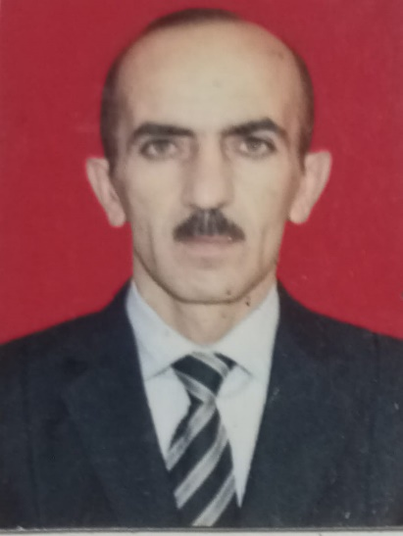
PERSONAL INFORMATION
Family Name | MAMMADOV |  | First Name (s) | ELSHAD
Birth Date | 17.02.1972 |  | Birth Place | AZERBAIJAN, MASALLI
Nationality | AZERBAIJAN |  | Nearest Airport | HEYDAR ALIYEV - BAKU
Marital Status | MARRIED |  | No. of Children | 3
Height (cm) | 160 |  | Weight (kg) | 58
Size of overall/ shoes | S / 40
ADDRESS (include telephone country & area codes)
Country | AZERBAIJAN |  | Email Address | elshadmammadov072@gmail.com
Postal (ZIP) Code | AZ1012 |  | Mobile Phone | +90 5312864796  5856452
City, Street & Nr. | AZERBAIJAN, MASALLI |  | Residence Phone | ---
NEXT OF KIN INFORMATION (person to contact in case of emergency & insurance beneficiary)
Family Name | MAMMADOV |  | First Name(s) | ISMAYIL
Nationality | AZERBAIJAN |  | Relationship | BROTHER
Location Country | AZERBAIJAN |  | Email Address | Ismail.mammadov.im@gmail.com
Postal (ZIP) Code | AZ |  | Mobile Phone | +994513104123
City,Street & Nr. | AZERBAIJAN, MASALLI |  | Residence Phone | ---
REMARKS
English Language Skills |  | Spoken: fluent / good / average / poor - Written: fluent / good / average / poor
Other Foreign Languages |  | TURKISH RUSSIAN
Professional School / Academy - Name & Period (From - To) |  | baku MARITIME SCHOOL
 |  | CERTIFICATE N: 115 01.11.1992 23.05.1994
Foreign Crew Experience  (specify nationalities) |  | TURKISH  RUSSIAN

LIST OF DOCUMENTS
Family  Name | MAMMADOV | First  Name(s) | ELSHAD |  | Rank | BOATSWAIN
A. TRAVEL DOCUMENTS AND MEDICAL CERTIFICATES
Document Name (Desciption) |  | Document Number |  | Country | Issue Place | Issue Date | Exp. Date
Passport |  | C02239919 |  | Azerbaijan | MIA | 02.12.2018 | 01.12.2028
Seaman's Book (national) |  | DQK 013381 |  | Azerbaijan | SMA | 10.01.2019 | 10.01.2024
Seaman's Book (LIBERIA) |  | 1745598 |  | LIBERIA | U.S.A | 31.10.2022 | 31.10.2027
RATING FORMING PART OF AN ENGINE-ROOM WATCH 1238/22 Azerbaijan SMPA 20.06.2022 02.06.2027
B. CERTIFICATES OF COMPETENCY & ENDORSEMENTS, COURSE CERTIFICATES
Document Name (Desciption) |  | Document Number |  | Country | Issue Place | Issue Date | Exp. Date
International Safety Management Code |  | SP- 2266-18 |  | Azerbaijan | SMA | 20.11.2018 | 20.11.2023
Personal survival techniques  Fire prevention an fire fighting  Elementary first aid  Personal safety and social responsibilities |  | SO-3141-18 |  | Azerbaijan | SMA | 21.12.2018 | 21.12.2023
Proficiency in survival craft and  boats other than fast rescue boats |  | SL-3042-18 |  | Azerbaijan | SMA | 24.12.2018 | 24.12.2023
Ship security-related familiarization  security-awareness training |  | SI-1921-18 |  | Azerbaijan | SMA | 13.11.2018 | 12.11.2023
Training for seafarers with designated security duties |  | SH-1520-18 |  | Azerbaijan | SMA | 28.11.2018 | 28.11.2023
Basic training and qualifications on oil and chemical tanker cargo operations |  | SA-0207-19 |  | Azerbaijan | SMA | 17.05.2019 | 17.05.2024
Medical First Aid |  | SN-1636-18 |  | Azerbaijan | SMA | 20.12.2018 | 20.12.2023

SEA SERVICE (LAST 10 YEARS)

Family Name: | MAMMADOV |  |  | First Name(s): |  | ELSHAD |  |  | Date of Birth: |  | 17.02.1972
Vessel's Name |  | Flag | GT | kW | Ship Type | Eng.Make | Rank | S/On Date | S/Off Date | Employer (company to contact for reference)
m/v GAHRAMAN  HUSEYNOV |  | Azerbaijan | 5000 | 2 x 1200 | Tanker | 6CNSP  18/22 | Chıef radio  operator | 12.08.1994 | 12.08.1995 | Caspıan Shıppıng Company
m/v APSHERON |  | Azerbaıjan | 7000 | 1 x 1800 | Tanker | 6CNSP | Chıef r/op. | 15.11.2004 | 03.06.2005 | Caspıan Sh Co.
m/v BALTIC MARINER |  | Valetta | 6000 | 2 x 1800 | Tanker | MAK  6M 25 | BOSUN | 14.07.2019 | 30.05.2020 | PALMALI
m/v CASPIAN MARINER |  | Valetta | 6000 | 2 x 1800 | Tanker | MAK  6M 25 | BOSUN | 30.05.2020 | 13.07.2020 | PALMALI
m/v OLGA GOLOVUSHKINA |  | Valetta | 7000 | 2 x 1200 | Tanker Oıl/chem. | Wartsıla  6L20 | BOSUN | 19.09.2020 | 21.04.2022 | PALMALI
m/v METIN HUSEYNOV |  | Lıberıa | 6000 | 2 x 1800 | Tanker Oıl/chem. | MAK  6M 25 | BOSUN | 05.10.2022 | 28.04.2023 | PALMALI

