 | CURRICULUM VITAE | 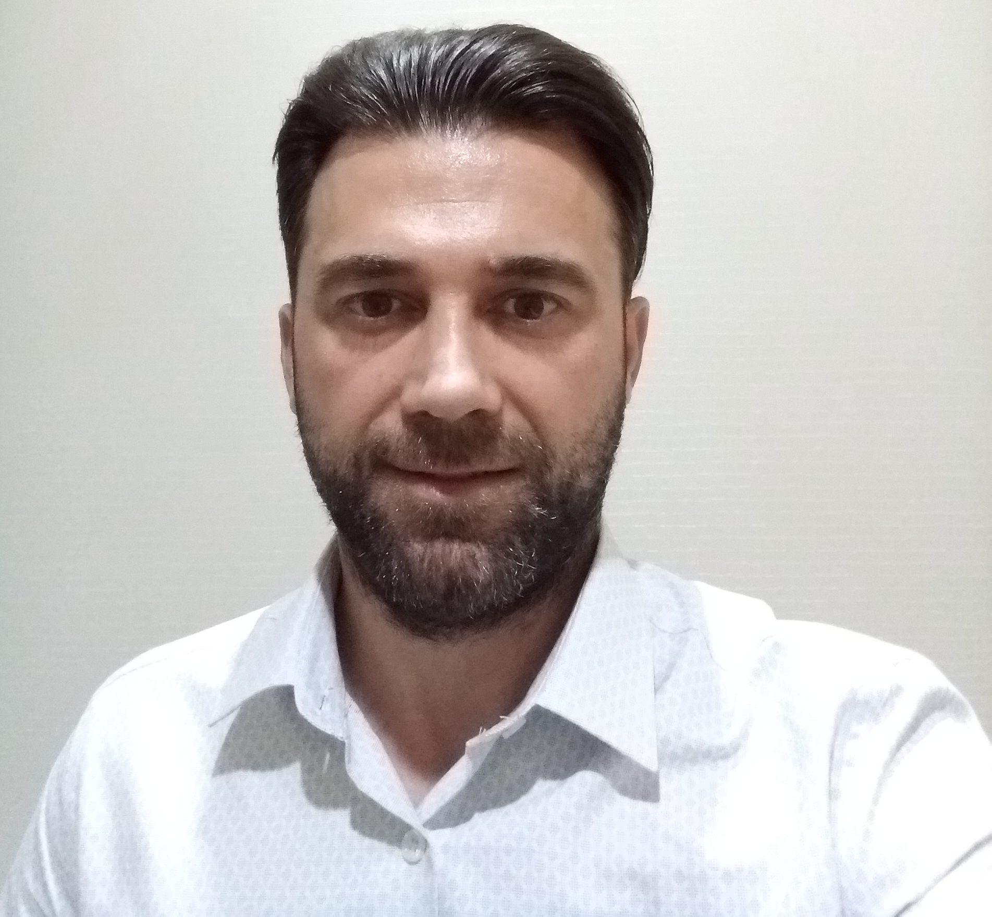

1. PERSONAL INFORMATION
RANK |  |  |  |  |  |  | Oceangoing Master |  |  |  |  |  |  |  |  |  |  | READY FROM |  |  |  |  |  |  |  |  |  |  |  |  |  | 01 Nov 2023
LAST NAME |  |  |  |  |  |  | KOSE |  |  |  |  |  |  |  |  |  |  | FIRST NAME |  |  |  |  |  |  |  |  | OZCAN
OTHER NAMES |  |  |  |  |  |  | -- |  |  |  |  |  |  |  |  |  |  | NATIONALITY |  |  |  |  |  |  |  |  | TURKISH
NEAREST AIRPORT |  |  |  |  |  |  | ISTANBUL AIR PORT (IST) |  |  |  |  |  | OVERALL SIZE |  |  |  |  |  | M |  |  |  |  |  |  |  | SHOES SIZE |  |  |  |  |  |  |  |  |  |  | 42
SEX | MALE |  |  |  |  |  | BIRTH PLACE |  |  |  |  |  | CAYELI |  |  |  |  |  |  |  |  |  |  |  |  |  | DATE OF BIRTH |  |  |  |  |  |  |  |  |  |  | 06/06/1982
MARITAL STATUS |  |  |  |  |  |  | MARRIED |  |  |  |  |  | COLOUR OF EYES |  |  |  |  |  |  |  |  | BROWN |  |  |  |  | COLOUR OF HAIR |  |  |  |  |  |  |  |  |  |  | BROWN
MOTHER’S NAME |  |  |  |  |  |  | EMINE |  |  |  |  |  |  |  |  |  |  | FATHER’S NAME |  |  |  |  |  |  |  |  | SALIH
HEIGHT (CM) |  |  |  |  |  |  | 170 |  |  |  |  |  | WEIGHT (KG) 70
2. ADDRESS (PERMANENT) |  |  |  |  |  |  |  |  |  |  |  |  |  |  |  |  |  | ADDRESS ( LOCAL )
STREET |  |  | CAKMAK /BARAJ NO 44-46 UMRANIYE |  |  |  |  |  |  |  |  |  |  |  |  |  |  | STREET
POST CODE |  |  | 34774 |  |  |  |  |  |  |  |  |  |  |  |  |  |  | POST CODE
CITY |  |  | ISTANBUL |  |  |  |  |  |  |  |  |  |  |  |  |  |  | CITY
COUNTRY |  |  | TURKEY |  |  |  |  |  |  |  |  |  |  |  |  |  |  | COUNTRY
TEL. NO. |  |  |  |  |  |  |  |  |  |  |  |  |  |  |  |  |  | TEL.NO.
MOBILE |  |  | +905424217569 |  |  |  |  |  |  |  |  |  |  |  |  |  |  | MOBILE
E-MAIL |  |  | ozcankose1982@gmail.com |  |  |  |  |  |  |  |  |  |  |  |  |  |  | E-MAIL
FAX |  |  |  |  |  |  |  |  |  |  |  |  |  |  |  |  |  | FAX

3. NEXT OF KIN
FULL NAME |  |  |  | ILYAS KOSE |  |  |  |  |  |  |  |  |  |  |  |  |  |  |  |  |  |  | RELATION |  |  |  |  |  | BROTHER
ADDRESS |  |  |  | CAKMAK MH.BARAJ SK. NO44 D14 UMRANIYE
CITY |  |  |  | ISTANBUL |  |  |  |  |  |  |  |  |  |  |  |  |  |  |  |  |  |  | COUNTRY |  |  |  |  |  | TURKEY
TEL. NO. |  |  |  |  |  |  |  |  |  |  |  |  |  | MOBILE PHONE NO. |  |  |  |  |  |  |  |  | +90541 352 0171 |  |  |  |  |  |  |  |  |  | FAX NO.
4. DETAILS OF CHILDREN
NAME OF CHILD |  |  |  |  |  |  |  |  |  |  |  |  |  |  |  |  |  |  |  |  |  |  | SEX |  |  |  |  |  | DATE OF BIRTH
ATAHAN KOSE |  |  |  |  |  |  |  |  |  |  |  |  |  |  |  |  |  |  |  |  |  |  | MALE |  |  |  |  |  | 23/05/2021

5. TRAVEL DOCUMENTS
DOC./VISA TYPE |  |  |  |  |  | DOC./VISA NO. |  |  |  |  |  | ISS.DATE |  |  |  |  | EXP. DATE |  |  |  |  |  | ISS. BY (AUTHORITY) |  |  |  |  |  |  |  |  |  |  |  |  | PLACE OF ISSUE
PASSPORT |  |  |  |  |  | U28748016 |  |  |  |  |  | 15/05/2023 |  |  |  |  | 15/05/2033 |  |  |  |  |  | Turkiye |  |  |  |  |  |  |  |  |  |  |  |  | Umraniye
SEAMAN BOOK |  |  |  |  |  | S00396834 |  |  |  |  |  | 25/05/2023 |  |  |  |  | 25/05/2028 |  |  |  |  |  | Turkiye |  |  |  |  |  |  |  |  |  |  |  |  | Istanbul
US C1/D VISA |  |  |  |  |  |  |  |  |  |  |  | 03/02/2014 |  |  |  |  | 29/01/2019 |  |  |  |  |  |  |  |  |  |  |  |  |  |  |  |  |  |  | Istanbul
US B1/B2 |  |  |  |  |  |  |  |  |  |  |  | 03/02/2014 |  |  |  |  | 29/01/2024 |  |  |  |  |  |  |  |  |  |  |  |  |  |  |  |  |  |  | Istanbul

6. EDUCATION
SCHOOL NAME |  |  |  |  | Rize Tevfik Ileri Electric/Electronic High School |  |  |  |  |  |  |  |  |  |  |  |  |  |  |  |  |  |  |  |  | FROM |  |  |  |  | 1994 |  |  |  |  |  | TO |  |  |  | 1998
SCHOOL NAME |  |  |  |  | Piri Reis University |  |  |  |  |  |  |  |  |  |  |  |  |  |  |  |  |  |  |  |  | FROM |  |  |  |  | 1999 |  |  |  |  |  | TO |  |  |  | 2003
SCHOOL NAME |  |  |  |  | 7.01 IMO Requirement Education (A-II/2) for Captain and Chief Officers |  |  |  |  |  |  |  |  |  |  |  |  |  |  |  |  |  |  |  |  | FROM |  |  |  |  | 02/2010 |  |  |  |  |  | TO |  |  |  | 07/2010
SCHOOL NAME |  |  |  |  | General English Course in NYC –USA |  |  |  |  |  |  |  |  |  |  |  |  |  |  |  |  |  |  |  |  | FROM |  |  |  |  | 2017 |  |  |  |  |  | TO |  |  |  | 2018

7. LICENCE INFORMATION
LICENCE NAME |  |  |  |  |  |  |  |  |  | NUMBER |  |  |  |  |  | ISSUE DATE |  |  |  |  | EXPIRY DATE |  |  |  |  |  |  | ISSUED BY (AUTHORITY) |  |  |  |  |  |  |  |  |  |  |  | ISSUED AT
OCEANGOING MASTER |  |  |  |  |  |  |  |  |  | 2001EE7F |  |  |  |  |  | 25/05/2023 |  |  |  |  | 25/05/2028 |  |  |  |  |  |  | Maritime Authority |  |  |  |  |  |  |  |  |  |  |  | Istanbul
GENERAL RADIO OPERATOR |  |  |  |  |  |  |  |  |  | 59848250 |  |  |  |  |  | 25/05/2023 |  |  |  |  | 25/05/2028 |  |  |  |  |  |  | Maritime Authority |  |  |  |  |  |  |  |  |  |  |  | Istanbul
STWC Certificates |  |  |  |  |  |  |  |  |  | NUMBER |  |  |  |  |  | ISSUE DATE |  |  |  |  | EXPIRY DATE |  |  |  |  |  |  | ISSUED BY (AUTHORITY) |  |  |  |  |  |  |  |  |  |  | ISSUED AT
Fire Prevention And Fire Fighting |  |  |  |  |  |  |  |  |  | 44DA66FB |  |  |  |  |  | 25/05/2023 |  |  |  |  | 03/04/2028 |  |  |  |  |  |  | Maritime Authority |  |  |  |  |  |  |  |  |  |  | Istanbul
Elemantary First Aid |  |  |  |  |  |  |  |  |  | 5643EDE6 |  |  |  |  |  | 25/05/2023 |  |  |  |  | 03/04/2028 |  |  |  |  |  |  | Maritime Authority |  |  |  |  |  |  |  |  |  |  | Istanbul
Personal Survival Techniques |  |  |  |  |  |  |  |  |  | 41873FB1 |  |  |  |  |  | 25/05/2023 |  |  |  |  | 03/04/2028 |  |  |  |  |  |  | Maritime Authority |  |  |  |  |  |  |  |  |  |  | Istanbul
Proficiency İn Survival Craft And Rescue Boat |  |  |  |  |  |  |  |  |  | 63FCB7A2 |  |  |  |  |  | 25/05/2023 |  |  |  |  | 24/05/2028 |  |  |  |  |  |  | Maritime Authority |  |  |  |  |  |  |  |  |  |  | Istanbul
Personel Safety And Social Responsibility |  |  |  |  |  |  |  |  |  | 292AE33 |  |  |  |  |  | 25/05/2023 |  |  |  |  | 03/04/2028 |  |  |  |  |  |  | Maritime Authority |  |  |  |  |  |  |  |  |  |  | Istanbul
Security Awareness Certificate |  |  |  |  |  |  |  |  |  | 10018512 |  |  |  |  |  | 20/11/2013 |  |  |  |  | Non expiry |  |  |  |  |  |  | Maritime Authority |  |  |  |  |  |  |  |  |  |  | Istanbul
Designated Security Duties Certificate |  |  |  |  |  |  |  |  |  | 10018513 |  |  |  |  |  | 20/11/2013 |  |  |  |  | Non expiry |  |  |  |  |  |  | Maritime Authority |  |  |  |  |  |  |  |  |  |  | Istanbul
Security-Related Familirization Certificate |  |  |  |  |  |  |  |  |  | 10018509 |  |  |  |  |  | 20/11/2013 |  |  |  |  | Non expiry |  |  |  |  |  |  | Maritime Authority |  |  |  |  |  |  |  |  |  |  | Istanbul
Advanced Fire Fighring |  |  |  |  |  |  |  |  |  | 4CFF9200 |  |  |  |  |  | 25/05/2023 |  |  |  |  | 24/04/2028 |  |  |  |  |  |  | Maritime Authority |  |  |  |  |  |  |  |  |  |  | Istanbul
Medical First Aid Training |  |  |  |  |  |  |  |  |  | 2013-43-53383 |  |  |  |  |  | 03/07/2013 |  |  |  |  | Non expiry |  |  |  |  |  |  | Maritime Authority |  |  |  |  |  |  |  |  |  |  | Istanbul
Medical Care Training |  |  |  |  |  |  |  |  |  | 2013-43-53378 |  |  |  |  |  | 03/07/2013 |  |  |  |  | Non expiry |  |  |  |  |  |  | Maritime Authority |  |  |  |  |  |  |  |  |  |  | Istanbul
Radar Observation And Plotting |  |  |  |  |  |  |  |  |  | 2013-43-53380 |  |  |  |  |  | 03/07/2013 |  |  |  |  | Non expiry |  |  |  |  |  |  | Maritime Authority |  |  |  |  |  |  |  |  |  |  | Istanbul
Automatic Radar Plotting Aids Training |  |  |  |  |  |  |  |  |  | 2013-43-53382 |  |  |  |  |  | 03/07/2013 |  |  |  |  | Non expiry |  |  |  |  |  |  | Maritime Authority |  |  |  |  |  |  |  |  |  |  | Istanbul
Electronic Chart Display Information System |  |  |  |  |  |  |  |  |  | 2012-43-84157 |  |  |  |  |  | 09/11/2012 |  |  |  |  | Non expiry |  |  |  |  |  |  | Maritime Authority |  |  |  |  |  |  |  |  |  |  | Istanbul
Bridge Resources Management (BRM) |  |  |  |  |  |  |  |  |  | 2012-43-84159 |  |  |  |  |  | 09/11/2012 |  |  |  |  | Non expiry |  |  |  |  |  |  | Maritime Authority |  |  |  |  |  |  |  |  |  |  | Istanbul
Ship Security Officer (SSO) |  |  |  |  |  |  |  |  |  | 38FA7914 |  |  |  |  |  | 25/05/2023 |  |  |  |  | 19/04/2028 |  |  |  |  |  |  | Maritime Authority |  |  |  |  |  |  |  |  |  |  | Istanbul
Medical Examination Certificate For Seafarers |  |  |  |  |  |  |  |  |  | 436401 |  |  |  |  |  | 15/05/2023 |  |  |  |  | 15/05/2025 |  |  |  |  |  |  | Health Authority |  |  |  |  |  |  |  |  |  |  | Istanbul
Yellow Ferver
Drug & Alcoh Test
8. ENGLISH PROFFICIENCY
FLUENT |  | x |  |  |  |  |  | V. GOOD |  |  |  |  |  |  | GOOD |  |  |  |  |  |  |  |  |  | FAIR |  |  |  |  |  |  |  |  |  | POOR

 |  |  | 9. SEA SERVICE
VESSEL NAME |  | COMPANY NAME |  |  | VESSEL TYPE / DWT | TEU | ENGINE TYPE ** | BHP | KW | RANK | SIGNED ON |  | SIGNED OFF
TK LONDON |  | BLUE ATLANTIC SHIPPING CO.LTD. |  |  | GENERAL CARGO Dwt 8535 |  | Kobe Mitsubishi | 4550 |  | 3.OFF | 01/10/2005 |  | 28/06/2006
TK HAMBURG |  | BLUE ATLANTIC SHIPPING CO.LTD. |  |  | GENERAL CARGO Dwt 8535 |  | Kobe Mitsubishi | 4550 |  | 2. OFF | 28/07/2006 |  | 29/11/2006
MSC ANDALUCIA II |  | OFER BROTHERS HOLDINGS - HAIFA, ISRAEL |  |  | Container Dwt 21857 | 2200 | SULZER |  | 22456 | 3. OFF | 08/01/2007 |  | 29/08/2007
FIONA |  | OFER BROTHERS HOLDINGS - HAIFA, ISRAEL |  |  | Container  Dwt 23011 | 1880 | Sulzer |  | 10300 | 3. OFF | 02/11/2008 |  | 20/06/2009
MSC ANDALUCIA II |  | OFER BROTHERS HOLDINGS - HAIFA, ISRAEL |  |  | Container Dwt 21857 | 2200 | SULZER |  | 22456 | 3+++. OFF | 01/11/2007 |  | 29/07/2008
FIONA |  | OFER BROTHERS HOLDINGS - HAIFA, ISRAEL |  |  | Container  Dwt 23011 | 1880 | Sulzer |  | 10300 | 2. OFF | 02/11/2008 |  | 20/06/2009
MOL UNIFIER |  | OFER BROTHERS HOLDINGS - HAIFA, ISRAEL |  |  | Container  Dwt 23045 | 1900 | MAN-B&W |  | 13320 | 2. OFF | 06/08/2009 |  | 14/02/2010
FURTH |  | MS FURTH SCHIFFSEIGENTUMS GMBH & CO.KG. |  |  | Container  Dwt 12900 | 1300 | MAN-B&W |  | 10500 | CHF. OFF | 20/08/2010 |  | 30/01/2011
CAFER DEDE |  | CAIB SCHIFFSEIGENTUMS GMBH & CO.KG |  |  | Container  Dwt 26811 | 1950 | MAN-B&W |  | 13280 | CHF.OFF | 10/03/2011 |  | 30/06/2011
SEDEF KALKAVAN |  | SEDI SCHIFFSEIGENTUMS GMBH & CO.KG |  |  | Container  Dwt 12900 | 1300 | MAN-B&W |  | 10500 | CHF. OFF | 01/07/2011 |  | 26/11/2011
IBRAHIM DEDE |  | CAIB SCHIFFSEIGENTUMS GMBH & CO.KG |  |  | Container  Dwt 26811 | 1950 | MAN-B&W |  | 13280 | CHF.OFF | 10/12/2011 |  | 19/07/2012
MUSTAFA DAYI |  | KASIF DENIZCILIK A.S |  |  | Container  Dwt 26850 | 1955 | MAN-B&W |  | 13300 | CHF. OFF | 30/11/2012 |  | 04/03/2013
CAFER DEDE |  | CAIB SCHIFFSEIGENTUMS GMBH & CO.KG |  |  | Container  Dwt 26811 | 1950 | MAN-B&W |  | 13280 | CHF.OFF | 10/08/2013 |  | 15/11/2013
IBRAHIM DEDE |  | CAIB SCHIFFSEIGENTUMS GMBH & CO.KG |  |  | Container  Dwt 26811 | 1950 | MAN-B&W |  | 13280 | MASTER | 08/05/2014 |  | 15/10/2014
CAFER DEDE |  | CAIB SCHIFFSEIGENTUMS GMBH & CO.KG |  |  | Container  Dwt 26811 | 1950 | MAN-B&W |  | 13280 | MASTER | 01/03/2015 |  | 30/07/2015
KAAN KALKAVAN |  | CAIB SCHIFFSEIGENTUMS GMBH & CO.KG |  |  | Container  Dwt 26811 | 1950 | MAN-B&W |  | 13280 | MASTER | 12/10/2015 |  | 03/03/2016
SEDEF KALKAVAN |  | SEDI SCHIFFSEIGENTUMS GMBH & CO.KG |  |  | Container  Dwt 12900 | 1300 | MAN-B&W |  | 10500 | MASTER | 12/06/2016 |  | 10/11/2016
CAFER DEDE |  | CAIB SCHIFFSEIGENTUMS GMBH & CO.KG |  |  | Container  Dwt 26811 | 1950 | MAN-B&W |  | 13280 | MASTER | 11/01/2017 |  | 22/05/2017
IBRAHIM DEDE |  | CAIB SCHIFFSEIGENTUMS GMBH & CO.KG |  |  | Container  Dwt 26811 | 1950 | MAN-B&W |  | 13280 | MASTER | 02/12/2018 |  | 20/03/2019
CAFER DEDE |  | CAIB SCHIFFSEIGENTUMS GMBH & CO.KG |  |  | Container  Dwt 26811 | 1950 | MAN-B&W |  | 13280 | MASTER | 02/05/2019 |  | 06/10/2019
ECLIPS |  | KASIF DENIZCILIK A.S |  |  | Container  Dwt 12820 | 1320 | MAN-B&W |  | 10500 | MASTER | 01/12/2019 |  | 10/03/2020
APOSTOLOS II |  | KASIF DENIZCILIK A.S |  |  | Container  Dwt 26850 | 1955 | MAN-B&W |  | 13280 | MASTER | 22/04/2020 |  | 18/09/2020
TURKON EGYPT |  | KASIF DENIZCILIK A.S |  |  | Container  Dwt 26850 | 1955 | MAN-B&W |  | 13300 | MASTER | 03/11/2020 |  | 24/04/2021
META ONE |  | CAPRAMAR SHIP MANAGEMENT |  |  | Container  Dwt 6500 | 900 | MAN-B&W |  | 3520 | MASTER | 15/06/2023 |  | 21/09/2023
10. REFERENCES
COMPANY NAME | CAPRAMAR SHIP MANAGEMENT |  |  | SELECT CREW MANAGEMENT & KASIF DENIZCILIK
ADDRESS | Soğanlık Yeni Mahalle Aliağa Sokak. No:8, Bumerang Kartal Rezidans K.23 D.121, Kartal / Istanbul |  |  | Esenyalı, Uygar Sk., 34903 Pendik/İstanbul
PHONE NO. | +90 538 474 95 00 |  |  | +90 536 779 39 38
FAX/E-MAIL | +90 216 771 20 22 |  |  | +90 216 10 30 50
CONTACT PERSON | HR Manager Cpt.Timur KIZILBUDAK |  |  | HR Manager Cpt. Murat SAHIN

