CV  AMİRASLANOV GASHAM  Chief engineer, Junior officer  emiraslanovqesem015@gmail.com  +994775445004
  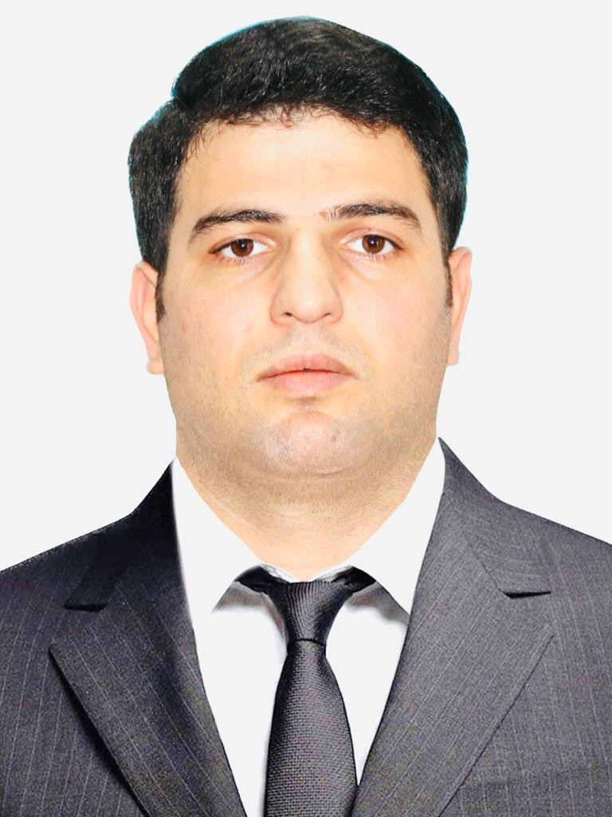
Main information
Position: | Chief engineer | Desired Type of Ship: | Any
Full Name: | GASHAM AMİRASLANOV | Date of birth: | 24.10.1989
Citizenship: | Azerbaijan | Place of birth: | Djalilabad, Azerbaijan
Phones: | +994775445004 | Country of residence: | Azerbaijan
E-mail address: | emiraslanovqesem015@gmail.com | City/ Address: | Djalilabad,Sabirabad

Passports / Smbk | # | Date of issue | Date of expire | Place of issue
Seaman's book | AZE018288 | 02.02.2019 | 02.02.2024 | Baku. AZE
International passport | C00290509 | 30.07.2014 | 29.07.2024 | MINISTRY OFINTERNAL AFFAIRS. AZE
Diplomas | # | Date of issue | Valid up | Place of issue
Rank | Chief engineer officer
Professional license | 000803/19 | 18.11.2019 | 18.11.2024 | Baku. AZE
Endorsement | 000803/19 | 25.09.2019 | 18.11.2024 | Baku. AZE
Certificates | # | Date of issue | Valid up | Place of issue
Proficiency in Survival craft and boats other than fast rescure boats | SL-3419-23 | 12.09.2023 | 12.09.2028 | Baku. AZE
International Safety Management Code | SP-3173-23 | 18.09.2023 | 18.09.2028 | Baku. AZE
STCW-78  Personal survival techniques:  Fire prevention and fire fighting:  elementary First aid:  personal safety and social: | SO-4857-23 | 25.09.2023 | 25.09.2028 | Baku. AZE
Crisis management and human behaviour training | SE-0191-20 | 09.10.2020 | 29.09.2025 | Baku. AZE
Engine resource management | ER-0300-20 | 18.12.2020 | 18.12.2025 | Baku. AZE
Advanced training for oil tanger cargo operations | SB-0103-23 | 31.03.2023 | 31.03.228 | Baku. AZE
Safe operation and maintenance of high woltage systems 1000 volts or more | DM-0232-23 | 06.09.2023 | 18.08.2028 | Baku. AZE
Medical First aid | SN-0442-23 | 14.03.223 | 10.03.2028 | Baku. AZE
Dangerous , hazardous and harmfull cargoes | SK-0392-22 | 30.06.2022 | 30.06.2027 | Baku. AZE
Training in advanced fire - fighting | SJ-0790-22 | 17.06.2022 | 17.06.2027 | Baku. AZE
+Training for seafarers with designated security duties | SH-2526-23 | 15.09.2023 | 15.09.2028 | Baku. AZE
Ship Security - related familiarization security-awareness training | SI-2972-23 | 11.09.2023 | 08.09.2028 | Baku. AZE
Advanced training for chemical tanker cargo  Operations | AS- |  |  | Baku.AZE
BASİC training and qualifications on oil and  Chemical tanker cargo operations | SA-0251-23 | 30.03.2023 | 28.03.2028 | Baku.AZE

Medicine | # | Date of issue | Valid up | Place of issue
Medical fitness certificate: | Seafarer’s polyclinic LLC | 13.06.2023 | 13.06.2024 | Unikal-A. MMC
Alco-drug certificate: | Seafarer’s polyclinic LLC | 13.06.2023 | 13.06.2024 | Unikal-A. MMC

Additional info
Education:  Bachelor 207-2011 |  |  |  | Knowledge of other languages:  ,Turkish, English
Specialty: Ship energetic equipments and their exploitation . |  |  |  | Computer skills: Windows, MS Office.
Sea experience (reverse order)
Position | Name | Type | Flag | DWT/  GTN | ME Type/kW | From - Till | Employer
Chief  engineer | Aghdam  IMO No.  9297826 | Ro-Ro Cargo (Vessel) | AZE | 5398 | 2x2000 KW | 25.12.2019 | ASCO
 |  |  |  |  |  | 12.06.2020 | ASCO
Chief  engineer | Mahmud Rahimov  IMO No. | DRY Cargo (Vessel) | AZE | 5400 | 2200 KW | 28.12.2020 | ASCO
 |  |  |  |  |  | 25.06.2021 | ASCO
Chief  engineer | Aghdam  IMO No.  9297826 | Ro-Ro Cargo (Vessel) | AZE | 5398 | 2x2000 KW | 14.12.2021 | ASCO
 |  |  |  |  |  | 20.06.2022 | ASCO
Chief  engineer | Ak Topcubaşov  IMO No.  8212570 | Ro-Ro Cargo (Vessel) | AZE | 3950 | 2x4500 KW | 15.12.2022 | ASCO
 |  |  |  |  |  | 05.04.2023 | ASCO
Chife  Engineer | Aghdam  IMO No.  9297826 | Ro-Ro Cargo (Vessel) | AZE | 5398 | 2x2000 KW | 01.06.2023 | ASCO
 |  |  |  |  |  | 01.09.2023 | ASCO
2rd Enginer | Aghdam  IMO No.  9297826 | Ro-Ro  Cargo  (Vessel) | AZE | 5985 | 2 x 2000 KW | 27.06.2019 | ASCO
 |  |  |  |  |  | 30.08.2019 | ASCO
2 rd engineer | Aghdam  İMO No 9297826 | Ro-Ro  Cargo vessel | AZE | 5985 | 2x2000  Kw | 24.07.2018 | ASCO
 |  |  |  |  |  | 20.01.2019 | ASCO
2rd  Engineer | Koroglu  IMO No  9347231 | Tanker | AZE | 7833 | 2x1620 KW | 18.10.2017 | ASCO
 |  |  |  |  |  | 01.03.2018 | ASCO
2 rd engineer | AK.ZARİFA ALİYEVA İMO No 9297838 | Ro- Ro  Cargo  (Vessel) | AZE | 5985 | 2x 2000  KW | 10.10.2016  10.04.2017 | ASCO

