CURRICULUM VITAE
PERSONAL DETAILS
Family name |  | GULİYEV |  |  | 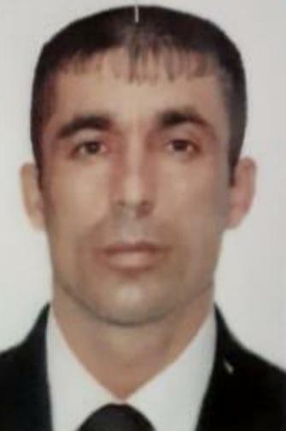
First name |  | RAMAN
Father’s name |  | FUAD
Date and place of birth |  | 08.04.1986 Azerbaijan
Nationality |  | Azerbaijani
Marital status |  | No
Permanent address |  | Azerbaijan, BAKU
Nearest airport |  | Heydar Aliyev International Airport Baku, Azerbaijan
Height (cm) | Weight (kg) | Eyes color | Hair color | Size of safety shoes | Size of coveralls
170 cm | 75 kg | BROWN | BLACK | 42 | 52
CONTACT DETAILS
Mobile | E-mail address
+994515075277
NEXT OF KIN (FOR EMERGENCY)
Next of kin |  | Relationship | Brother
Date of birth |  | Address | Baku,Azerbaijan
Phone |  | Mobile phone
TRAVEL PASSPORT DETAILS
Document | Number | Place of Issue | Issued | Valid
PASSPORT | P5477291 | Azerbaijan | 18.05.2023 | 17.05.2023
SEAMAN’S BOOK DETAILS
Document | Number | Place of Issue | Issued | Valid
Seaman book | DGK018371 | Azerbaijan ,Baku | 09.09.2021 | 09.09.2026
SEAARERS IDENTITY | AZE023292 | Azerbaijan ,Baku | 09.09.2021 | 09.09.2026
EDUCATION
Full name of School | Place of Issue | Grade/Class | From | To
Azerbajan Marine Akademiy | Azerbaijan , Baku | A/B 0413/22 | 03.03.2022
KNOWLEDGE OF LANGUAGES
Languages | Speaking | Reading | Writing
Azerbaijan | Excellent | Excellent | Excellent
Russian | Excellent | Excellent | Excellent
Turkish | Excellent | Excellent | Excellent
COMPUTER SKILLS
Windows | Microsoft Office | Internet
Excellent | Excellent | Excellent
MEDICAL INFORMATION
Document | Grade | Place of issue | Date of issue | Date of expiry
Med.Sertificate | A/B | Azerbaijan | 30.08.2021 | 30.08.2023
CERTIFICATE OF COMPETENCY
Class/Grade | Issuing country | Certificate No. | Date issued | Expires | Details of Limitations
AB SEAMAN | Azerbaijan Marine Administration | A/B 0413/22 | 03.03.2022 |  | A-II/4
STCW AND OTHER CERTIFICATES
Name of course/Certificate | Institute | Place | Date of issue | Cert.No | Date of expiry
International Safety Management | Azerbaijan Marine Adminstration | Azerbaijan Baku | 02.12.2021 | SP-2185-21 | 24.11.2026
Proficiency in survival craft and boats other than fast rescue boats | Azerbaijan Marine Adminstration | Azerbaijan Baku | 30.11.2021 | SL-2084-21 | 22.11.2026
Training for seafarers with designated security duties | Azerbaijan Marine Adminstration | Azerbaijan Baku | 23.06.2021 | SH-0475-21 | 23.06.2026
Basic safety trainig | Azerbaijan Marine Adminstration | Azerbaijan Baku | 26.11.2021 | S0-3129-21 | 26.11.2026
Ship Security-related familization security-awareness | Azerbaijan Marine Adminstration | Azerbaijan Baku | 24.11.2021 | SI-1476-21 | 18.11.2026
SEA EXPERIENCE (LAST 5 YEARS – MOST RECENT EXPERIENCE ON TOP LINE)
Vessel | Company | Type of vessel | Flag | DWT | GRT | BHP | Rank | Sign on | Sign off
MIKAYIL MUSHFIG | CASPIAN SHIPPING | GEN CARGO | AZERBAIJAN | 4150 | 3714 | 123.5 x 15.03 | SEAMAN  FİTER | 20.01.2020 | 15.07.2020
BAKI 357 | SAMAYE  SHIPPING | TANKER | AZERBAIJAN | 3280 | 2615 | 119.04 x 13.46 | SEAMAN  FİTER | 18.12.2020 | 21.06.2021
AMUR 2528 | DARYADALEN  SHIPPING | General Cargo | Russia | 3332 | 3086 | 116.03 x 13.43 | SEAMAN  FİTER | 15.08.2021 | 05.03.2022
ABSHERON | HAZRI SHIPPING | General cargo | Togo | 3344 | 2998 | 2×515 | BOATSWAIN | 06.05.2022 | 15.09.2022

