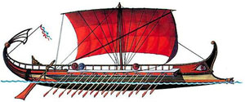

APPLICANT’S PERSONAL DATA

POSITION APPLIED FOR: DATE:
FIRST/LAST NAME :  HUSEYN HUSEYNOV | E-MAIL: hh4631835@gmail.com | 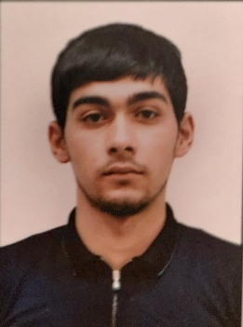
FATHER’S NAME :  ETIBAR HUSEYNOV | Mob.phone: +994514329588
DATE/PLACE OF BIRTH: 11.06.2001 SALYAN AZERBAIJAN | MARITAL STATUS : SINGLE
DATE/PLACE OF BIRTH: 11.06.2001 SALYAN AZERBAIJAN | NUMBER OF CHILDREN: N/A
CITIZENSHIP : AZERBAIJAN
ADDRESS : A.HESENOV BABAZANLI SALYAN Azerbaijan

MARINE EDUCATION RECE
NAME OF SCHOOL |  |  |  | FROM | TILL |  | TYPE OF DEGREE RECEIVED
MARITIME KOLLEGE “AZERBAYCAN DENIZCILIK KOLLEC” |  |  |  | 15.19.2016 | 15.06.2020 |  | $3^{rd}$ officer
DOCUMENTS |  | NO. |  |  | Place of issue |  |  | Date of issue/validity
SEAMAN’S PASSPORT |  | DQK 020142 |  |  | BAKU |  |  | 11.05.2022 / 11.05.2027
TRAVELLING PASSPORT |  | C03742202 |  |  | BAKU |  |  | 07.04.2022 / 06.04.2032
OTHER S/B
VISA USA
SERTIFICATE | GRADE |  | NO. |  |  | Place of issue |  |  | Date of issue/validity
NAT.LICENCE :  Certificate of Competency | ABLE SEAFER DECK 2/5 |  | RP11260 |  |  | BAKU |  |  | 28.04.2022
Traning for seafarers with designated security duties IMO Model Course 3.19 |  |  | SH-0284-22 |  |  | BAKU Azerbaijan |  |  | 04.03.2022 / 04.03.2027
Ship Security-related familiarization security awareness training IMO Model Course 3.27 |  |  | SI-0330-22 |  |  | BAKU Azerbaijan |  |  | 24.02.2022 / 21.01.2027
“Safety Familiarization Training”. Personal Survival Techniques”. IMO MODEL Courses 1.13,1.19,1.20,1.21 |  |  | SO-0701-22 |  |  | BAKU Azerbaijan |  |  | 22.02.2022 / 21.01.2027
Proficiency in survival craft and boats other than fast rescue boats |  |  | SL-0441-22 |  |  | BAKU Azerbaijan |  |  | 28.02.2022 /28.02.2027
International Safety Management Code |  |  | SP-0445-22 |  |  | BAKU Azerbaijan |  |  | 18.02.2022 / 25.01.2027

SIZES : ENGLISH:
CLOTHES | SHOES | HEIGHT | WEIGHT | POOR | SATISFACTORY | MODARATE | GOOD | EXELLENT
46 | 41 | 178 | 63 |  |  | YES
SEA-GOING SERVICE:

VESSEL’S NAME | COMPANY | FLAG | VSL’S TYPE | DWT | ENGIN | BHP | RANK | EMPLO  M/Y | MENT  M/Y
STARLET | EZE DENIZCILIK SIRKETI | ST VINCENT | DRY CARGO | 1500 | MAN |  | A/B SEAMEN | 11.07.2022 | 15.09.2022
LADY SEMA | GN GROUP | PANAMA | DRY CARGO | 16100 | MAN |  | A/B SEAMEN | 08.10.2022 | 04.06.2023

