CURRICULUM VITAE
PERSONAL DETAILS
Family name |  | BAGIROV |  |  | 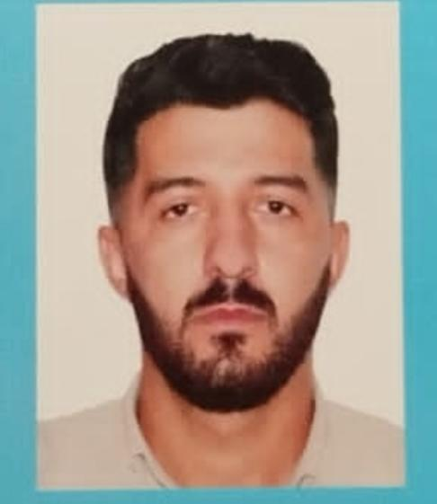
First name |  | EMIL
Father’s name |  | BALAYAR
Date and place of birth |  | 03.06.1998
Nationality |  | Azerbaijan
Marital status |  | Singl
Permanent address |  | Azerbaijan Siyazan
Nearest airport |  | Heydar Aliyev International Airport Baku, Azerbaijan
Height (cm) | Weight (kg) | Eyes color | Hair color | Size of safety shoes | Size of coveralls
1.70 cm | 74 kg | BROWN | BLACK | 42 | XL
CONTACT DETAILS
Mobile | E-mail address
+99451 512 94 23  Watcaap | Emil.98mail.ru@gmail.com
NEXT OF KIN (FOR EMERGENCY)
Next of kin | BAGHIROV BALAYAR | Relationship | FATHER
Phone | +99451 521 94 27 | Address | AZERBAIJAN Siyazan Hazi Aslanov str
TRAVEL PASSPORT DETAILS
Document | Number | Place of Issue | Issued | Valid
PASSPORT | C02698804 | Azerbaijan | 09.07.2019 | 08.07.2029
SEAMAN’S BOOK DETAILS
Document | Number | Place of Issue | Issued | Valid
Seaman book | DGK024311 | Azerbaijan ,Baku | 06.07.2023 | 06.07.2028
SEAARERS IDENTITY | AZE029182 | Azerbaijan ,Baku | 06.07.2023 | 06.07.2028
EDUCATION
Full name of School | Place of Issue | Grade/Class | From | To
ADDA AZERBAIJAN MARRINE COLLEGE | Azerbaijan , Baku | AA N-115050 electro technical raiting | 15.09.2014 | 05.07.2018
KNOWLEDGE OF LANGUAGE
Languages | Speaking | Reading | Writing
Azerbaijan | Excellent | excellent | Excellent
Turkish | Excellent | excellent | Excellent
English | Excellent | Excellemt | Excellent
COMPUTER SKILLS
Windows | Microsoft Office | Internet
Excellent | Excellent | Excellent
MEDICAL INFORMATION
Document | Grade | Place of issue | Date of issue | Date of expiry
Med.Sertificate | Electro technical raiting | Azerbaijan Baku | 08.05.2023 | 08.05.2025
CERTIFICATE OF COMPETENCY
Class/Grade | Issuing country | Certifikate | Date issued | Expires | Details of Limitations
Electro-technical raiting | Azerbaijan Marine Administration | No 1514-23  RP-13140 | 23.06.2023 | No limit | A-3/7
STCW AND OTHER CERTIFICATES
Name of course/Certificate | Institute | Place | RANK | Date of issue | Cert.No | Date of expiry
International Safety Managemen | Azerbaijan Marine Adminstration | Azerbaijan Baku | Rating forming part of a navigational watch | 19.05.2023 | SP-1507-23 | 11.05.2028
Proficiency in survival craft and boats other than fast rescue boats | Azerbaijan Marine Adminstration | Azerbaijan Baku | Rating forming part of a navigational watch | 15.05.2023 | SL-1660-23 | 15.05.2028
Training for seafarers with designated security duties | Azerbaijan Marine Adminstration | Azerbaijan Baku | Rating forming part of a navigationak watch | 17.05.2023 | SH-1179-23 | 17.05.2028
Basic safety trainig | Azerbaijan Marine Adminstration | Azerbaijan Baku | Rating forming part of a navigationak watch | 12.05.2023 | S0-2135-23 | 05.05.2028
Ship Security-related familization security-awareness | Azerbaijan Marine Adminstration | Azerbaijan Baku | Rating forming part of a navigational watch | 15.05.2023 | SI-1295-23 | 08.05.2028
SEA EXPERIENCE (LAST 5 YEARS – MOST RECENT EXPERIENCE ON TOP LINE)
Vessel | Company | Type of vessel | Flag | DWT | GRT | Rank | Sign on | Sign off

