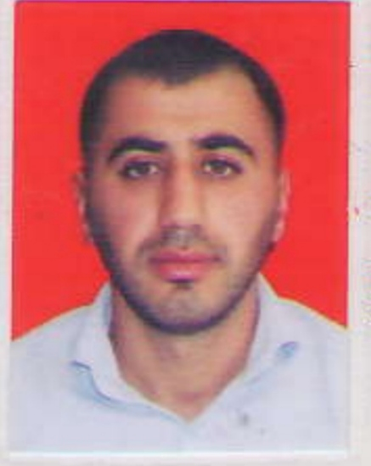

APPLICATION FORM

A | Z | E | 1 | 7 | 6 | 6 | 3 | 3 | 4 | 1
Personal ID Number

Position Applied for: able seaman | Date Available from: ANY TIME

1. Personal Data
Family Name:BABAYEV | First Name: FİRDOVSİ | Middle Name:
Date of Birth:25.08.1992 | Place of Birth (City and Country):Azerbaijan.Astara. | Citizenship: AZERBAIJANIAN
Permanent Address:Astara vil.Shiyakaran |  | Phone Mobile: +994514948935  E-mail: babayebfirdovsi@gmail.com

2. Maritime Education
Name of school | Town | Country | From | To | Type of degree or diploma
School number 1. | Astara | Azerbaijan | 1998 | 2009 | High school
“KASPIAN EDUCATION CENTER” MMC | Lankaran | Azerbaijan | 2022 | 2022 | SECONDARY EDUCATION

3. Professional Test
English Test Date | Name of Test
Professional Test Date | Name of Test
Professional Interview Date | Result

4. Family Details
Civil Status(Single, Married, Separated, Divorced, Widowed) :
Single
Next of Kin (the first emergency contact)  Rzayev İslam | Relationship:  Brother
Address of Residence Astara.Azerbaijan | Phone : +994508407333

 | Daughter | Son
Family Name
First Name
Date of Birth
City of living
Phone Numbers

5. Identity Documents
Document | Country | Number |  | Place of Issue |  | Issue Date | Expiry Date
Certificate of competency | Azerbaijan | RP12542 |  | Azerbaijan State Maritime Administration (SMA) |  | 24.02.2023 | 24.02.2028
Seaman's Book | Azerbaijan | AZE  027764 |  | Azerbaijan State Maritime Administration (SMA) |  | 04.03.2023 | 04.03.2028
Travel Passport | Azerbaijan | C02243934 |  | MIA |  | 24.12.2018 | 23.12.2028
Civil Passport | Azerbaijan | AZE17663341 |  | ASTARA RPSH |  | 16.03.2018 | 25.08.2027
6. Valid Visa
Country or Union |  |  | Type |  | Valid Until
N/A |  |  | N/A |  | N/A
N/A |  |  | N/A |  | N/A

7. Courses Attended and Certificates Obtained
Document | Number | Dates |  | Place
Document | Number | Issue | Expiry | Place

Certificate of Competency
Basic training and qualifications on oil and chemical tanker cargo operations | SA-0757-22 | 30.09.2022 | 30.09.2027 | Azerbaijan
Safe operation and maintenance of high voltage systems 1000 volts or more
Training for seafarers with designated security duties
Ship Security-related training and instruction
Engine resource management
Passenger safety,cargo safety and hull integrity training
Dangerous hazardous and harmfull cargoes
Inert Gas system
Advanced training for oil tanker cargo operations
Gas Analysers and Their Operation
Proficiency in Survival Craft and Rescue Boats | SL-2947-22 | 21.09.2022 | 19.09.2027 | Azerbaijan
Advanced Fire Fighting
Medical First Aid Training
Medical First Aid Training and Medical Care
Leadership and Teamwork
GMDSS General Operator
GMDSS Endorsement
Radar Observation & Plotting
Automatic Radar Plotting Aids Simulator (ARPA)
Bridge Team Management
Shiphandling& Maneuvering
Ship Security-related Training and instruction | SI-2219-22 | 15.09.2022 | 15.09.2027 | Azerbaijan
Operational Use of Electronik Chart Display and information Systems
Crowd management training
Crisis management and human behaviour training
Training and qualification for ro-ro passenger ship
International Safety Management Code | SP-2823-22 | 21.09.2022 | 21.09.2027 | Azerbaijan
Shıp Security Officer
Training for seafarers with designated security duties | SH-1890-22 | 23.09.2022 | 23.09.2027 | Azerbaijan
-personal survival techniques –fire prevention avdfire fighting –elementary first aid –personal safety and social responsibilities | SO-4225-22 | 14.09.2022 | 14.09.2027 | Azerbaijan

8. Physical Data
Height | 172 cm.
Weight | 72
Colour of Hair | Brown
Colour of Eyes | Brown
Boilersuit Size | M
Shoes Size | 43

9. Medical History | Yes | No
Have you ever signed off a ship due to medical reasons? |  | No
Did you undergo any medical operation in the past? |  | No
Have you consulted a doctor during the last 12 months for an illness/accident? |  | No
Do you have any health or disability problems now? |  | No

If yes, please give full details:

 | Passed: | Valid till:
International Medical Examination
Vaccination Against Yellow Fiver | N/A | N/A
Vaccination Against Diphtheria | N/A | N/A

10. References (please give name and address of your current or past employer) | Office remarks

Name of Company | Azerbaijan Caspian Shipping Company-
Name of person to contact
Address | Azerbaijan
Phone

11. Bank address for allotments
Beneficiary
Account No.
Name of Bank
Bank Address

12. Knowledge and experience | Yes | No
OCIMF vetting experience: |  | +
ISGOT knowledge: |  | +

13. I hereby declare that the above, including Medical History, is true
Place: | Date | Signature

14. For Office use only

15. Seagoing Experience

Name of vessel | Flag | Vessel’s Type | DWT | GRT | Manager or Owner | Rank | From d/m/y | To  d/m/y | Total  m/d
MV ANASTASIA | Palau | General cargo | 4041.41 | 2528 | Southern breeze shipping | Able seaman | 26.04.2023 | 07.11.2023 | 6M 12 days.

Total rank sea service: Total type of vessel sea service:
Rank |  |  | Type of vessel
Able seaman | 6 M 12days
 |  |  | General cargo | 1
Total | 6M 12 days |  | Total: | 1

