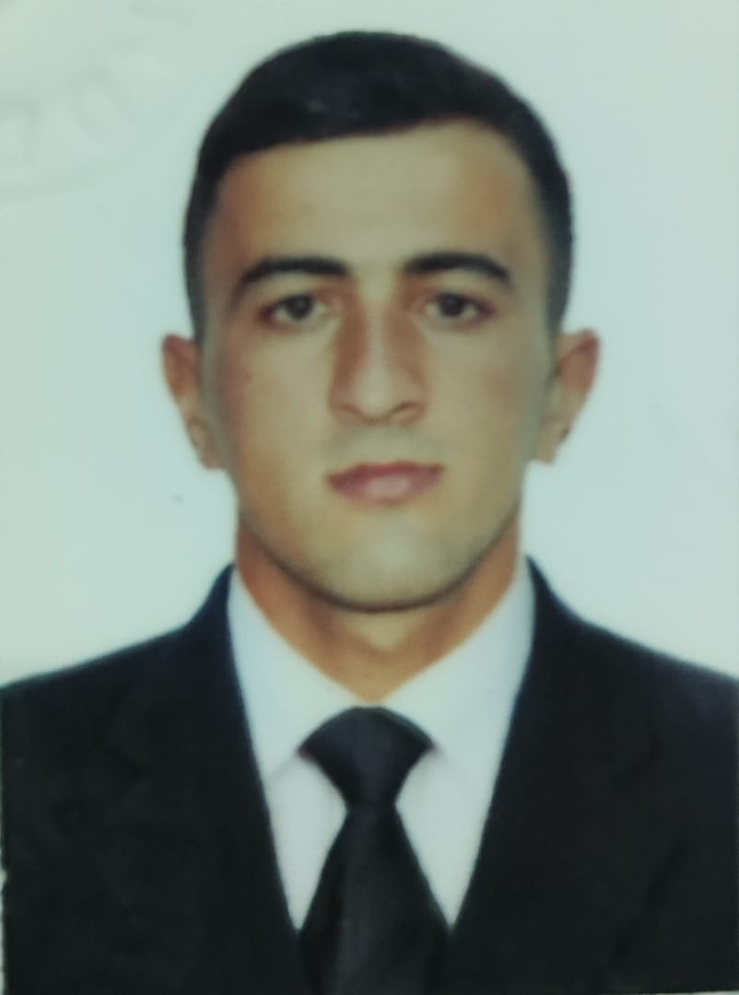
APPLICATION FORM

 |  |  |  |  | 7 | A | 5 | 5 | Q | S | Z
Personal ID Number

Position Applied for: ELECTRO-TECHNİCAL RATİNG (|||/7) | Date Available from:ANY TIME

1. PersonalData
Family Name: Mirzayev | First Name: Mirkalam | Middle Name:Mursal
Date of Birth:14.07.2000 | Place of Birth:Azerbaijan  Neftchala | Citizenship: Azerbaijani
Permanent Address: Azerbaijan/Neftchala |  | Phone (Home): +994507515787  Whatshapp +994507515787  E-mail: miragahesim@gmail.com

2. MaritimeEducation
Nameofschool | Town | Country | From | To | Type of degree or diploma
‘Azerbaijan Marine Academy’ | Baku | Azerbaijan | 2017 | 2021 | Bakalavr

3. ProfessionalTest
EnglishTest Date | Nameof Test | score
Professional TestDate | Nameof Test | Score
Professional Interview Date | Result

4. FamilyDetails
Civil Status (Single, Married, Separated, Divorced, Widowed) : Single

Next of Kin (the first emergency contact) : | Relationship /father
Address of Residence:  Azerbaijan/Neftchala | +994518693855

5. IdentityDocuments
Document | Country | Number | PlaceofIssue | IssueDate | ExpiryDate
Seaman'sBook | Azerbaijan | DQK 022656 | State Maritime Adminstration | 08.02.2023 | 08.02.2028
TravelPassport | Azerbaijan | C02676086 | Ministry of Internal Affairs | 29.06.2019 | 28.06.2029

6. ValidVisa
CountryorUnion | Type | ValidUntil

7. Courses Attended and Certificates Obtained
Document | Number | Dates |  | Place
Document | Number | Issue | Expiry | Place

CertificateofCompetency
MalteseEndorsementof COC
OilTankerEndorsement
ChemicalTankerEndorsement
GasTankerEndorsement
OilTankerFamiliarizationTraining
ChemicalTankerFamiliarizationTraining
GasTankerFamiliarizationTraining
OilTankersSpecializedTraining
ChemicalTankerSpecializedTraining
GasTankerSpecializedTraining
BasicTrainings | SO-0024-23 | 11.01.2023 | 11.01.2028 | State Maritime Administration
Proficiency in Survival Craft and Rescue Boats | SL-1542-21 | 14.09.2021 | 13.09.2026 | State Maritime Agency
AdvancedFireFighting
MedicalFirstAidTraining
Medical First Aid Training and Medical Care
GMDSS
GMDSS Endorsement
RadarObservation&Plotting
Automatic Radar Plotting Aids Simulator (ARPA)
BridgeTeamManagement
Shiphandling&Maneuvering
Ship Security-related familiarization security-awareness training | SI-0008-23 | 06.01.2023 | 06.01.2028 | State Maritime Administration
MalteseEndorsementof SSO
ISM Code | SP-3870-22 | 29.12.2022 | 29.12.2027 | State Maritime Administration
SafetyOfficer
ECDISTrainingCourse
RiskAssessmentCourse
C.O.W./ I.G.S
FirePracticeonTankers
VapourRecoverySystem
UnmannedMachinerySpace
FRAMO FamiliarizationCourse
Cargo Ballast Operations on Oil/Chemical Tankers
HazardousMaterials
Welder
Turner
Risk Management And Incident Investigation
Training of seafarers with designated security duties | SH-0811-21 | 09.09.2021 | 09.09.2026 | State Maritime Agency
Dangerous hazardous and harmfull cargoes
BasicTraining and qualifications on oil and chemical tanker cargo operations
Crowd management training

8. PhysicalData
Height | 178 sm
Weight | 76
ColourofHair | Black
ColourofEyes | Brown
BoilersuitSize | XL
ShoesSize | 42

9. MedicalHistory | Yes | No
Have you ever signed off a ship due to medical reasons?
Did you undergo any medical operation in the past?
Have you consulted a doctor during the last 12 months for an illness/accident?
Do you have any health or disability problems now?

If yes, please give full details:

 | Passed: | Validtill:
International Medical Examination | 22.09.2022 | 22.09.2024
Vaccination Against YellowFiver
Vaccination Against Diphtheria

10. References (please give name and address of your current or past employer) | Officeremarks

NameofCompany
Name of person to contact
Address
Phone

NameofCompany
Name of person to contact
Address
Phone

11. Bank address forallotments
Beneficiary
AccountNo.
NameofBank
BankAddress

12. Knowledgeandexperience | Yes | No
OCIMF vetting experience:
ISGOT knowledge:

13. I hereby declare that the above, including Medical History, is true
Place

14. ForOfficeuseonly

15. SeagoingExperience

Nameofvessel | Flag | Vessel’sType | DWT | EngType | HP | Manageror Owner | Rank | From d/m/y | Tod/m/y | Total  m/d
İsrafil Hüseynov | Azerbaijan | PLBH |  | Diesel |  | ASCO | practitioner | 01.09.3018 | 026.10.2018 | 1 m, 26d.
Sabit Orujov | Azerbaijan | Persons |  | Diesel |  | ASCO | Practitioner | 02.09.2019 | 25.10.2019 | 1m, 23d
Ak.Zarifa Aliyeva | Azerbaijan | Ro-Ro |  | Diesel |  | ASCO | Practitioner | 02.08.2020 | 26.10.2020 | 2 m, 24d
Zulfi Haciyev | Azerbaijan | Crane |  | Diesel |  | ASCO | Practitioner | 14.03.2021 | 25.05.2021 | 2 m, 11d
Suadiye | Panama | Cargo ship |  | Diesel |  | Cunda shipping LTD | Electrician | 10.12.2021 | 17.06.2022 | 6 m, 7d
Volzhskiy 33 | Comoros | Cargo ship |  | Diesel |  | Cunda shipping LTD | Electrician | 23.09.2022 | 17.12.2023 | 3 m,24d
Medar | Panama | Cargo ship |  | Diesel |  | Bro Maritime LTD | Electrician | 10.03.2023 | 09.09.2023 | 6 m,0d

Total rank sea service: Total type of vessel sea service:
Rank | Years |  | Typeofvessel | Years
Able seaman |  |  | OIL TANKER
 |  |  | LPG
 |  |  | DRY CARGO
 |  |  | TANKER ICE
 |  |  | OIL /CHEMICAL TANKER
 |  |  | FERRY
Total |  |  | Total:

