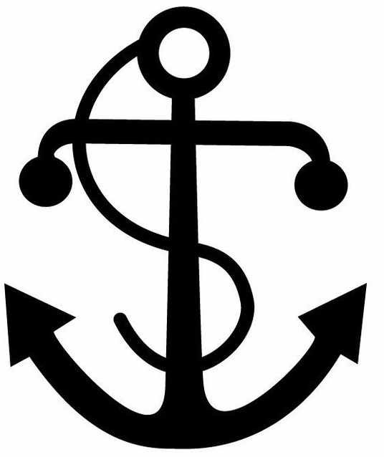

PERSONAL DETAILS

Family name |  | Qafari |  |  | 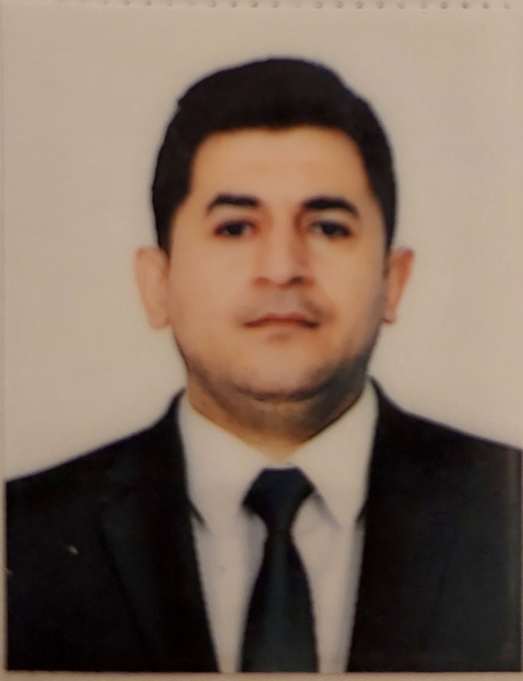
First name |  | Samir
Father’s name |  | Hicran
Date and place of birth |  | 21 APRİL 1993/Azerbaijan NEFTCHALA
Nationality |  | Azerbaijanian
Marital status |  | Married
Permanent address |  | Azerbaijan,SHİRVAN city
Nearest airport |  | Haydar Aliyev Airport/Baku, Azerbaijan
Height (cm) | Weight (kg) | Eye's color | Hair color | Size of safety shoes | Size of coveralls
172 | 72 | Brown | Brown | 43 | L
CONTACT DETAILS

Mobile | E-mail address
+994 50 515 9828 | Qafarisamir7@gmail.com
NEXT OF KIN IN CASE OF EMERGENCY

Next of kin | Qafari ARİF | Relationship | Uncle
Address | Shirvan, Azerbaijan
Mobile phone | +994 55 6518499
TRAVEL PASSPORT DETAILS

Document | Number | Place of Issue | Issued | Valid
National Travelling Passport | C 00871581 | Ministry of Internal Affairs of Azerbaijan Republic | 14.10.2015 | 13.10.2025
SEAMAN’S BOOK DETAILS

Document | Number | Place of Issue | Issued | Valid

National Seaman’s Book | DQK 022212 | Azerbaijan State Maritime Administration | 13.12.2022 | 13.12.2027
COMPUTER SKILLS

Windows | Microsoft Office | Internet | AutoCAD
Excellent | Excellent | Excellent | Null

EDUCATION

Full name of School | Place of Issue | Grade/Class | From | To
Azerbaijan State Marine Academy | Azerbaijan, Baku | Marine engineering (Bachelor’s degree) | 2011 | 2015
KNOWLEDGE OF LANGUAGES

Languages | Speaking | Reading | Writing
Azerbaijan | Native | Native | Native
Turkish | Good | Good | Good
English | Medium | Good | Good
Russian | Low | Medium | Medium
MEDICAL INFORMATION

Document | Grade | Place of issue | Last exam | Next exam
Seaman’s Medical Certificate | Health Certificate | Azerbaijan State Maritime Administration | 30.11.2022 | 30.11.2024
CERTIFICATE OF COMPETENCY

Class/Grade | Issuing country | Certificate  No. | Date issued | Valid until

2nd Engineer of Ship Powered by Main Propulsion Machinery 3000 kW Propulsion Power or More | Azerbaijan State Maritime Administration | 0006504 | 27.01.2022 | 27.01.2027
Endorsement | Azerbaijan State Maritime Administration | 000071/22 | 27.01.2022 | 27.01.2027

STCW AND OTHER CERTIFICATES

Name of course/ Certificate | Institute | Place | Date of issue | Cert. No | Date of expiry
Basic safety training | STCW | Azerbaijan | 17.01.2023 | № SO- 0196-23 | 17.01.2028
Ship Security-related familiarization security- awareness training | STCW | Azerbaijan | 28.11.2020 | № Sİ-0801- 20 | 28.11.2025
Proficiency in survival craft and boats other than fast rescue boats | STCW | Azerbaijan | 04.12.2020 | №SL -1191-20 | 04.12.2025
Training for seafarers with designated security duties | STCW | Azerbaijan | 19.02.2021 | № SH- 1719-23 | 13.07.2028
International Safety Management Code | STCW | Azerbaijan | 12.07.2023 | № SH-0085-21 | 19.02.2026
Training in Advanced Fire Fighting | STCW | Azerbaijan | 25.02.2021 | №  SJ-0114-21 | 25.02.2026
Leadership and Team Work | STCW | Azerbaijan | 13.08.2021 | №  DL-0752-21 | 12.08.2026
Engine Resource Management | STCW | Azerbaijan | 11.03.2021 | №  ER-0113-21 | 11.03.2026

Medical First Aid | STCW | Azerbaijan | 26.02.2021 | №  SN-0095- 21 | 26.02.2026
Refresher | STCW | Azerbaijan | 01.04.2021 | № YS-0057-21 | 01.04.2026
Passenger safety,cargo safety and hull integrity training  Crowd management  training  İnternational Safety  Management | STCW  STCW  STCW | Azerbaijan  Azerbaijan  Azerbaijan | 18.08.2021  25.08,2021  07.02.2023 | № SF-0041-21  № SC-0167-  21  № SP-0393-23 | 18.08.2026  25.08.2026  07.02.2028

SEA EXPERIENCE (MOST RECENT EXPERIENCE ON TOP LINE)

Vessel | Company | Type of vessel | DWD | Engine Power | Flag | Rank | Sign on | Sign off
Fikret A Amirov | "Azerbaij an Caspian Shipping " CJSC" | Ro-Ro | 6894 | 2000 kW | Azerbaijan | 3nd Engineer | 07.05.2019 | 05.10.2019
Gara Garayev | Azerbaijan Caspian Shipping CJSC | Ro-Ro | 6894 | 2000kW | Azerbaijan | 3nd  Engineer | 10.06.2020 | 27.10.2020
Azerbaijan | Azerbaijan Caspian Shipping CJSC | Ro-Ro | 5496 | 2000kW | Azerbaijan | 2nd Engineer | 10.07.2022 | 05.12.20  22
Azerbaijan | "Azerbaij an Caspian Shipping " CJSC" | Ro-Ro | 5496 | 2000 kW | Azerbaijan | 3rd Engineer | 07.05.2020 | 14.12.2020
Aerbaijan | "Azerbaij an Caspian Shipping " CJSC" | Ro-Ro | 5496 | 2000 kW | Azerbaijan | 2rd Engineer | 16.05.2021 | 20.10.2021
ZENGEZUR | "Azerbaij an Caspian Shipping " CJSC" | Oil Tanker | 13054 | 1620 kW | Azerbaijan | 3rd Engineer | 08.11.2021 | 14.04.2022
Heydar Aliyev | "Azerbaij an Caspian Shipping " CJSC" | Oil Tanker | 13054 | 1620 kW | Azerbaijan | Oiler | 17.03.19 | 15.07.19
Ak.Zarifa  Aliyeva | "Azerbaij an Caspian Shipping " CJSC" | Ro-Ro | 5496 | 2000W | Azerbaijan | 2 dr  Enginer | 03.10.18 | 28.12.18

Ali  Bayramov | "Azerbaij an Caspian Shipping " CJSC | General cargo | - | - | Azerbaija n | 2dr  Enginer | 26.01.18 | 28.02.18

