CURRICULUM VITAE
PERSONAL DETAILS
Family name |  | Aliyev |  |  | 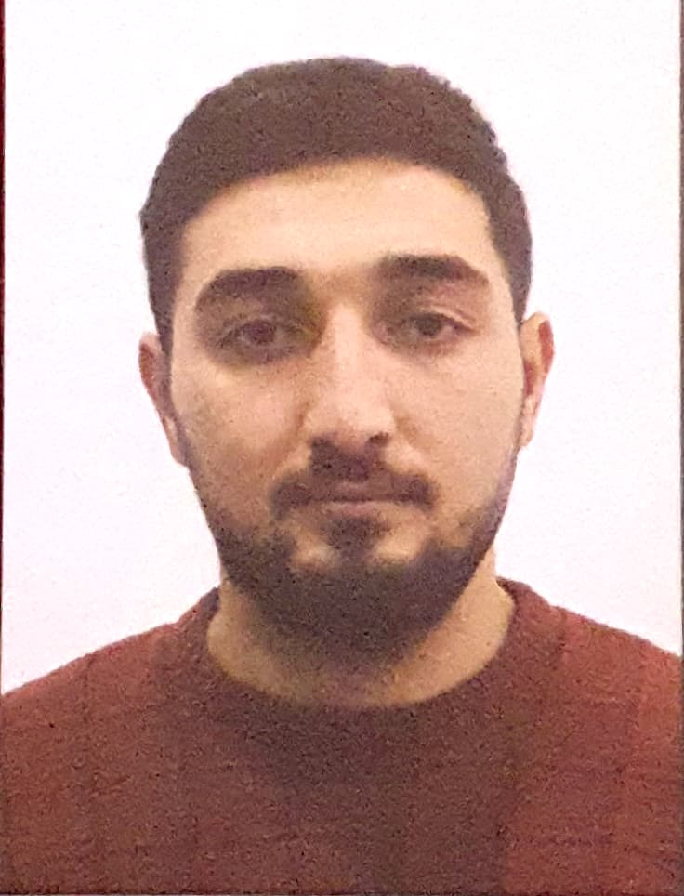
First name |  | Aqshin
Father’s name |  | Shahin
Date and place of birth |  | 12-Nov-1997
Nationality |  | Azerbaijani
Marital status |  | Married
Permanent address |  | Azerbaijan, BAKU
Nearest airport |  | Heydar Aliyev International Airport Baku, Azerbaijan
Height (cm) | Weight (kg) | Eyes color | Hair color | Size of safety shoes | Size of coveralls
180 | kg | BROWN | BLACK | 43 | 53
CONTACT DETAILS
Mobile | E-mail address
+994 55 276 52 42 | Aqshinaliyev1197@gmail.com
NEXT OF KIN (FOR EMERGENCY)
Next of kin | Aliyev Vugar | Relationship | Brother
Date of birth | 12.09.1990 | Address | Baku,Azerbaijan
Phone | +994703633535 | Mobile phone
TRAVEL PASSPORT DETAILS
Document | Number | Place of Issue | Issued | Valid
PASSPORT | C01672074 | Azerbaijan | 15/11/2017 | 14.11.2027
SEAMAN’S BOOK DETAILS
Document | Number | Place of Issue | Issued | Valid
Seaman book | DGK014067 | Azerbaijan ,Baku | 04.05.2019 | 04.05.2024
SEAARERS IDENTITY | AZE018931 | Azerbaijan ,Baku | 04/05/2019 | 04/05/2024
EDUCATION
Full name of School | Place of Issue | Grade/Class | From | To
Azerbaijan State Marine Academy | Azerbaijan , Baku | passed | 15-09-2018 | 15-07-2022
KNOWLEDGE OF LANGUAGES
Languages | Speaking | Reading | Writing
Azerbaijan | Excellent | Excellent | Excellent
Russian | Less than average | Less than average | Less than average
Turkish | Excellent | Excellent | Excellent
English | Less than average | Less than average | Less than average

COMPUTER SKILLS
Windows | Microsoft Office | Internet
Excellent | Excellent | Excellent
MEDICAL INFORMATION
Document | Grade | Place of issue | Date of issue | Date of expiry
Med.Sertificate | A/B | Azerbaijan | 10.01.2023 | 10.01.2025
CERTIFICATE OF COMPETENCY
Class/Grade | Issuing country | Certificate No. | Date issued | Expires | Details of Limitations
MOTORMAN | Azerbaijan Marine Administration | A/N 0981/21 | 18.11.2021
STCW AND OTHER CERTIFICATES
Name of course/Certificate | Institute | Place | Date of issue | Cert.No | Date of expiry
International Safety Management | Azerbaijan Marine Adminstration | Azerbaijan Baku | 05.05.2019 | SP-0650-19 | 22.04.2024
Proficiency in survival craft and boats other than fast rescue boats | Azerbaijan Marine Adminstration | Azerbaijan Baku | 09.01.2023 | SL-0009-23 | 09.01.2028
Training for seafarers with designated security duties | Azerbaijan Marine Adminstration | Azerbaijan Baku | 12.01.2023 | SH-0039-23 | 12.01.2028
Basic safety trainig | Azerbaijan Marine Adminstration | Azerbaijan Baku | 08.05.2019 | S0-1318-19 | 15.04.2024
Ship Security-related familization security-awareness | Azerbaijan Marine Adminstration | Azerbaijan Baku | 10.05.2019 | SI-1299-19 | 18.04.2024
Basic training and qualifications on oil and chemical tanker cargo operations | Azerbaijan Marine Adminstration | Azerbaijan  Baku | 05.01.2023 | SA-0012-23 | 05.01.2028

7. SEAFARERS SAILING RECORD

(LAST 5 YEARS)
NAME: | Aliyev Agshin |  |  | RANK: | OILER |  |  |  | DATE
VESSEL NAME |  | COMPANY NAME | VESSEL TYPE | ENG TYPE | G.R.T | BHP | RANK | SIGNED ON | SIGNED OFF
President Heydar Aliyev |  | Caspian Shipping Company | Oil Tanker | WARTSILA  9L20 | 13470T |  | Oiler | 01.09.2019 | 26.11.2019
Dagestan |  | Caspian Shipping Company | Ro-Ro | Wartsıla W12V26 | 11450T |  | Oiler | 03.08.2020 | 26.10.2020
Dagestan |  | Caspian Shipping Company | Ro-Ro | Wartsıla W12V26 | 11450T |  | Oiler | 29.06.2021 | 14.09.2021
Shahdag |  | Caspian Shipping Company | Ro-Ro | 5S26MC | 8547T |  | Oiler | 01.02.2022 | 27.05.2022
Lady Darya |  | GN Group | General Cargo | MAK 8M25 | 2999 |  | Oiler | 15.02.2023 | 17.09.2023

