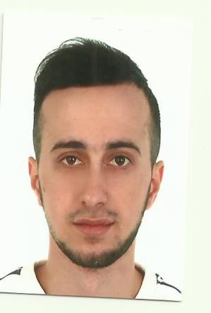

POSITION | SEAMAN | Readiness | +
LAST NAME | ALİYEV | Citizenship | Azerbaijan
FIRST NAME | ULVI | Marital status | single
BIRTH DATE | 19.01.1997 | Children
HOME ADDRESS | Baku,Azerbaijan | Nationality | Azerbaijani
ENGLISH LEVEL | B1 | Birth place | Azerbaijan
RUSSIAN LEVEL | A1 | Phone mobile | +994703819099
 |  | Email | ulvi.eliyev0119@gmail.com
EDUCATION
EDUCATIONAL  INSTITUTION | SPECIALITY | FACULTY | PLACE | FROM | TILL
Azerbaijan  Marine  College | ETO  (Electrician) | Marine | Baku | 15.09.2015 | 24.06.2020

Title | Class | Number | Place of issue | Issued | Valid
 |  | Passport
Seaman's book |  | DQK 021284 | BAKU, AZE | 09.09.2022 | 09.09.2027
Seafarers indetity document |  | AZE 026149 | BAKU,AZE | 09.09.2022 | 09.09.2027
 |  | Certificates
Basic Safety Training (VI/1.1-4) |  | SO-3638-22 | Baku, AZE | 09.08.2022 | 08.08.2027
Proficiency in Survival Craft (VI/2) |  | SL-2369-22 | Baku, AZE | 15.08.2022 | 15.08.2027
International Safety Management Code |  | SP-2382-22 | Baku, AZE | 11.08.2022 | 11.08.2027
Ship security-related familiarization security – awareness training (STCW code –A –VI/6, Pa  1 , Pa 4) |  | SI-1906-22 | Baku, AZE | 10.08.2022 | 09.08.2027
Training for seafarers with designated security duties (STCW Code A-VI/6 ,Pa 6 to Pa 8) |  | SH-1582-22 | Baku, AZE | 17.08.2022 | 17.08.2027
Medical Certificate |  |  | Baku, AZE | 01.08.2022 | 01.08.2027

Sea-going Experience (practice)
Vessel’s Name |  | Company | Position | On | Of
SABIT ORUCOV (practice) | CASPIAN SHIPPING |  | ELECTRICIAN | 15.04.2021 | 18.07.2021
AMUR 2528 | DARYADALAN |  | ELECTRICIAN | 08.02.2022 | 25.07.2022
ATLANTIS | SUENKA SHIP COMPANY |  | ELECTRICIAN | 27.01.2023 | 27.07.2023

