APPLICATION FORM

Position: | OILER | Citizenship: | 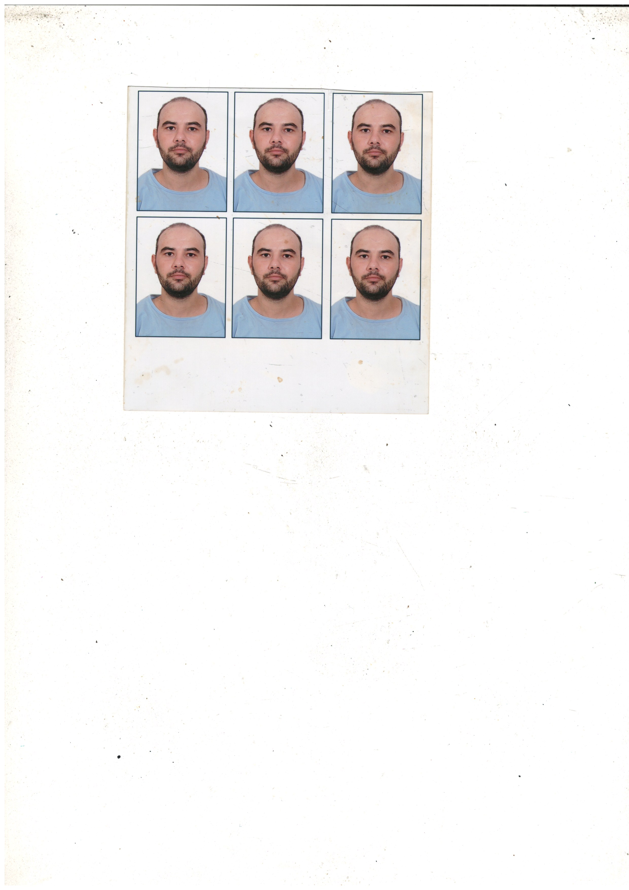  AZERBAİJAN
Last name: | MANSIMOV | Marital status | MARRIED
First name: | PARVIZ | Children:
Middle name: | ELSHAD | Nationality: | AZERBAİJAN
Birth date: | 16.05.1995 | Birth place: | AZERBAİJAN. NEFTCHALA
Home address: | AZERBAİJAN, NEFTCHALA | Phone mobile: | +994-50-764-65-16  Whats app
Home address: | AZERBAİJAN, NEFTCHALA | E-mail: | pervizmensimov1995  @gmail.com

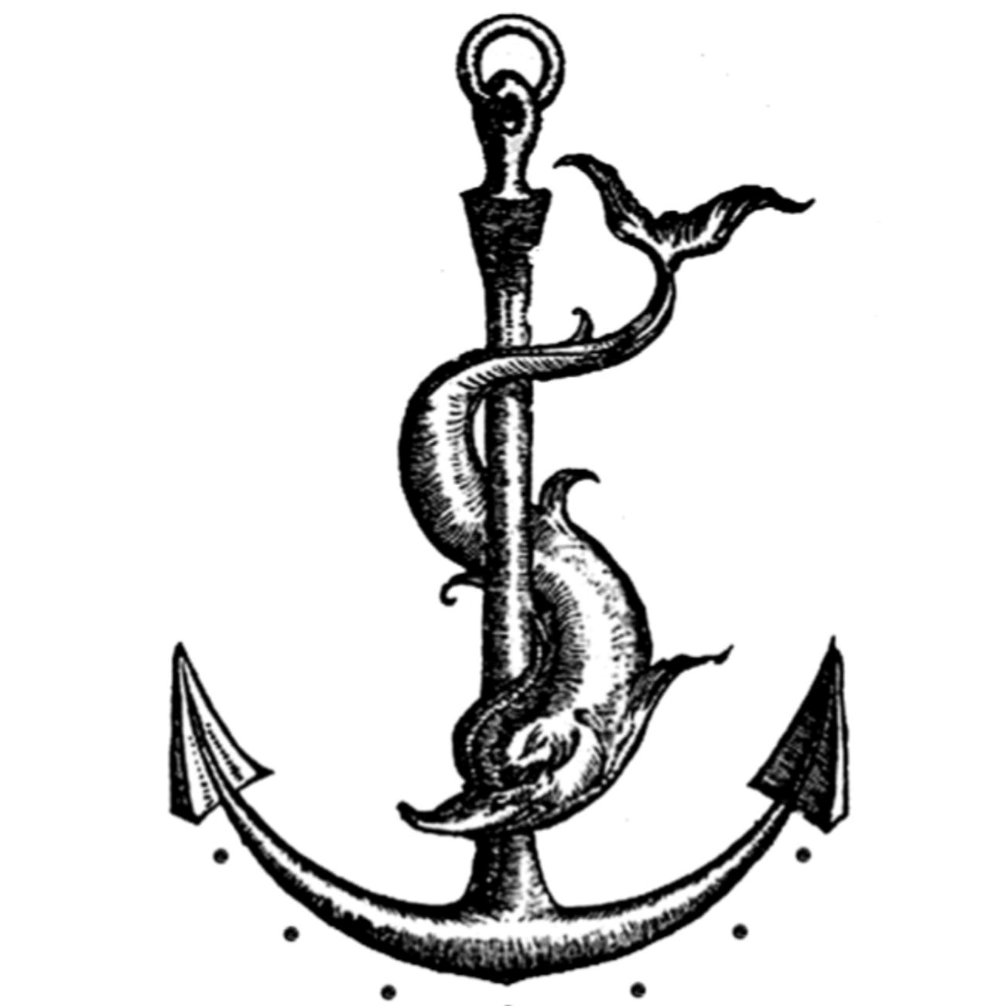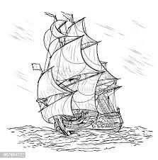Passports & Seaman’s Book

Title | Number | Place of issue | Issued | Valid
INTERNATIONAL PASSPORT | AZE C01304655 | Azerbaijan, Baku | 23.11.2016 | 22.11.2026
SEAMAN’S BOOK | DQK 023235 | Azerbaijan, Baku | 10.03.2023 | 10.03.2028
SEAFARERS İDENTITY DOCUMENT | AZE 028103 | Azerbaijan, Baku | 10.03.2023 | 10.03.2028

Diplom & Certificates

Title | Number | Place of issue | Issued | Valid
CERTIFICATE OF COMPETENCY.  RATING FORMING PART OF AN ENGINE- ROOM WATCH A-III/4 | № RP09744  0900/19 | Azerbaijan, Baku | 16.08.2022 | 16.08.2024
Has successfully completed following safety familiarization basic training and instruction for all seafarers courses which has been developed in accordance with the mandatory minimum requirements of Regulation VI/I of the international Convention STCW- 78.As amended and of the Section A-VI/I 0f STCW Code and on programmer approved by the State Maritime Administration:  -safety familiarization training  (STCW-78, A-VI/1 pa.1)  -personal survival techniques (STCW-78, A-VI/1 pa.2.1.1)  -fire prevention and fire fighting (STCW-78, A-VI/1 pa.2.1.2)  -elementary first aid  (STCW-78, A-VI/1 pa.2.1.3)  -personal safety and social responsibilities (STCW-78, A-VI/I pa.2.1.4) | № SO-0411-23 | Azerbaijan, Baku | 26.01.2023 | 25.01.2028

-Ship security –related familiarization security- awareness training  (STCW Code, A-VI/6,Pa.1 to Pa.4 ) | № SI-0271-23 | Azerbaijan, Baku | 26.01.2023 | 25.01.2028
Has successfully completed “INTERNATOINAL SAFETY MANAGEMENT CODE” course which has been developed in accordance with the requirements of Chapter IX of the International Convention SOLAS-74 ,as amended and International Safety Management Code and on programme approved by the State Maritime  Agency | № SP-0278-23 | Azerbaijan, Baku | 31.01.2023 | 31.03.2028
-Proficiency in survival craft and boats other than fast rescue boats  (STCW Code ,A-VI/2 Pa.1, Pa.2,Pa.3 and Pa.4) | № SL-0293-23 | Azerbaijan, Baku | 30.01.2023 | 30.01.2028
-Training for seafarers with designated security duties  (STCW Code , A-VI/6, Pa.6 to Pa.8 ) | № SH-0252-23 | Azerbaijan, Baku | 02.02.2023 | 02.02.2028
-Basic training and qualifications on oil and chemical tanker cargo operations  (STCW Code , A-V/1-1, Pa.1; IMO Model Course 1.01 ) | № SA-0088-23 | Azerbaijan, Baku | 07.02.2023 | 07.02.2028

Medical Information

Title | Number | Place of issue | Issued | Valid
-Extraction From Seafarers Medical Certificate |  | Azerbaijan, Baku | 03.08.2022 | 03.08.2024
-COVID -19 SINOVAC BUSTER Vaccination  4 th -Dose |  | Azerbaijan, Baku | 25.03.2022

Knowledge of other Languages

1.AZERBAIJAN | 2.TURKISH | 3.ENGLISH | 4. RUSSIAN
GOOD | GOOD | N/A | N/A

Biometrics

SEX : MALE | HEIGHT : 175 sm | OVERALL SIZE : L
EYES COLOR : BROWN | WEIGHT : 92 kg | SHOE SIZE : 43 sm

Next of Kin

Next of kin : | Brother | Kin phone : | +994-51-911-55-28 What’s app
Kin name, surname : | Mansımov Farhad | Kin address : | Azerbaijan, Baku

