APPLICATION FORM
Officer in charge of an engineering watch
Personal Data
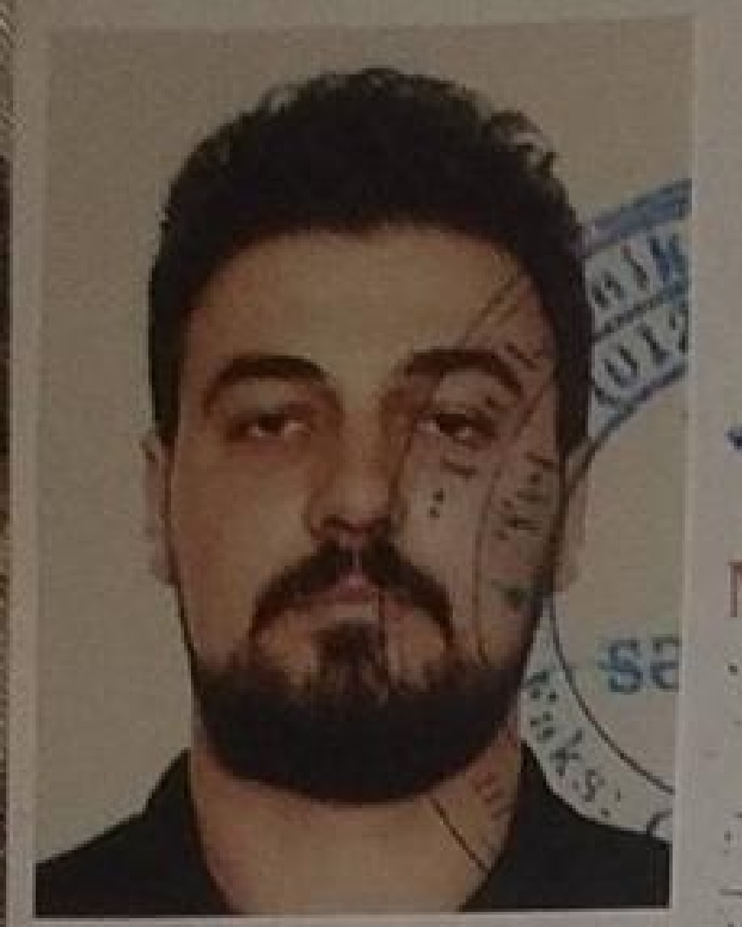

First name: Rustam
Second name: Karimli
Date of birth: 20.11.1998
Place of birth: Tartar/Azerbaijan
Nationality: Azerbaijani
Marital status: Single
Permanent address: Tartar/Azerbaijan

Phone: +994516084302

WhatsApp: +994516084302

Certificate | Number | Issued | Valid | Place of Issue
Certificate of Competency | 0007447 | 23.05.2022 | 23.05.2027 | Azerbaijan State Maritime Administration
International Safety Management Code | SP-0716-22 | 30.03.2022 | 30.03.2027 | Azerbaijan State Maritime Administration+
Ship Security-related familiarization security-awareness training | SI-0743-22 | 13.04.2022 | 08.04.2027 | Azerbaijan State Maritime Administration+
Security training for seafarers with designated security duties | SH-0184-21 | 02.04.2021 | 18.03.2026 | Azerbaijan State Maritime Administration+
Proficiency in survival craft and boats other than fast rescue boats | SL-0741-22 | 07.04.2022 | 07.04.2027 | Azerbaijan State Maritime Administration+
Engine resource managment | ER-0231-22 | 11.04.2022 | 11.04.2027 | Azerbaijan State Maritime Administration+
Leadership and Teamwork | DL-0604-22 | 15.04.2022 | 15.04.2027 | Azerbaijan State Maritime Administration+
(IMO Model Courses 1.13,1.19,1.20,1.21) | SO-12-86-22 | 31.03.2022 | 31.03.2027 | Azerbaijan State Maritime Administration+
Adavanced Training For Oil Tanker Cargo Operations |  | 17.02.2022 | 17.02.2027 | Nikolaev Centre of Training of Seafarers
Advanced Training for Chemical Tanker Cargo Operations |  | 17.10.2023 | 17.10.2028
TRAINING IN ADVANCED FIRE-FIGHTING | SJ-0340-22 | 05.04.2022 | 05.04.2027 | Azerbaijan State Maritime Administration
Medical First Aid Training | SN-0296-22 | 01.04.2022 | 01.04.2027 | Azerbaijan State Maritime Administration
Seaman record book | DQK 019933 | 21.04.2022 | 21.04.2027 | Azerbaijan State Maritime Administration
Passport | C02570668 | 13.05.2019 | 12.05.2029 | Azerbaijan State Maritime Administration
Certificate of medical |  | 19.10.2023 | 19.10.2025 | Azerbaijan republic ministry of health

Job Experience

Company & Owner | Vessel | Type of Vessel | Flag | DWT | GRT | BHP | Rank | Area of Operation | Type of ops | From | To
SEA PİONEER | T-MARE | Container | Panama | 6000 | 3893 | 4285 | 3 RD ENGİNEER | A-1,A-2,A-3 | Container | 24.01.2023 | 12.09.2023
FG GROUP | FG ARZU | G/Cargo | Panama | 3300 | 2200 | 1353 | 3 RD ENGİNEER | A-1,A-2,A-3 | Mix Cargo | 27.09.2022 | 30.12.2022
METILDA SHIPPING | ISTRA | Oıl Tanker | Russıa | 4500 | 2904 | 2x 536 | 3 RD ENGINEER | A-1, A-2, A-3 | OIL | 30.06.2022 | 24.09.2022
CUNDA SHIPPING | VOLGODON-79 | G/Cargo | Cameroon | 5765 | 3994 | 2X662 | 3 RD ENGINEER | A-1, A-2, A-3 | Mix Cargo | 09.08.2021 | 18.03.2022
Palmali shipping | Nakhchıvan | G/Cargo | Malta | 6933 | 5684 | 2x882 | Motorman | A-1, A-2, A-3 | Mix Cargo | 11.05.2020 | 01.11.2020
Palmali shipping | Sultan bey | G/Cargo | Malta | 6036 | 4109 | 1X7000 | Motorman | A-1, A-2, A-3 | Mix Cargo | 01.08.2019 | 01.02.2020
Asco | Bunkerovshik-6 | Tanker | Azerbaijan | 3389 | 1896 | 2x443 | motorman | A-1,A-2,A-3 | Oil | 22.07.2018 | 26.10.2018
Asco | Zengezur | Tanker | Azerbaijan | 13054 | 7834 | 2x1120 | motorman | A-1,A-2,A-3 | Oil | 22.06.2017 | 26.10.2017
Nationalities sailed with: South Korea, China,Singapore,Russia, Ukraine,Greece, Turkey, Israel, Bulgaria,Romania,Egypt,Livia,,Tunis

Languages: Fluent Moderate Basic

Azerbaijan x x
English x
Russian
Turkish x
Computer Skills
Advanced: Word,and Internet Explorer.

Date available: 01.12.2023

2nd Engineer Rustam Karimli

