CURRICULUM VITAE
PERSONAL DETAILS
Family name |  | AKHUNDOV |  |  | 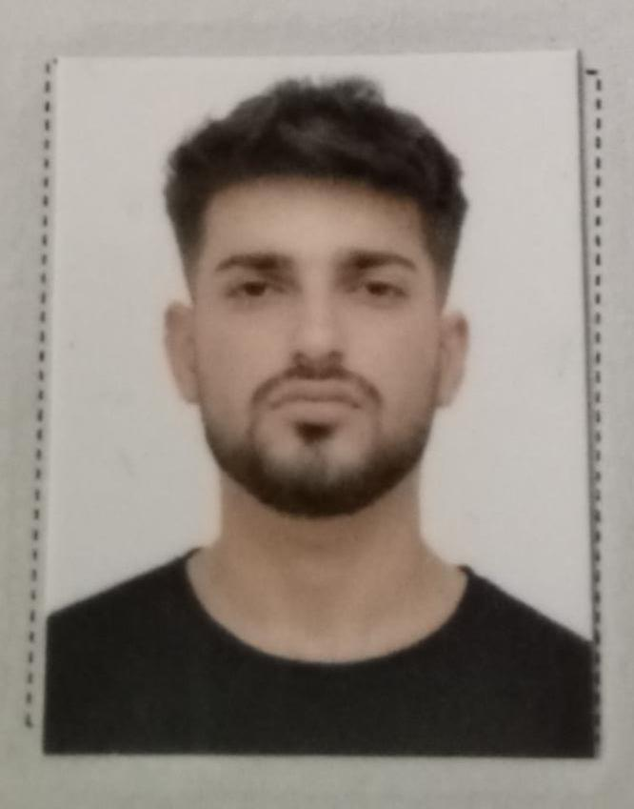
First name |  | ELBURUS
Father’s name |  | JEYHUN
Date and place of birth |  | 07.09.2003
Nationality |  | Azerbaijan
Marital status |  | Singl
Permanent address |  | Azerbaijan, Bilasuvar
Nearest airport |  | Heydar Aliyev International Airport Baku, Azerbaijan
Height (cm) | Weight (kg) | Eyes color | Hair color | Size of safety shoes | Size of coveralls
1.67 cm | 65 kg | BROWN | BLACK | 42 | XL
CONTACT DETAILS
Mobile | Gmail adrees
+99450 858 65 01  Whatsapp | elburusaxundov880@gmajl.com
NEXT OF KIN (FOR EMERGENCY)
Next of kin | AKHUNDOV FADAIL | Relationship | BROTHER
Phone | +99470 576 26 97 | Address | AZERBAIJAN Bilasuvar Aghalikand village
TRAVEL PASSPORT DETAILS
Document | Number | Place of Issue | Issued | Valid
PASSPORT | C03512648 | Azerbaijan Baku | 23.11 2023 | 22.11.2033
SEAMAN’S BOOK DETAILS
Document | Number | Place of Issue | Issued | Valid
Seaman book | DGK025748 | Azerbaijan ,Baku | 14.11.2023 | 14.11.2028
SEAARERS IDENTITY | AZE030620 | Azerbaijan ,Baku | 14.11.2023 | 14.11.2028
EDUCATION
Full name of School | Place of Issue | Grade/Class | From | To
Azerbaijan State Marrine Academy | Azerbaijan , Baku | AA N-178519  Oiler | 15.09.2019 | 31.05.2023
KNOWLEDGE OF LANGUAGE
Languages | Speaking | Reading | Writing
Azerbaijan | Excellent | excellent | Excellent
Turkish | Excellent | excellent | Excellent
Russia | Excellent | Excellent | Excellent
COMPUTER SKILLS
Windows | Microsoft Office | Internet
Excellent | Excellent | Excellent
MEDICAL INFORMATION
Document | Grade | Place of issue | Date of issue | Date of expiry
Medical Sertificate | Able seafarer engine | Azerbaijan Baku | 13.09..2023 | 13.09.2025
CERTIFICATE OF COMPETENCY
Class/Grade | Issuing country | Certifikate  No-2406-23 | Date issued | Expires | Details of Limitations
ABLE SEAFARER ENGINE | Azerbaijan Marine Administration | RP-13858 | 31.10.2023 | NO LIMIT | A-3/5 OILER
STCW AND OTHER CERTIFICATES
Name of course/Certificate | Institute | Place | Date of issue | RANK | Cert.No | Date of expiry
International Safety Managemen | Azerbaijan Marine Adminstration | Azerbaijan Baku | 24.01.2023 | OILER | SP-0190-23 | 24.01.2028
Proficiency in survival craft and boats other than fast rescue boats | Azerbaijan Marine Adminstration | Azerbaijan Baku | 18.09.2023 | OILER | SL-3508-23 | 06.09.2028
Training for seafarers with designated security duties | Azerbaijan Marine Adminstration | Azerbaijan Baku | 06.07.2023 | OILER | SH-1634-23 | 04.07.2028
Basic safety trainig | Azerbaijan Marine Adminstration | Azerbaijan Baku | 23.01.2023 | OILER | S0-0260-23 | 19.01.2028
Ship Security-related familization security-awareness | Azerbaijan Marine Adminstration | Azerbaijan Baku | 23.01.2023 | OILER | SI-0215-23 | 23.01.2028
SEA EXPERIENCE (LAST 5 YEARS – MOST RECENT EXPERIENCE ON TP LINE)
Vessel | Company | Type of vessel | Flag | DWT | BHB | Rank | Sign on | Sign off
MV SABIT ORUCOV | AXDG | PASSENGER SHIP | Azerbaijan | 2821 | 2855 Kw | Practitioner | 22 06.2021 | 30.08.2021
MV SABIT ORUCOV | AXDG | PASSENGER SHIP | Azerbaijan | 2821 | 2855 Kw | Practitioner | 09.02.2022 | 23.08.2022
MV GENERAL ESEDOV | AXDG | PASSENGER SHIP | Azerbaijan | 2621 | 2600 Kw | Practitioner | 01.03.2023 | 03.05.2023

