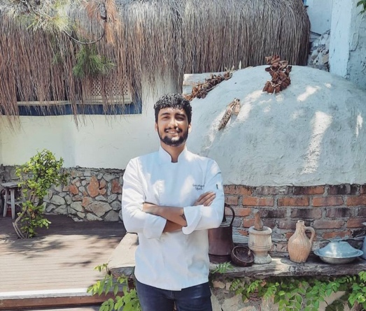

YOUR NAME : UĞUR FİLİZ. . 01.10.1994
JOB NAME : / head chef / Private chef / yatch chef
Address : TURKEY / MUĞLA / BODRUM
Tel : +905300447793
Email : ugurfiliz469@gmail.com
İNSTAGRAM / https://instagram.com/ugur_cheff?igshid=YmMyMTA2M2Y=
İNSTAGRAM / ugur_cheff

The trainings she received
- STCW
- ship health report
- Yatch cook
- Passport
- Gastronomy mastery 2020 Fatih sultan Mehmet university
- culinary mastery certificate MEB
- hygiene certificate MEB
- food safety MEB

cover letter
- hello i am ugur filiz

I've been working on culinary arts for 13 years, I worked and worked as a chef in the country's leading tourism brands. I generally worked on Mediterranean, Italian and Far East cuisines and improved myself. Cooking is a way of life for me. I am a person in love with my profession. Working with a presentation is my biggest fantasy in this profession, I'm sure the people who work with me will be happy, thank you

January 2013 - November 2013 Rixsos
- A la carte Turkish cuisine
- Demi chef
February 2014 - June 2014 Merit Casino
- A la carte greek cuisine
- Domi chef de parite
July 2014 - December 2015 Mandarin Oriantel
- Word cuisine a la carte
- Write a menu
- Cost control
- Chef de partie
January 2015 - October 2015 Hilton Istanbul
- Modern Turkish cuisine, indian cuisinee
- Cheef de partie
December 2015 - November 2016 Cape Bodrum Beach
- Italian cuisine
- Chef de partie

August 2017 – September 2020 Ramada by Wyndham
- Head chef / finedining
NOVAMBER 2020 / jaunary 2021 GERTURSAN HOTEL
- Head chef / finedining

APRİL 2021/ NOVAMBER 2021 / Perdue yacht 32 metre m/y charter

- Head chef
MARCH 2022 / NOVAMBER 2022/ Nirvana by the sea yacht 33 metre m/y

- Head chef
- high level service, we visited all the Mediterranean regions with foreign flags

ATLANTIKA YACHT 43 METRE CHARTER M/S

- Head chef

JADEM FISH AND WİNE january 2023
- CONSULTANT CHEF
- A place that serves fine dining with our world cuisine menu that we have created ourselves.

- Turkey golden chief of the year
- Modern Turkish cuisine golden medal
- Lamb cuisine golden medal

- NAME : VASFI BAL
- COMPANY : NİRVANA BY THE SEA
- TASK : Yacht CAPTAİN
- TELEPHONE : +905336686890
3.
- NAME : HÜSYİN CEYLEN
- COMPANY: DREAM
- TASK : HEAD CHEF
- TELEPHONE : +905530883720

