APPLICATION FORM |  |  | 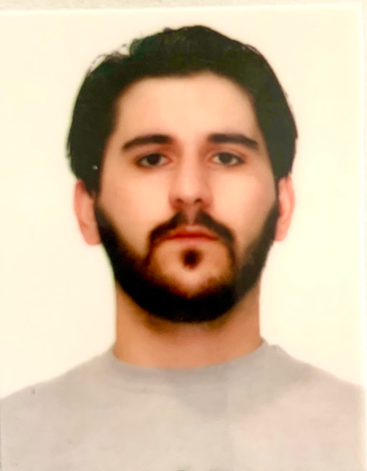
Position: | Officer | Desired Type of Ship: |  | General cargo vessel.
 |  | Available from: |  | January 2023
Full Name: | Aliyev Khan | Date of birth: |  | 05.03.1999
Citizenship: | Azerbaijan | Place of birth: |  | Baku,Azerbaijan
Home Phones: Mobile : | +994 55 814 39 42 | Country of residence: |  | Baku,Azerbaijan
E-mail adress: | xan.1999.barca@gmail.com | City: |  | Baku,Azerbaijan
Skype: | N/A | Full Address: |  | Absheron ds. Fatmayı vl.
English level: | Intermediate | USA visa valid up: |  | None

Passports / Smbk |  | № | Date of issue |  | Place of issue | Date of expire
Seaman's book |  | AZE024108 | 25.01.2022 |  | Azerbaijan, Baku | 25.01.2027
International passport |  | C02444563 | 30.11.2019 |  | Azerbaijan, Baku | 29.11.2029
Diplomas (COC) |  | № | Date of issue |  | Place of issue | Valid up
Rank |  | Officer in charge of a navigational watch certificate of competency
Professional license |  | 000271/22 | 10.03.2022 |  | Azerbaijan, Baku | 10.03.2027
Endorsement | Officer in charge of a navigational watch |  |  | Gmdss general operatir
Certificates |  | № | Date of issue |  | Place of issue | Valid up
International Management Safety Code |  | SP-0077-22 | 19.01.2022 |  | Azerbaijan, Baku | 19.01.2027
Proficiency in survival craft and boats other other than fast rescue boats |  | SL-2314-21 | 21.12.2021 |  | Azerbaijan, Baku | 21.12.2026
Safety familiarization training  Personal survival techniques  Fire prevention and fire fighting  Elementary first aid  Personal safety and social responsibilities |  | SO-3530-21 | 25.12.2021 |  | Azerbaijan, Baku | 25.12.2026
Ship Security related familiarization security awareness training |  | SI-0100-22 | 25.01.2022 |  | Azerbaijan, Baku | 17.01.2027
Training for seafarers with designated security duties |  | SH-0042-21 | 06.02.2021 |  | Azerbaijan, Baku | 04.02.2026
GMDSS General Operator |  | DQ-0304-19 | 11.07.2019 |  | Azerbaijan, Baku | 11.07.2024
Operational Use of Electronic Chart Display and Information Systems |  | SZ-0160-20 | 04.05.2020 |  | Azerbaijan, Baku | 21.01.2025
Radar navigation, radar plotting and use of ARPA |  | SR-0073-20 | 25.02.2020 |  | Azerbaijan, Baku | 07.01.2025
Bridge resource management |  | SW-0020-22 | 14.01.2022 |  | Azerbaijan, Baku | 14.01.2027
Leadership and Teamwork |  | DL-1336-21 | 16.12.2021 |  | Azerbaijan, Baku | 16.12.2026
Training in advanced fire-fighting |  | SJ-0011-22 | 11.01.2022 |  | Azerbaijan, Baku | 11.01.2027
Medical first aid |  | SN-0900-21 | 20.12.2021 |  | Azerbaijan, Baku | 20.12.2026

Sea service
Position | Name of Ship | Type of Ship | DWT | ME Type/kW | From - Till | Employer
2nd Officer | M/V İsik 2 | General Cargo | 6167 | MAN / 3840 | 11.04.2023  10.09.2023 | İsik Shipping LTD
2nd Officer | Volgo-balt 213 | General Cargo | 3492 | Skoda  2x515kwt | 27.04.2022  18.11.2022 | Orbital Shipmanagement  LTD
A/B | M/V Orion S | General Cargo | 6933 | Wartsila  6L20  2 * 1120 | 01.06.2021  05.12.2021 | ORAS SHIPPING CO LTD
A/B | M/V Ilyas Efendiyev | General Cargo | 6933 | Wartsila  6L20  2 * 1120 | 15.06.2020  15.08.2020 | PALMALI SHIPPING CO LTD
Cadet | Lankaran | AHTS | 3000 | 2 x 8000 BHP MAN | 13.07.2019  31.08.2019 | CASPIAN  MARINE  SERVICES
Cadet | Ehram Khaligov | AHTS | 1393 | 2 x 2650 | 03.08.2018  25.10.2018 | ASCO  XDND
Cadet | Ak. Zarifa Aliyeva | Ferries | 5985 | 2 x 200 | 22.06.2017  25.10.2017 | ASCO  DND

Education: Higher education |  | Knowledge of other languages: Turkey(excelent),English(very well)
Specialty: OFFICER |  | Lathe machine skills: NO
Second (relative) specialty: NO |  | Welding skills: NO
Next of kin: Brother |  | Phone: +994 77 520 66 17
Name, Surname: Aliyev Farid |  | Address: Absheron ds. Fatmayı vl.
Biometrical data
Sex: Male | Height: 182 |  | Overall size: L
Eyes color: Black | Weight: 100 |  | Shoe size: 43

