Cv Form
PERSONAL DETAILS
Family name |  | Jabrayilzade |  |  | 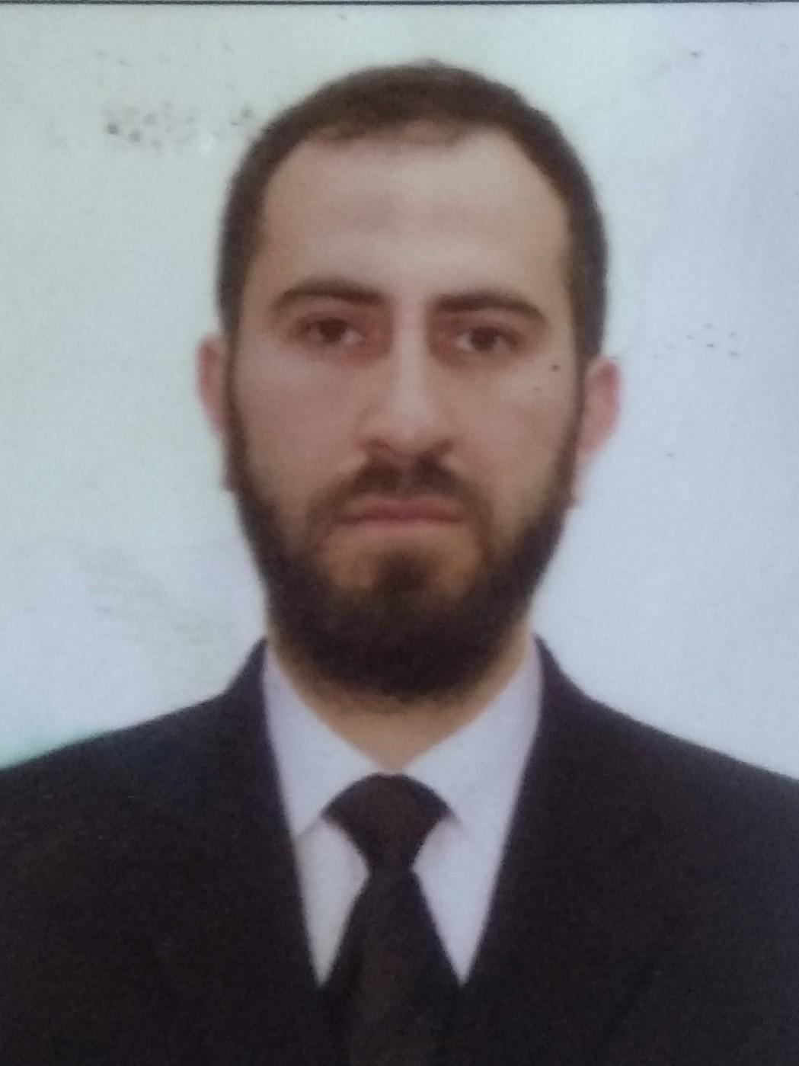
First name |  | Nurlan
Father’s name |  | Abdul
Date and place of birth |  | 28.02.1994 Azerbaijan,Quba
Nationality |  | Azerbaijanian
Marital status
Permanent address
Nearest airport
Height (cm) | Weight (kg) | Eyes color | Hair color | Size of safety shoes | Size of coveralls
1.73 cm | 70 kg | Mix | Black | 42 | L
CONTACT DETAILS
Mobile | E-mail address
(+994)70-515-16-97 | nurlancebrayilzade@mail.ru
NEXT OF KIN (FOR EMERGENCY)
Next of kin | Jabrayilzade Abdul | Relationship | Father’s
Phone | (+994)50-785-19-20 | Address | Azerbaijan,Quba
TRAVEL PASSPORT DETAILS
Document | Number | Place of Issue | Issued | Valid
Republic of Azerbaijan pasport | C02885724 | Azerbaijan | 04.11.2019 | 03.11.2029
SEAMAN’S BOOK DETAILS
Document | Number | Place of Issue | Issued | Valid
Seaman’s record book | 015289 | State Maritime and Port Agency | 26.10.2019 | 26.10.2024
Seafarer’s identity document | AZE020197 | State Maritime and Port Agency | 26.10.2019 | 26.10.2024
EDUCATION
Full name of School | Place of Issue | Grade/Class | From | To
Azerbaijan State Marine Academy,State marine collec | Azerbaijan,Baki | Subbakalavr | 15.09.2009 | 15.04.2013
KNOWLEDGE OF LANGUAGE
Languages | Speaking | Reading | Writing
Azerbaijan | Excellent | Excellent | Excellent
Turkish | Good | Good | Good
Russia | None | None | Good
English | Good | Good | Good
COMPUTER SKILLS
Windows | Microsoft Office | Internet
Excellent | Excellent | Excellent
MEDICAL INFORMATION
Document | Grade | Place of issue | Date of issue | Date of expiry
Seafarer’s medical |  | Customs Hospital | 01.02.2023 | 01.02.2024
CERTIFICATE OF COMPETENCY
Class/Grade | Issuing country | Certificate | Date issued | Expires | Details of Limitations
II/1 | Azerbaijan | Officer in Charge of Navigational Watch Certificate of Competency | 02.06.2023 | 02.06.2028 | None
STCW AND OTHER CERTIFICATES
Name of course/Certificate | Institute | Place | Date of issue | RANK | Cert.No | Date of expiry
International Safety Management | Azerbaijan State Maritime and Port Agency | Azerbaijan Baku | 03.09.2029 | Officer in charge of a navigational watch | SP-1273-19 | 03.09.2024
Proficiency in survival craft and boats other than fast rescue boats | Azerbaijan State Maritime and Port Agency | Azerbaijan Baku | 12.09.2019 | Officer in charge of a navigational watch | SL-1108-19 | 12.09.2024
Training for seafarers with designated security duties | Azerbaijan State Maritime and Port Agency | Azerbaijan Baku | 28.08.2019 | Officer in charge of a navigational watch | SH-1176-19 | 28.08.2024
Basic safety training | Azerbaijan State Maritime and Port Agency | Azerbaijan Baku | 23.08.2019 | Officer in charge of a navigational watch | SO-2037-19 | 23.08.2024
Ship Security-related familiarisation security-awareness | Azerbaijan State Maritime and Port Agency | Azerbaijan Baku | 16.08.2019 | Officer in charge of a navigational watch | SI-1981-19 | 15.08.2024
Leadership and Teamwork | Azerbaijan State Maritime and Port Agency | Azerbaijan Baku | 04.07.2022 | Officer in charge of a navigational watch | DL-1025-22 | 30.06.2027
Operational Use of Electronic Chart Display and Information | Azerbaijan State Maritime and Port Agency | Azerbaijan Baku | 01.09.2023 | Officer in charge of a navigational watch | SZ-0471-22 | 31.08.2027
Training in advanced fire-fighting | Azerbaijan State Maritime and Port Agency | Azerbaijan Baku | 10.10.2022 | Officer in charge of a navigational watch | SJ-1420-22 | 10.10.2027
Medical First Aid | Azerbaijan State Maritime and Port Agency | Azerbaijan Baku | 20.10.2022 | Officer in charge of a navigational watch | SN-1367-22 | 20.10.2027
Crowd management training | Azerbaijan State Maritime and Port Agency | Azerbaijan Baku | 25.10.2022 | Officer in charge of a navigational watch | SE-0119-22 | 25.10.2027
GMDSS General Operator | Azerbaijan State Maritime and Port Agency | Azerbaijan Baku | 24.02.2023 | Officer in charge of a navigational watch | DQ-0154-23 | 24.02.2028
Radar ARPA,bridge teamwork and search and rescue (Management Level) | Azerbaijan State Maritime and Port Agency | Azerbaijan Baku | 09.03.2023 | Officer in charge of a navigational watch | SQ-0128-24 | 09.03.2028
Bridge Resource Management | Azerbaijan State Maritime and Port Agency | Azerbaijan Baku | 04.05.2023 | Officer in charge of a navigational watch | SW-0186-23 | 01.05.2028
SEA EXPERIENCE (LAST 5 YEARS – MOST RECENT EXPERIENCE ON TP LINE)
Vessel | Company | Type of vessel | Flag | DWT | GRT | Rank | Sign on | Sign off
General Asadov | ASCO | Passenger vessel | Azerbaijan | 549 | 2621 | Able seafarer deck | 31.05.2010 | 10.09.2010
General Asadov | ASCO | Passenger vessel | Azerbaijan | 549 | 2621 | Able seafarer deck | 31.05.2011 | 15.09.2012
MPK-459 | ASCO | Passenger vessel | Azerbaijan | 35 | 280 | Able seafarer deck | 15.03.2021 | 01.11.2022
Atlet -8 | ASCO | Crane ship | Azerbaijan | 457 | 1384 | Able seafarer deck | 01.11.2022 | 01.12.2022
Zulfi Hajiyev | ASCO | Crane ship | Azerbaijan | 1392 | 2700 | Able seafarer deck and 3 rd officer | 01.12.2022 | 01.11.2023
Xazar -3 | ASCO | Tanker ship | Azerbaijan | 235 | - 4455 | Chief Officer | 01.11.2023 | 01.12.2023

