CURRICULUM VITAE
PERSONAL DETAILS
Family name |  | MEHDIZADA |  |  | 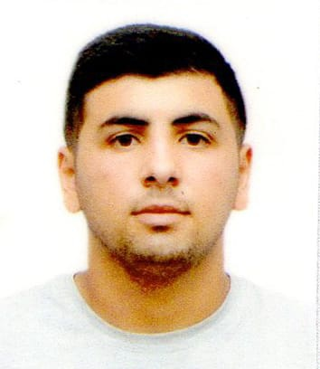
First name |  | RAHIB
Father’s name |  | VAGIF
Date and place of birth |  | 19.12.2003 Azerbaijan
Nationality |  | Azerbaijani
Marital status |  | No
Permanent address |  | Azerbaijan, BAKU
Nearest airport |  | Heydar Aliyev International Airport Baku, Azerbaijan
Height (cm) | Weight (kg) | Eyes color | Hair color | Size of safety shoes | Size of coveralls
160 cm | 86 kg | BROWN | BLACK | 42 | 48
CONTACT DETAILS
Mobile | E-mail address
+994515949167
NEXT OF KIN (FOR EMERGENCY)
Next of kin |  | Relationship | Brother
Date of birth |  | Address | Baku,Azerbaijan
Phone |  | Mobile phone
TRAVEL PASSPORT DETAILS
Document | Number | Place of Issue | Issued | Valid
PASSPORT | C02606297 | Azerbaijan | 10.01.2021 | 10.01.2028
SEAMAN’S BOOK DETAILS
Document | Number | Place of Issue | Issued | Valid
Seaman book | DGK021265 | Azerbaijan ,Baku | 09.09.2022 | 09.09.2027
SEAARERS IDENTITY | AZE026130 | Azerbaijan ,Baku | 09.09.2022 | 09.09.2027
EDUCATION
Full name of School | Place of Issue | Grade/Class | From | To
Azerbajan Marine Akademiy | Azerbaijan , Baku | 0454/23 | 14.02.2023
KNOWLEDGE OF LANGUAGES
Languages | Speaking | Reading | Writing
Azerbaijan | Excellent | Excellent | Excellent
Russian | Excellent | Excellent | Excellent
Turkish | Excellent | Excellent | Excellent

COMPUTER SKILLS
Windows | Microsoft Office | Internet
Excellent | Excellent | Excellent
MEDICAL INFORMATION
Document | Grade | Place of issue | Date of issue | Date of expiry
Med.Sertificate | A/B | Azerbaijan | 22.07.2022 | 22.07.2024
CERTIFICATE OF COMPETENCY
Class/Grade | Issuing country | Certificate No. | Date issued | Expires | Details of Limitations
MOTORMAN | Azerbaijan Marine Administration | 0454/23 | 14.02.2023 |  | A-III4
STCW AND OTHER CERTIFICATES
Name of course/Certificate | Institute | Place | Date of issue | Cert.No | Date of expiry
International Safety Management | Azerbaijan Marine Adminstration | Azerbaijan Baku | 03.08.2022 | SP-2346-22 | 03.08.2027
Proficiency in survival craft and boats other than fast rescue boats | Azerbaijan Marine Adminstration | Azerbaijan Baku | 17.08.2022 | SL-2410-22 | 17.08.2027
Training for seafarers with designated security duties | Azerbaijan Marine Adminstration | Azerbaijan Baku | 17.02.2023 | SH-0311-23 | 17.02.2028
Basic safety trainig | Azerbaijan Marine Adminstration | Azerbaijan Baku | 09.08.2022 | S0-3623-22 | 08.08.2027
Ship Security-related familization security-awareness | Azerbaijan Marine Adminstration | Azerbaijan Baku | 11.08.2022 | SI-1939-22 | 11.08.2027
SEA EXPERIENCE (LAST 5 YEARS – MOST RECENT EXPERIENCE ON TOP LINE)
Vessel | Company | Type of vessel | Flag | DWT | GRT | BHP | Rank | Sign on | Sign off
AMUR 2528 | RN GROUP | General Cargo | Russia [RU] | 3332 | 3086 | 116.03 x 13.43 | MOTORMAN | 11.08.2021 | 15.02.2022
DELPHINUS | KOLYONCU SHIPPING | Container Ship | Cameroon | 6912 | 5730 | 121.81 x 19.24 | MOTORMAN | 04.04.2023 | 20.10.2023

