APPLICATION FORM |  |  |  | 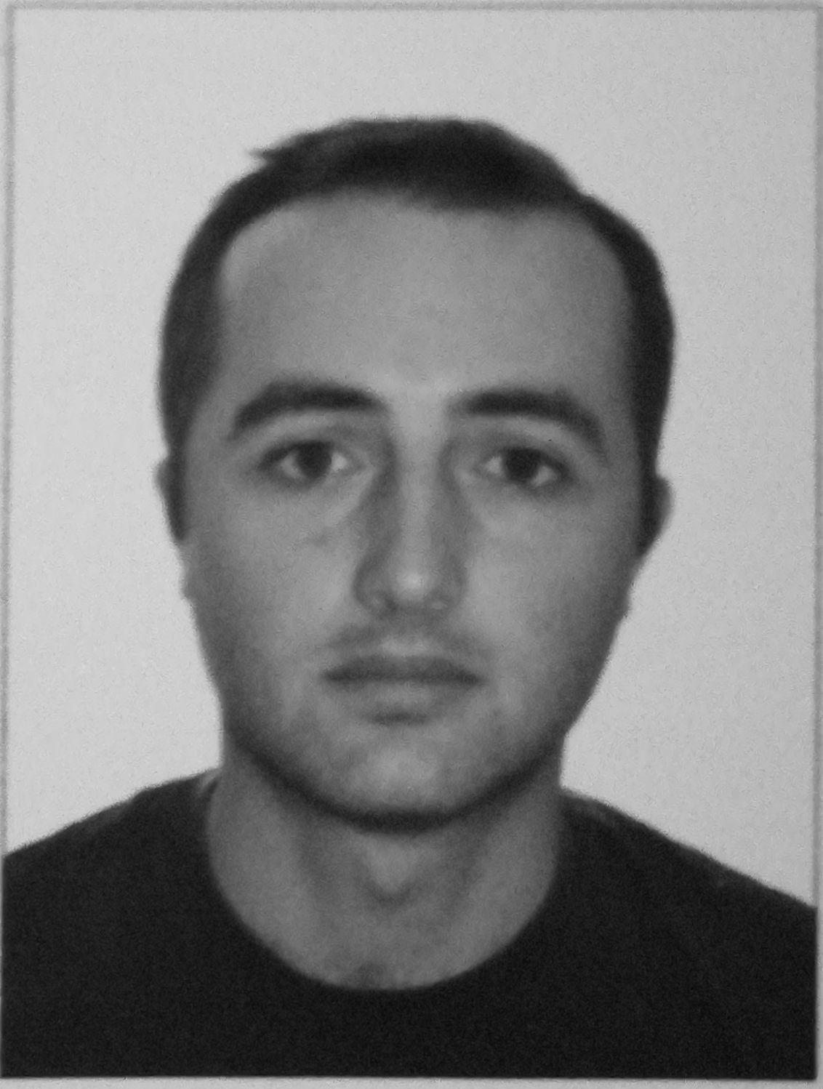
MAIN INFORMATION
POSITION: | CHIEF OFFICER | DSIRED TYPE of Ship: | AHTS/ TUG BOAT/ASD/BULK
Full Name: | RODAM PUTKARADZE | Date of birth: | 08.08.1989
CITIZENSHIP: | GEORGIAN | Place of birth: | GEORGIA / BATUMI
PHONES: | +995558474601/WhatsApp | COUNTRY of residence: | TBILISI
E-MAIL ADRESS: | putkaradzerodam26@gmail.com | CITY: | BATUMI

PASSPORT / SMBK | № | DATE OF ISSUE | PLACE OF ISSUE | Date of expire
SEAMAN'S BOOK | SOO4949 | 03.10.2022 | GEORGIA | 30.09.2032
INTERNATIONAL PASSPORT | 17AA13222 | 12.02.2018 | GEORGIA | 12.02.2028
DIPLOMAS | № | DATE OF ISSUE | PLASE OF ISSUE | VALID UP
RANK | CHIEF OFFICER
PROFESSIONAL LICENSE | 22G02-04-006939 | 01.03.2022 | GEORGIA | 01.03.2027
ENDORSMENT NO | 22G02-04-006939-01 | 01.03.2022 | GEORGIA | 01.03.2027
CERTIFICATES | № | DATE OF ISSUE | PLASE OF ISSUE | VALID UP
GMDSS general operator | 17G09-23-002366-02 | 14.09.2022 | GEORGIA | 09.09.2027
GMDSS ENDORSMENT | 1301005567 | 14.09.2022 | GEORGIA | 09.09.2027
ADVANCED FIRE FIGHTING | AFT01-170512 | 20.09.2022 | GEORGIA | 18.09.2027
MEDICAL Care | MFC01-153773 | 24.01.2022 | GEORGOA | 21.01.2027
Proficiency in Survival craft | FRB01-170514 | 20.09.2022 | GEORGIA | 19.07.2027
Security Awareness Training | SEC01-170513 | 20.09.2022 | GEORGIA | 01.09.2027
Ship Security Officer | SSO02-188823 | 11.05.2023 | GEORGIA | 26.04.2028
training for seafarers designated security duties | SEC01-125379 | 06.08.2020 | GEORGIA | 05.08.2025
PERSONAL SURVIVAL TECHNIQUES | BST01-171021 | 30.09.2022 | GEORGIA | 29.09.2027
ELEMENTARI FIRST AID | BST01-171021 | 30.09.2022 | GEORGIA | 29.09.2027
PERSONAL SAFETY AND SOCIAL RESPONSIBILITIES | BST01-171021 | 30.09.2022 | GEORGIA | 29.09.2027
FIRE Prevention And Firefighting | BST01-171021 | 30.09.2022 | GEORGIA | 29.09.2027
FURUNO ECDIS CERTIFICATE | 2021-03963 | 25.05.2021 | Course NO | FEC2014-001
USE OF Electronic Chart Display and information systems (ECDIS) | ECS02-168734 | 26.08.2022 | GEORGIA | 19.08.2027
RADAR MANAGEMENT RADAR PLOTTING AND USE OF ARPA | RB S02-168737 | 26.08.2022 | GEORGIA | 12.08.2027
Leadership and Managerial Skills | LDM02-168731 | 26.08.2022 | GEORGIA | 26.08.2027
BRIDGE RESOURCE MANAGEMENT | BTM02-168724 | 26.08.2022 | GEORGIA | 30.07.2027

SEA SERVICE
POSITION | NAME of Ship | Type of Ship | GRT. | ME TYPE/KW | FROM - TILL | Employer
2ND OFFICER | SEA DIAMOND XVI | AHTS | 1592 | 5500 | 26/02/2015 14/11/2015 | ASAKERMARINE&SHIPPING AGENCY
2ND OFFICER | SEA DIAMOND XVI | AHTS | 1592 | 5500 | 03/04/2017  27/09/2017 | ASAKER ARINE&SHIPPING AGENCY
3RD OFFICER | M/V VANGUARD | BULK CARRIER | 22072 | 7955KW | 05/06/2018 30/10/2019 | BEYAZ SHIPPING LTD
3rd OFFICER | M/V NAVIN HAWK | BULK CARRIER | 5087 | 8DKM-28x500KW | 18/07/2019 28/06/2020 | BRIGHT SHIPPING
2ND OFFICER | BVT FORMIDABLE | TUG BOAT | 422T | RUSTON DIESEL TYPE342840 | 01/09/2020 07/04/2021 | BVT CHARTERING&LOGISTICS
2ND OFFICER | BVT FORMIDABLE | TUG BOAT | 422T | RUSTON DIESEL TYPE342840 | 18/05/2021 17/12/2021 | BVT CHARTERING&LOGISTICS
CHIEF MATE | LEV TWISTER | Offshore support vessel | 2295 | M/E 4 x2310KW | 05/03/2022  06/07/2022 | BVT CHARTERING&LOGISTICS
CHIEF MATE | JAWAR DIYALA | ASD/TUG | 381T | 2×2525KW | 14/10/2022  09/04/2023 | JAWAR AL KHALEEJ SHIPPING L.L.C
CHIEF MATE | GUANG RONG | GENERAL CARGO | 5264 | 2876KW  DAIHATSU | 08/06/2023  12/10/2023 | SEA COMMANDER. S.R.L  STEMA. S.R.L

