CURRICULUM VITAE
PERSONAL DETAILS
Family name |  | MAMMADOV |  |  | 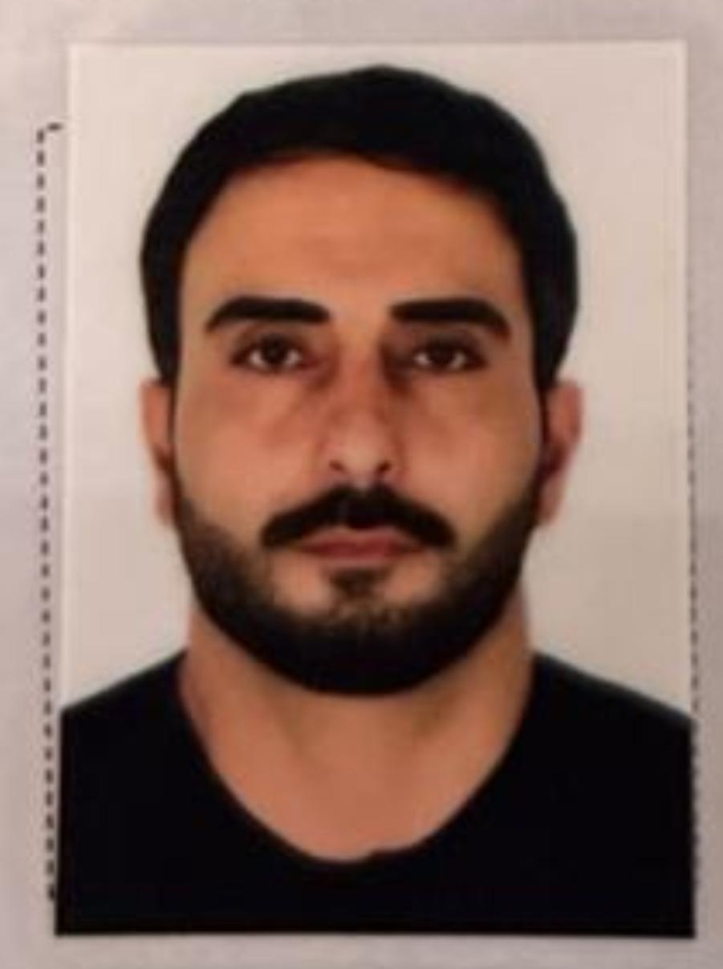
First name |  | TURAL
Father’s name |  | TAHIR
Date and place. of birth |  | 27.04.1990
Nationality |  | Azerbaijani
Marital status |  | Married
Permanent address |  | Azerbaijan, Shusha
Nearest airport |  | Heydar Aliyev International Airport Baku, Azerbaijan
Height (cm) | Weight (kg) | Eyes color | Hair color | Size of safety shoes | Size of coveralls
177 cm | 84 kg | BROWN | BLACK | 42 | XL

CONTACT DETAILS
Mobile | E-mail address
+99455 811 04 11 | tural.t.mammadov@gmail.ru
WhatsApp
Document | Grade | Place of issue | Date of issue | Date of expiry
BACHELOR’S DIPLOMA | B22 No191801 | UKRAINE | 01.09.2018 | 22.07.2022

NEXT OF KIN (FOR EMERGENCY)
Next of kin | MAMMADOV TAHIR | Relationship | FATHER
Phone | 055 633 97 92 | ADRESS | Azerbaijan Sumgayit Mikroregion-18

TRAVEL PASSPORT DETAILS
Document | Number | Place of Issue | Issued | Valid
PASSPORT | C01966820 | Azerbaijan | 01 05.2018 | 30.04.2028

SEAMAN’S BOOK DETAILS
Document | Number | Place of Issue | Issued | Valid
Seaman book | DGK018045 | Azerbaijan ,Baku | 23.07.2021 | 23 07.2026
SEAARERS IDENTITY | AZE022968 | Azerbaijan ,Baku | 23.07.2021 | 23.07.2026

KNOWLEDGE OF LANGUAGES
Languages | Speaking | Reading | Writing
Azerbaijan | excellent | excellent | Excellent
Russian | excellent | excellent | Excellent
Turkish | excellent | excellent | Excellent

COMPUTER SKILLS
Windows | Microsoft Office | Internet
Excellent | Excellent | Excellent

MEDICAL INFORMATION
Medical Sertificate | 3 ND ENGINEER | Azerbaijan Baku | 18.07 2023 | 18 07.2025

CERTIFICATE OF COMPETENCY
Class/Grade | Issuing country | Certificate  No.0007993 | Date issued | Expires | Details of Limitations
Officer in charge of an engineering watch | Azerbaijan  Marine  Administration | 001132-23 | 25 10..2023 | 25.10.2028 | 3/1

STCW AND OTHER CERTIFICATES
Name of course/Certificate | Institute | Place | Date of issue | Cert.No | Date of  expiry
International Safety  Management | Azerbaijan  Marine  Adminstration | Azerbaijan Baku | 30.08.2021 | SP-1540-21 | 30.08 2026
Proficiency in survival craft and boats other than fast rescue boats | Azerbaijan  Marine  Adminstration | Azerbaijan Baku | 26.08 2021 | SL-1335-21 | 26.08.2026.
ENGINE  RESOURCE  MANAGEMENT | Azerbaijan  Marine  Adminstration | Azerbaijan Baku | 24 07.2023 | ER-0222-23 | 24.07.2028.
MEDICAL  FIRIST AID | Azerbaijan  Marine  Adminstration | Azerbaijan Baku | 28.07.2023 | SN-1181-23 | 28.07.2028
Ship securityrelated familiarization security awareness training | Azerbaijan  Marine  Adminstration | Azerbaijan Baku | 26.08.2921 | SI-1022-21 | 20.08.2026
Leadership And Teamwork | Azerbaijan  Marine  Adminstration | Azerbaijan Baku | 03.08.2023 | DL-0626-23 | 31.07 2028
Training in advanced fire fighting | Azerbaijan  Marine  Adminstration | Azerbaijan Baku | 04.08.2023 | SJ-1014-23 | 03.08.2028.
Basic safety trainig | Azerbaijan  Marine  Adminstration | Azerbaijan Baku | 27.08.2021 | S0-2224-21 | 19.08.2026
Trainig for seafarers with  desgnated security  duties | Azerbaijan  Marine  Adminstration | Azerbaijan Baku | 24.08.2021 | SH-0749-21 | 23. 08.2026
SEA EXPERIENCE (LAST 5 YEARS – MOST RECENT EXPERIENCE ON TOP LINE)
VESSEL | COMPANY | TPUE OF VESSEL | FLAG | DWT | M/E TYPE | RANK | SIGN ON | SIGN OFF
AMANOS | BRO MARRINE | GENERAL CARGO | PALAU | 1855 | MAN 1150 kv | OILER | 15.10.2021 | 12.04.2022
NAVRUZ | ENKA SHIPPING | AHTS | KAZAKSTAN | 4500 | SKODA 2x850 kv | OILER | 03.05.2022 | 08.10.2022
METIN DADAYLI | DADAYLI SHIPING | GENERAL CARGO | PANAMA | 5220 | MAN 1485 kv | OILER | 28.10.2022 | 28 12.2022
SKY MARRINE | FEYZ GRUP | GENERAL CARGO | PANAMA | 4570 | MAK 2200 KV | OILER | 04 01.2923 | 01.07.2023

