CURRICULUM VITAE
PERSONAL DETAILS
Family name |  | TANIRVERDIYEV |  |  | 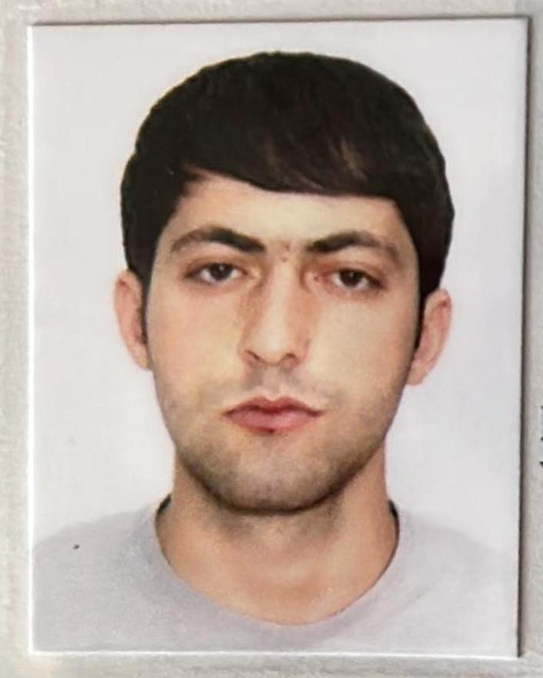
First name |  | ISA
Father’s name |  | JEYHUN
Date and place of birth |  | 13.01.2004
Nationality |  | Azerbaijan
Marital status |  | Singl
Permanent address |  | Azerbaijan Shamkir
Nearest airport |  | Heydar Aliyev International Airport Baku, Azerbaijan
Height (cm) | Wei ght (kg) | Eyes color | Hair color | Size of safety shoes | Size of coveralls
1.78 cm | 68 kg | BROWN | BLACK | 42 | XL
CONTACT DETAILS
Mobile | E-mail address
+99450 504 34 98  Watcaap | tanrverdiyev557@gmail.com
NEXT OF KIN (FOR EMERGENCY)
Next of kin | TANIRVERDIYEV JEYHUN | Relationship | FATHER
Phone | +99451 567 81 67 | Address | AZERBAIJAN Shamkir Garajamirli village
TRAVEL PASSPORT DETAILS
Document | Number | Place of Issue | Issued | Valid
PASSPORT | C03507289 | Azerbaijan | 19.07.2023 | 18.07.2033
SEAMAN’S BOOK DETAILS
Document | Number | Place of Issue | Issued | Valid
Seaman book | DGK025168 | Azerbaijan ,Baku | 23.09.2023 | 23 09.2028
SEAARERS IDENTITY | AZE030041 | Azerbaijan ,Baku | 23.09 2023 | 23.09.2028
EDUCATION
Full name of School | Place of Issue | Grade/Class | From | To
KAINAT MARITIME MMC | Azerbaijan , Baku | KM-000053  Oiler | 06.01.2023 | 31.07.2023
KNOWLEDGE OF LANGUAGE
Languages | Speaking | Reading | Writing
Azerbaijan | Excellent | excellent | Excellent
Turkish | Excellent | excellent | Excellent
COMPUTER SKILLS
Windows | Microsoft Office | Internet
Excellent | Excellent | Excellent
MEDICAL INFORMATION
Document | Grade | Place of issue | Date of issue | Date of expiry
Medical Sertificate | Engine-room watch | Azerbaijan Baku | 01.05.2023 | 01.05.2025
CERTIFICATE OF COMPETENCY
Class/Grade | Issuing country | Certificate | Date issued | Expires | Details of Limitations
Rating forming part of an engine-room  Watch | Azerbaijan Marine Administration | No-2013-23  RP-13541 | 12.09.2023 | No limit | A-3/4. OILER
STCW AND OTHER CERTIFICATES
Name of course/Certificate | Institute | Place | Date of issue | RANK | Cert.No | Date of expiry
International Safety Managemen | Azerbaijan Marine Adminstration | Azerbaijan Baku | 19.05.2023 | Engine-room watch | SP-1526-23 | 15.05..2028
Proficiency in survival craft and boats other than fast rescue boats | Azerbaijan Marine Adminstration | Azerbaijan Baku | 11.05.2023 | Engine-room watch | SL-1589-23 | 11.05.2028
Training for seafarers with designated security duties | Azerbaijan Marine Adminstration | Azerbaijan Baku | 08.05.2023 | Engine-room watch | SH-1112-23 | 08.05.2028
Basic safety trainig | Azerbaijan Marine Adminstration | Azerbaijan Baku | 12.05.2023 | Engine-room watch | S0-1978-23 | 12.05.2028
Ship Security-related familization security-awareness | Azerbaijan Marine Adminstration | Azerbaijan Baku | 15.05.2023 | Engine -room watch | SI-1328-23 | 10.05.2028
SEA EXPERIENCE (LAST 5 YEARS – MOST RECENT EXPERIENCE ON TP LINE)
Vessel | Company | Type of vessel | Flag | DWT | GRT | Rank | Sign on | Sign off

