CURRICULUM VITAE
PERSONAL DETAILS
Family name |  | KHANOGHLANZADE |  |  | 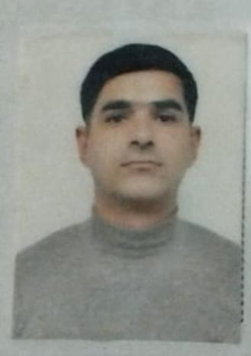
First name |  | MIJAT
Father’s name |  | HIKMAT
Date and place of birth |  | 15.03.1993
Nationality |  | Azerbaijan
Marital status |  | Married
Permanent address |  | Azerbaijan, Salyan
Nearest airport |  | Heydar Aliyev International Airport Baku, Azerbaijan
Height (cm) | Weight (kg) | Eyes color | Hair color | Size of safety shoes | Size of coveralls
1.78 cm | 65 kg | BROWN | BLACK | 42 | M
CONTACT DETAILS
Mobile
+99455 649 00 52
Whatsapp
NEXT OF KIN (FOR EMERGENCY)
Next of kin | SULEYMANOV HIKMAT | Relationship | FATHER
Phone | +99450 347 25 98 | Address | AZERBAIJAN Salyan Arbatan village
TRAVEL PASSPORT DETAILS
Document | Number | Place of Issue | Issued | Valid
PASSPORT | C03872297 | Azerbaijan Baku | 11.08 2022 | 10.08.2032
SEAMAN’S BOOK DETAILS
Document | Number | Place of Issue | Issued | Valid
Seaman book | DGK020302 | Azerbaijan ,Baku | 25.05.2022 | 25.05.2027
SEAARERS IDENTITY | AZE025166 | Azerbaijan ,Baku | 25.05.2022 | 25.05.2027
EDUCATION
Full name of School | Place of Issue | Grade/Class | From | To
Azerbaijan Marrine academy marine collage | Azerbaijan , Baku | AA N-156826  Oiler | 15.09.2017 | 25 06.2021
KNOWLEDGE OF LANGUAGE
Languages | Speaking | Reading | Writing
Azerbaijan | Excellent | excellent | Excellent
Turkish | Excellent | excellent | Excellent
Russia | Excellent | Excellent | Excellent
COMPUTER SKILLS
Windows | Microsoft Office | Internet
Excellent | Excellent | Excellent
MEDICAL INFORMATION
Document | Grade | Place of issue | Date of issue | Date of expiry
Medical Sertificate | Able seafarer engine | Azerbaijan Baku | 15.11.2021 | 15.11.2023
CERTIFICATE OF COMPETENCY
Class/Grade | Issuing country | Certifikate  No-0917-22 | Date issued | Expires | Details of Limitations
ABLE SEAFARER ENGINE | Azerbaijan Marine Administration | RP-11292 | 17.05 2022 | NO LIMIT | A-3/5 OILER
STCW AND OTHER CERTIFICATES
Name of course/Certificate | Institute | Place | Date of issue | RANK | Cert.No | Date of expiry
International Safety Managemen | Azerbaijan Marine Adminstration | Azerbaijan Baku | 16.05.2021 | Able seafarer engine | SP-0672-21 | 28.04.2026
Proficiency in survival craft and boats other than fast rescue boats | Azerbaijan Marine Adminstration | Azerbaijan Baku | 31.01.2022 | Able seafarer engine | SL-0225-22 | 28.01.2027
Training for seafarers with designated security duties | Azerbaijan Marine Adminstration | Azerbaijan Baku | 08.02.2022 | Able seafarer engine | SH-0132-22 | 04.02.2027
Basic safety trainig | Azerbaijan Marine Adminstration | Azerbaijan Baku | 18.05.2021 | Able seafarer engine | S0-0894-21 | 26.04.2026
Ship Security-related familization security-awareness | Azerbaijan Marine Adminstration | Azerbaijan Baku | 08.05.2021 | Able seafarer engine | SI-0368-21 | 30.04.2026
Basic training on qualification oil and chemical tanker cargo operations | Azerbaijan Marine Adminstration | Azerbaijan Baku | 14.02.2022 | Able seafarer engine | SA-0069-22 | 08.02.2027
SEA EXPERIENCE (LAST 5 YEARS – MOST RECENT EXPERIENCE ON TP LINE)
Vessel | Company | Type of vessel | Flag | DWT | GRT | Rank | Sign on | Sign off
MV SIFTERI | TOPA SHIP MANAGAMENT | GENERAL CARGO | MONROVIYA | 7180 | 3728 | OILER | 13.12.2022 | 5 04.2023

THE HONOR IS GIVEN BASED ON HIS ACTIVE PARTICIPATION IN THE EXPERIENCE HE PASSED ON THE BALAKAN SHIP

