 | 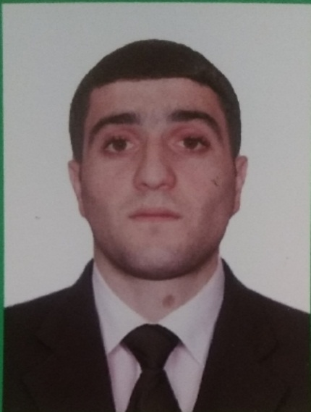
  SEAFARER'S APPLICATION FORM
  Position: | Fitter | Readiness: | 2022
  Position: | Fitter | Citizenship: | Azerbaijan
  Last name: | Agharzazade | Marital status | Single
  First name: | Zahid | Children: | No
  Middle name: | Fikret | Nationality: | Azerbaijan
  Birth date: | 03.10.1997 | Birth place: | Azerbaijan / Salyan
  Home address: | Salyan /Azerbaijan | Phone mobile:  Viber: + | +994505900138
  Home address: | Salyan /Azerbaijan | Phone home: | +994518820463
  Home address: | Salyan /Azerbaijan | Email: | Elgun.19901234@gamil.com
  English level: | Low

Salary | Minumum: | Expected: | Last: 1500 | $/month

Education
Educational institution | Speciality | Faculty | Place | Number | From | Till
KAINAT-M TM LLC | Rating forming part of a navigational watch | Rating forming part of a navigational watch | BAKU | MA № 000075 | 2019 | 2019

Passports, Licenses & Certificates
Title | Class | Number | Place of issue | Issued | Valid
Passports & Visas
Civil passport |  | AZE 14360552 | BAKU/AZERBAIJAN | 14.12.2013 | 03.10.2022
Travel passport |  | C01644954 | BAKU / AZERBAIJAN | 02.02.2017 | 01.02.2027
Seaman's book |  | AZE 019576 | BAKU / AZERBAIJAN | 20.07.2019 | 20.07.2024
Diplomas & Endorsements
Certificate of Competency | Rating forming part of a navigational watch | 1308/19 | BAKU/AZERBAIJAN | 12.12.2019 | 12.12.2024
Certificates & Licenses
INTERNATIONAL SAFETY MANAGEMENT CODE |  | SP-1655-19 | BAKU/AZERBAIJAN | 18.11.2019 | 18.11.2024
TRANING FOR SEAFARERS WITH DESIGNATED SECURITY DUTIES (STCW Code, A-VI/6, Pa.6 to Pa. 8) |  | SH-1465-19 | BAKU/AZERBAIJAN | 28.11.2019 | 20.11.2024
PROFICIENCY IN SURVIVAL CRAFT AND BOATS OTHER THEN FAST RESCUE BOATS (STCW Code, A-VI/2 Pa.1, Pa.2, Pa.3 AND Pa.4) |  | SL-1392-19 | BAKU/AZERBAIJAN | 16.11.2019 | 16.11.2024
-PERSONAL SURVIVAL TECHNIQUES (STCW-78, A-VI/1-1)  -FIRE PREVENTION AND FIRE FIGHTING (STCW-78, A-VI/1-2)  -ELEMENTARY FIRST AID (STCW-78, A-VI/1-3)  -PERSONEL SAFETY AND SOCIAL RESPONSIBILITIES (STCW-78, A-VI/1-4) |  | SO-2761-19 | BAKU/AZERBAIJAN | 18.11.2019 | 18.11.2024
SHIP SECURITY-RELATED FAMILIARIZATION SECURITY-AWARENESS TRANING (STCW Code, A-VI/6, Pa.1 TO Pa.4.) |  | SI-2435-19 | BAKU/AZERBAIJAN | 12.11.2019 | 12.11.2024
ELECTRICAL WELDER |  | № 0951 | BAKU/AZERBAIJAN | 20.06.2017 | -------
Medical Certificates
Medical Fitness Certificate |  | N-043050 | BAKU/AZERBAIJAN | 21.07.2023 | 21.07.2025

Sea-going experience
 | Vessel’s  Name | Flag | Type | Engine | Rank | From | Shipowner
 | Vessel’s  Name | Year | DWT | HP | Rank | Till | Crew Agency
1 | OMEGA | MALTA | GENERAL CARGO | 7594 | Fitter  O/S | 20.12.2019 | FOR A MARINE.
1 | OMEGA |  | 25537 | kw | Fitter  O/S | 26.07.2020 | Contact whit company  021202557679
2 | MY EFEKAN1 | Cook Island | GENARAL CARGO  1246 | 749  kw | Fitter  O/S | 25.08.2020  08.02.2021 | MY SHIP  .Contact whit company  +905454099947
3 | NATRA | VANUATU | GENERAL CARGO | 1030 | Fitter  O/S | 16.04.2021 | ISKELE DENIZCILIK,
3 | NATRA |  | 2996 | kw | Fitter  O/S | 17.11.2021 | Conpany whit company  +90533420
 | RIVER GRACE | PANAMA | GENERAL CARGO  5091 | 2x883  kw | Fitter  O/S | 14.04.2022  28.01.2023 | CUNDA  Company whit company  +902165742512
 | RIVER GRACE | PANAMA | GENERAL CARGO | 2x883 | Fitter  O/S | 09.08.2023  17.11.2023 | CUNDA  Company whit company  +902165742512

General Physical State
Height (cm) | Weight (kg) | Shoes | Clothes | Hair color | Eye color
182 | 75 | 43 | M | BLACK | BROWN

Date applied: |  |  | Signature:

